**STOCK FORECASTING PROJECT**

**Vraj Parmar**

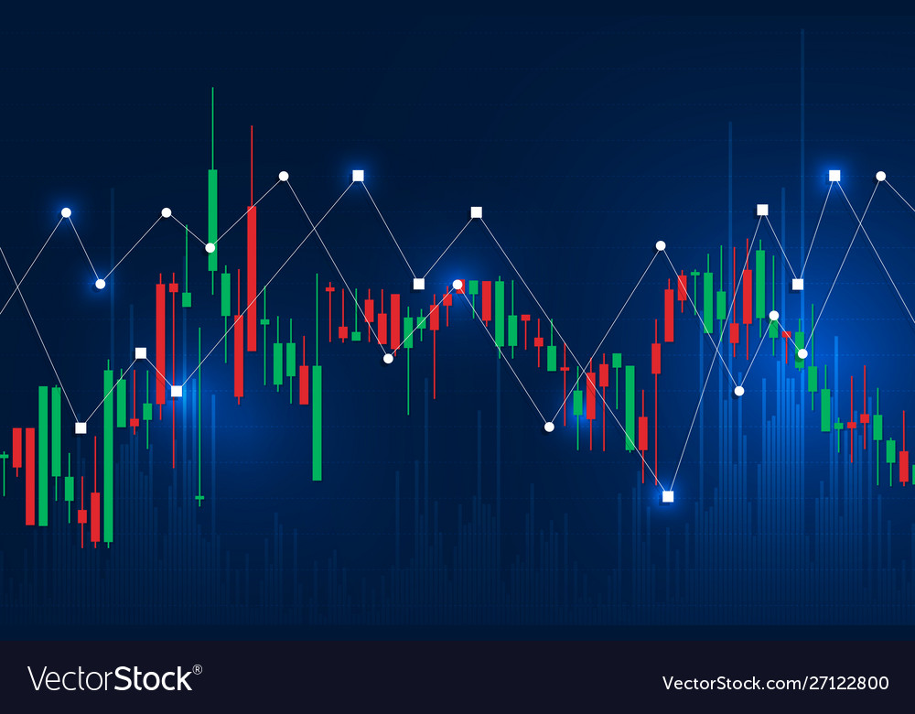

**ANALYSIS**

**Problem Definition and Stakeholders**

Mr Sandip Parmar is a current owner of a thriving business in the technology sector, with in-depth knowledge about the chip industry. He is my father and has a passion for computer architecture and hardware through which he gets inspiration for his business and provides the best service to his clients. Sandip has recently seen the rapid growth in share prices for large technological firms during the pandemic (as well as cryptocurrency). Due to his successful business, he has a quite a significant amount of money just sitting in the bank, and therefore wants to invest this into the stock market for a gaining profit but, more importantly, understanding the stock markets’ fluctuations through global events thereby becoming an independent investor with no profit being cut by financial planners.

I will be creating a web app to help my father on the journey to understanding the specific stock markets, which he can then apply to other closely linked sectors or business firms to expand his experience. As he is new to this sector, I aim to first introduce him to how stocks work with a few examples and key meanings (e.g., share prices and volatility). Additionally, until he is comfortable with the basics, extra information will be hidden to remove the possibility of anxiety as overloading from the start may deteriorate his enthusiasm. Once he is confident with the basics, the more advanced information will be shown through a simple update.

To put it into perspective, I have decided to have a login system for my father to access the web app securely whereby he will be greeted to a welcome page after successfully logging in. On the welcome page, I imagine there should be buttons (links) to the stock prediction app and other important sites that Sandip would like to access. All this allows for a tailored experience, making the app as effective as possible and providing the best methodical way of getting into becoming an independent investor in the stock market.

As this is a forecasting app, it can never be 100% accurate as stock prices depend on many other factors and global events other than just previous prices. However, for the sake of educating and getting knowledge, the modelling algorithm can be tested by Sandip and see how the actual prices vary in the future compared to the predictions outputted by the app. All this provides an interactive and thought-provoking process on understanding the stocks leading to a gain in confidence as well as improvements on previous mistakes without losing money.

**Justification of Computational Methods**

Computers have allowed education in all fields to become livelier. Videos, web apps and interactive quizzes are all examples of how methods of learning have evolved from plain old textbooks. This makes gaining knowledge more interesting and dynamic - most people will be more willing to learn through videos and quizzes over textbooks. Specifically for the stock market, knowledge cannot be earned through reading about it but only through experience as the current stock market is always different to the past and the future stock market will always be different from the current. As a result, this instinct of accurately enough predicting the stocks can only come through experience, although this usually always means the loss of money in the past, however, due to computers and their ability to learn patterns, through machine learning, it makes a reasonable substitute.

* **Using Abstraction**

As stocks fluctuate throughout the day and vary every second, storing or using web scrapping to get these prices would use too much storage and require a lot of processing power. For the purpose of decreasing the processing time substantially by sacrificing a little accuracy, I will be using the opening and closing stock prices only for each day over the previous years.

* **Thinking Ahead**

Computers also allow for storing mass data such as login details in a database. Compared to paper-based systems, specific records are easier to search up and update if required. Additionally, if this data is private and confidential, it can be backed - up to a server and encrypted.

The links available on the welcome page will provide in-depth knowledge in a manageable and concise format.

Moreover, computers provide great convenience. With technologies such as Bootstrap and improvements in smartphones, websites and web apps can be accessed from anywhere - even on the go. This feature can be provided with a simple update in the future to view this web app from his smartphone as currently, the app requires a desktop PC or laptop. This will eventually allow Sandip to have direct access to how the stock prices are currently at and if it's the correct time to invest or sell his shares.

* **Problem Decomposition: Procedural Thinking**

As web apps consist of many layers: HTML files, external CSS files, PHP files and JavaScript files, it is important to think procedurally with decomposition. Modular programming is necessary as it allows me to decompose my final goal of creating a Stock Forecasting Web App into smaller and more manageable sub-tasks or sections. For example, there is going to be a login system connected with a database, so programs for the login page, reset password page and welcome page are individual files that are interlinked via the database; completing each of the sub-tasks mentioned and linking them together to produce a fully functioning login system can tick off on the subsections of my project through completing the sub-tasks in each section.

* **Working Logically**

Lastly, I must work logically, starting with appropriate themes and design inspirations to formulate one of my own.

Through this, I must keep my father’s interest and perspective at the forefront as this is to aid him.

**Hardware and Software Requirements**

Hardware Requirements:

* CPU: 2GHz or faster
* RAM: 8GB or more

Software Requirements:

* OS: macOS Monterey 12.0.0 or later
* Python 3.8

As well as Python, some of the libraries that will be used such as ‘streamlit’, ‘yfinance’, ‘fbprophet’ and ‘plotly’ must be installed manually. On macOS, it is done through using a Python tool known as ‘pip install’ command on Terminal.

I have chosen to use Python for mainly 4 reasons:

1. It is a high-level programming language which makes programming easier and is suitable for such a task.
2. It is easy to use and understand which should reduce development times and make it easier to program the product.
3. It has many building in libraries.
4. It has many debugging facilities, which will aid and make the process of development easier and faster.

**Research**

To make a good overall product, I will research existing websites and apps that relate directly to my product and other products that may not necessarily be about the stock market but contain features that I may want to include. This allows me to develop a good understanding as to what my final product should look like.

1. Apple Stock App

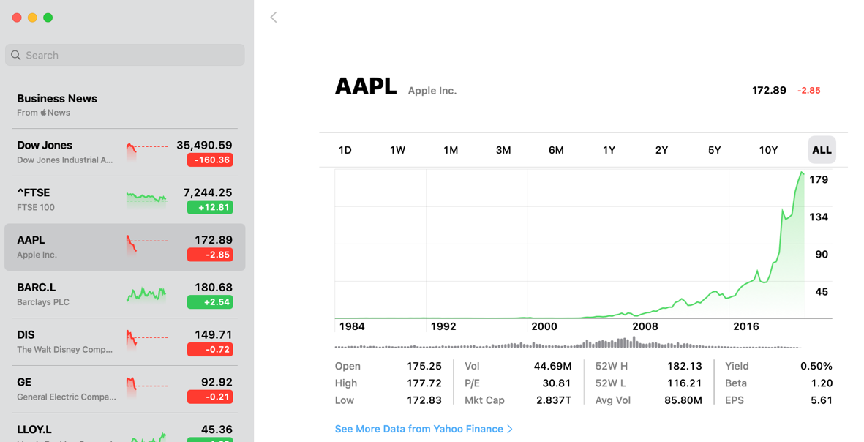

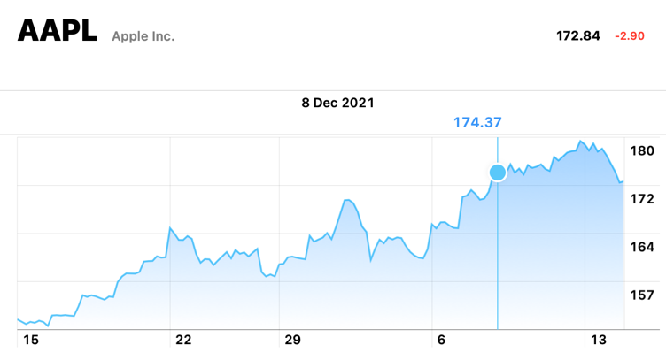

|  |  |
| --- | --- |
| **Pros** | **Cons** |
| * Easy to use * Ability to see stocks in more or less detail depending on time frame * Hovering cursor over the graph displays stock prices and the exact date * A lot of stock related information below the graph | * It only allows one format to view the data (as a line graph) whereas it may be better as a candle graph (in Yahoo Finance below) * A lot of useful information and news below the graphs but may be a bit too much for a beginner to understand * Lack in customisation and adaptation for users’ needs |

This has a simplistic but informative design, which is useful as I want to graph my stock prices in a similar manner.

1. Yahoo Finance

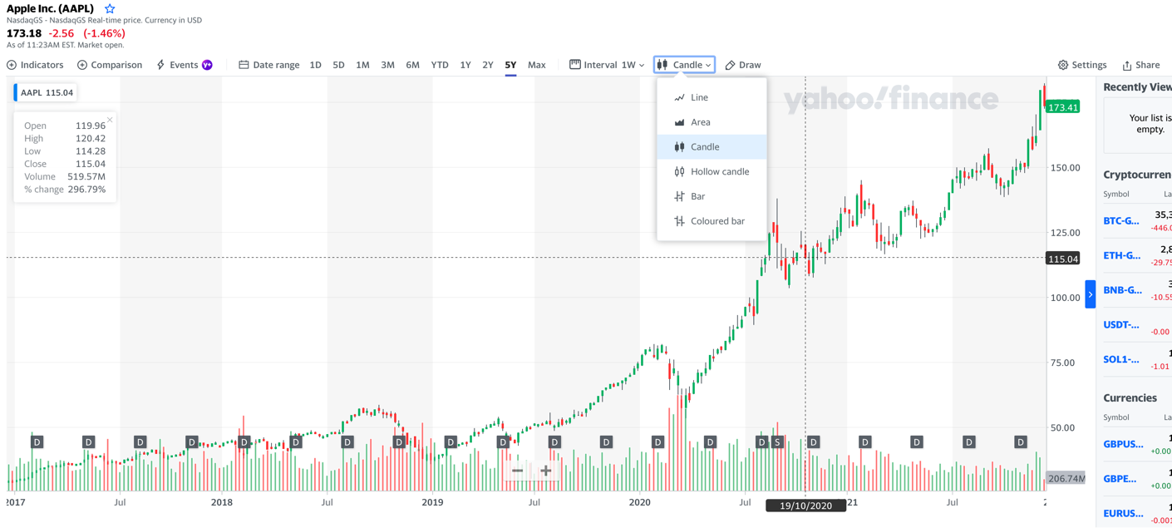

This has a very similar purpose as 1. Apple Stock App however is more popularly used.

|  |  |
| --- | --- |
| **Pros** | **Cons** |
| * Ability to see stocks in more or less detail depending on time frame * Ability to see certain formats in greater detail through changing intervals * Hovering cursor over the graph displays stock prices and the exact date with grid lines for extra clarity * A lot of stock related information when hovering over the graph * Allows multiple different formats to show the stock prices * Overall superior customisation and adaptable to users’ needs | * Not as easy to use as others * A lot of useful information and news below the graphs but may be a bit too much for a beginner to understand * Does seem more technical and ‘hectic’ which is good if the user is experienced but many discourage beginners |

1. 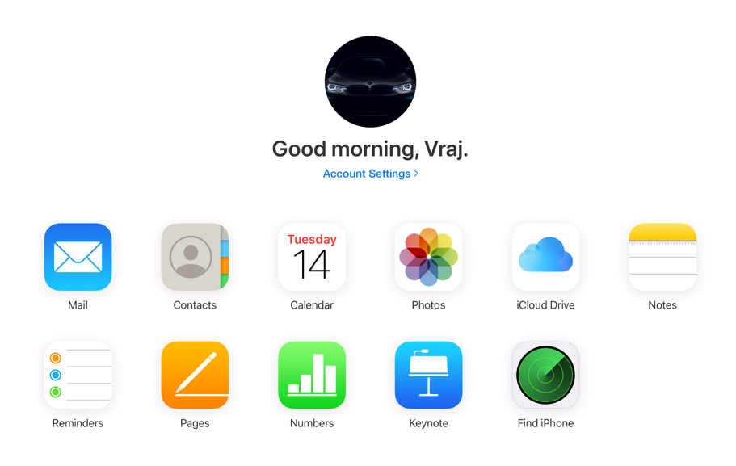iCloud Login

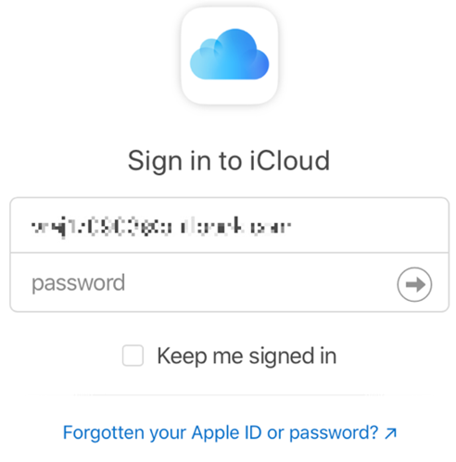

This is a very simple but functional login interface which I will require to securely login in the user to access the web app.

|  |  |
| --- | --- |
| **Pros** | **Cons** |
| * Easy to use * Very neat and professional looking * Welcome the user * There is an option to stay signed in * There is an option for forgotten password * The login page has a simple layout with large clear categories to access other more specific pages * Link to page regarding account information | * This format is suited for not too many but also not too few categories to select (too few = looks empty and too many = crowded) * Need to design icons for each category |

1. 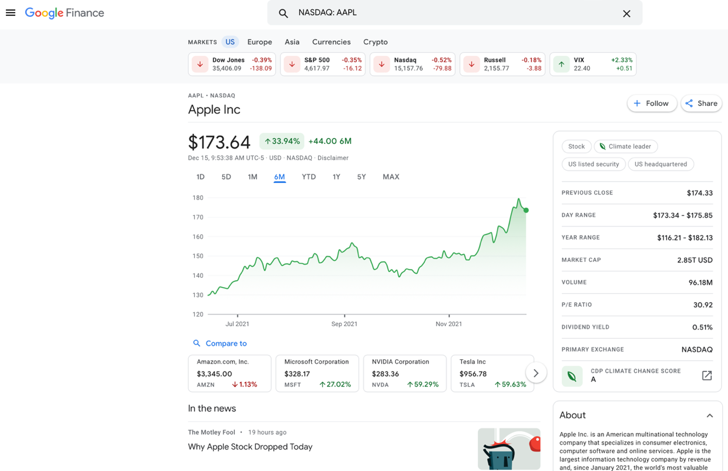Google Finance

|  |  |
| --- | --- |
| **Pros** | **Cons** |
| * Easy to use * Very neat and professional looking * There are other recommended markets which may be of interest to the user with short important information as well * Ability to vary time period of stock to be viewed * When hovered over the graph, gives important information for that point * Widget to the right providing easy to grasp information * Below the widget, there is a widget titled “About” for extra information about that cooperation * Refreshes automatically every 10 seconds or so * Shows Primary Exchange | * It only allows one format to view the data (as a line graph) whereas it may be better as a candle graph (in Yahoo Finance as previously shown) * A lot of useful information and news below the graphs but may be a bit too much for a beginner to understand * Lack in customisation and adaptation for users’ needs * May be a little too focused for beginners to be critical * Some information is not very useful |

Through this research, I decided that it would be best to start off with keeping it simple and easy to use basing the design and layout briefly on the iCloud login page and the icons and welcome page from it as well.

Once Sandip has had more experience and gets to know the basics and knowhow of the stocks, the more complex information can be included through an over the air update which he can then familiarise with and use to his advantage to further understand the market and make more profitable decisions based on this extra information.

**Client Interview**

I interviewed my father as he is the indented user for this product to gain a better understanding into what he wants specifically so don’t need to speculate and possibly make disadvantageous changes which might limit his progress.

1. Do you have any prior experience of investing, buying, or selling shares?

No. I am doing this for the first time and would like to get some experience so I can become more independent with my investments and therefore get to keep more of the profits that is made from the money I invest in. In simpler terms, getting more out of investing in the same amount.

1. Why do you want to use this product?

I want to able to see the stock market share prices presently and previously graphically so I may make a fairly accurate estimate of where that market may be in 1 week, 1 month or possibly 1 year. However, for the beginning, I would like some assistance through graphical representation to forecast the stock market prices.

1. What are the main requirements?

Fundamentally, I would like a secure login page through which I can access my personalised webpages and layout on the welcome page. There should be links on the page that take me to some required areas such as changing the password, logout, and stock predictions web app. The web app should be titles clearly and with clear information and links for more information if required. Graphical representation of the stocks is likely and only some the stocks should be visible (the ones I am interested in investing and ones which I have already invested in). Although loading stock shares may take some time, I would like the experience to be as swift and optimised as possible, with good response times when refreshing the page to get the latest prices.

1. Are there any additional features that you would like?

I would be nice to see the thought process and possibly the pattern or trends the computer notices to see how it approaches the problem so that I may gain the skill to recognise similarly. Additionally, icons could be a nice touch to include for further clarity.

1. What do you not like about equivalent products available?

I find them to be slightly overcomplicated and complex to understand due to the overcrowding of information and sometimes lags as a result of running them via the internet.

1. Do the aesthetics of the program matter?

Not particularly. As long as the placement of specific items are logical and clearly layabout, it doesn’t really matter so much.

1. Do you want to have any specific fonts, colours, themes etc.?

No; as mentioned before, it just has to be clear and easy to use.

1. Would you like to be notified of popular or upcoming profitable markets?

It would be advantageous to know this however it would be I dislike it on this tailed experience as I would not like to be disturbed or take my eyes off from the main stocks, I invest in. Maybe providing a link to another website for this information as it is not necessary for this product.

1. How would you like the key information to be displayed?

I would like there to be a small box with brief important information where I hover over the stock shares, so the information is only there when I need it increasing my available screen real-estate.

1. Is there any specific reason you are stepping into this field instead further expanding your current business?

This is more a curiosity-based decision rather than an economic one so I may gain a skill which coincidentally makes many people around the world millions.

**Features of Proposed Solution**

Having researched existing solutions and consulted with the stakeholder, I have decided to include the following features in my program.

The program will consist of four main parts:

1. The user registration system (Sign up and Login)
2. The welcome page with links / buttons to other webpages
3. The main page with the stock forecasting algorithm
4. Database

User Registration System:

When users first open the program, they will be presented with a Login Page (from where they can navigate to the sign - up if necessary). This is for two reasons: firstly, upon signing up, they will have the option to save their password for future through their web browser app which removes the hassle of remembering passwords and also maintains the same or sometimes even greater level of security if biometric authentication is required to automatically enter the password in computers such as Macs. Secondly, for the personalised and more interactive experience, the registration system allows each user to be recognised and therefore display the required alteration of the product.

The welcome page will be very clear and simplistic for a smooth experience with no confusions. There will be a personalised greeting at the start of the page. Buttons to access different pages; for example, resetting the password, the link for the stock forecasting web app and to logout.

The main page is the most important. In summary, it will have a clear heading with an image below relating to stocks. There will be a drop-down menu for selecting which stock market the user wants to use with a slider below that of for selecting the extent of time the user wants to forecast in years ranging from one to four. Under this will the graph showing the past, present and future stock, which will be clearly visible. More in-depth information about the trends and patterns will be provided below and also a snapshot of the raw data also used as per the client’s request.

| **Feature** | **Justification** |
| --- | --- |
| Clear and clean user interface for registration system | Will allow user to easily use the program. The client said they want this from Q6 and 7 |
| Colour scheme - mainly white with hints of blue | Colours aren’t a major part of the program, so will depend on personal preference however, keeping it simple for ease of use and also makes it looks more professional like the Apple Stock App |
| Navigation bar of options on welcome page | Will allow user to navigate easily across all the programs as required in from the client interview |
| User registration system | Will allow the user to create an account from Q3 from the client interview |
| Login / Logout system | Will allow user to login / logout of the program respectively from Q3 in the client interview |
| Uploading dataset (containing username and password) to the database | Will allow user to easily login to the program and access their personalised account formatting |
| Graphical presentation of the stock markets | All allow the user to visualise the data; this was mentions as one of the fundamentals for this product in Q3 |
| Forecasting future stock prices | Will allow the user the user to determine whether it is worth investing for a profitable gain over a period of time from Q3 in the client interview |
| Uncertainties due to forecasting | Will allow the user to recognise the risk in investing in markets with volatility and whether or not is worth taking risk (additional requirement from the client interview) |
| Extra information regarding the algorithm for forecasting | Will allow the user to recognise the patterns and trends the algorithm has found for the highs and lows of the market and when they happen for a more thought through decision and, most likely, a better investment opportunity i.e., better bang for your buck. (Additional requirement from the client interview) |
| SQLite Database | As the project is currently small - scale, a small local database is better to use |
| Input validation | Will ensure correct and secure data is entered as per Q3 from the client interview |

Further features can be added to the program if the client is not satisfied.

**Limitations of Proposed Solution**

There are - main limitations as follows:

Firstly, time. Due to the short time frame available, the quality of the product, as well as the number of features, will be limited.

Secondly, skillset. Although I have a basic skillset which will allow me to make a basic version of the program, my skillset is not so advanced to allow me to add more complex features to make a high-level program.

Lastly, features. Due to the above reasons, some of the features will be limited. For example, the custom interface for each user can’t made for each user as their requirements have to be taken and then coded for specifically. However, a long-term solution may include some inbuild pre-set themes to choose which may satisfy the majority of users.

**Requirements of System**

| **Requirement** | **Justification** |
| --- | --- |
| Should load the Welcome page at start, then can access the Login Page | Users need to (have an account) and login before they can use the program via the welcome page |
| Should allow users to go from Login page to Sign Up page if they don’t have an account | Users need to be able to make an account if they don’t have one |
| Should validate inputs on Sign Up page | Need to ensure users enter valid data e.g., usernames that are a certain length for security reasons |
| Database system | Needs to have a database to store data such as usernames and passwords. |
| Validate inputs on Login page | Need to ensure users with correct credentials can login for security reasons |
| If a user registers their account should be created and added to the database | This is necessary to then allow the user to log in |
| Main page should not be loaded till user has logged in or signed up | Member only program so you must have an account to use the program. |
| Once a user logs in or creates an account, the main page should be loaded | The main page contains the main features of the program so logically this is the page that should be loaded |
| Navigation bar | This will allow users to navigate across the program |
| Should be able to predict data | This is the main purpose of the program and is necessary to allow users to make predictions based on existing data. The client noted this in Q3 of the interview. |
| Graphical representation | In the interview, the client stated that they want to see a graph (Q3), so this is required. This will be achieved through finding general trends over years, months and weeks combined for the best possible output. |
| Allow user to log out | Once users are finished, they should be able to log out for security reasons. |
| Easy to use | The program needs to be user friendly to make it easier to use. The client noted in Q5 of the interview that they want an easy-to-use program indirectly, so I need to include this. |

**Success Criteria**

| **#** | **Requirement** | **Justification** |
| --- | --- | --- |
| 1 | Should load the Welcome page at start, then can access the Login Page | Users need to (have an account) and login before they can use the program via the welcome page |
| 2 | Should allow users to go from Welcome page to Sign Up page if they don’t have an account | Users need to be able to make an account if they don’t have one |
| 3 | Should validate inputs on Sign Up page | Need to ensure users enter valid data e.g., usernames that are a certain length for security reasons |
| 4 | Database system | Needs to have a database to store data such as usernames and passwords. |
| 5 | Validate inputs on Login page | Need to ensure users with correct credentials can login for security reasons |
| 6 | If a user registers their account should be created and added to the database | This is necessary to then allow the user to log in |
| 7 | Main page should not be loaded till user has logged in or signed up | Member only program so you must have an account to use the program. |
| 8 | Once a user logs in or creates an account, the main page should be loaded | The main page contains the main features of the program so logically this is the page that should be loaded |
| 9 | Navigation bar | This will allow users to navigate across the program |
| 10 | Should be able to predict data | This is the main purpose of the program and is necessary to allow users to make predictions based on existing data. The client noted this in Q3 of the interview. |
| 11 | Graphical representation | In the interview, the client stated that they want to see a graph (Q3), so this is required. This will be achieved through finding general trends over years, months and weeks combined for the best possible output. |
| 12 | Allow user to log out | Once users are finished, they should be able to log out for security reasons. |
| 13 | Easy to use | The program needs to be user friendly to make it easier to use. The client noted in Q5 of the interview that they want an easy-to-use program indirectly, so I need to include this. |

**DESIGN**

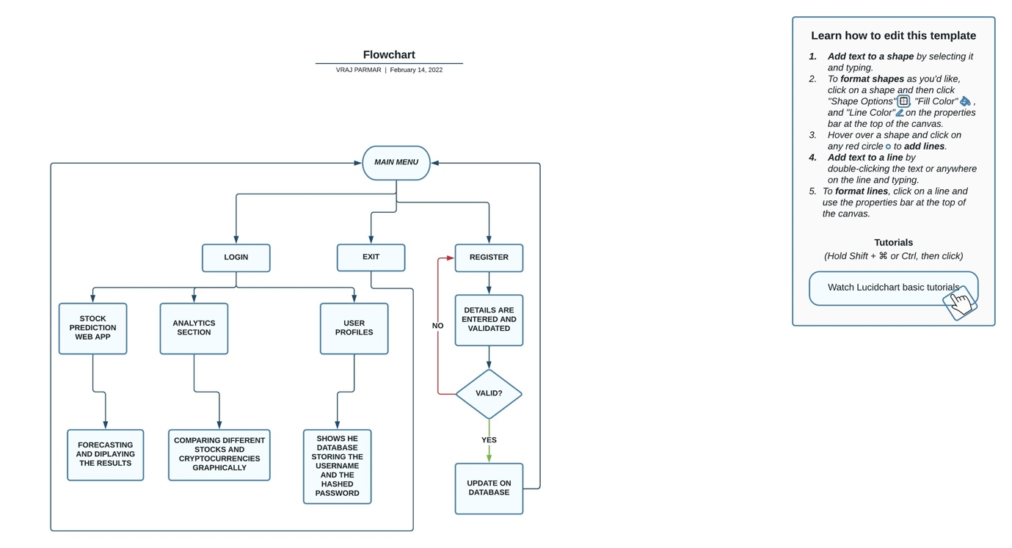

To get to this diagram, the user requires a main menu whereby they can navigate through the web app. The following options from the main menu (LOGIN, EXIT and REGISTER) can be access though drop-down menus in the sidebar as per success criteria #9.

In the LOGIN, they can enter their username and password and it is then authenticated by searching through with the database and if correct, gives them access to the other available pages (STOCK PREDICTON WEB APP, ANALYSIS and USER PROFILES) through a drop-down menu on the main page i.e., not in the sidebar.

In STOCK PREDICTION, they can access the graphical representation of the stocks and below will show predicted data overlayed on the actual previous data. Other trend information will also be provided as per Q3 in the client interview.

In ANALYSIS SECTION, they can graphically compare two different stock markets overlayed on each other to show the general market trends as per Q3 in the client interview.

In USER PROFILE, it is just for the convenience and some freedom from using external apps like DB Browser and save time when testing in the future.

In EXIT, the user will be able to exit through the sidebar provided and can be displayed or removed as required and as per success criteria #12.

In REGISTRATION, the user will be able to sign up if the username and password are valid and do not already exist on the database as per #3 in the success criteria and Q3 in the client interview. If incorrect credentials are entered, there should be a message given to the user to notify them.

**Registration Page**

* This page will allow the user to create an account by entering by entering a username and password
* The username must be valid and unique
* The page will be handled by a single module

Database Structure

The data entered will be stored in the ‘users’ table as follows:

|  |  |
| --- | --- |
| Username | Password |
| user_name | pass_word |
| … | … |

|  |  |  |  |  |
| --- | --- | --- | --- | --- |
| **Field Name** | **Variable Type** | **Validation** | **Location** | **Use** |
| username | String (possible alphanumeric) | Can’t already exist in the table | User table | Stores the username |
| password | Alphanumeric string | Must be alphanumeric | User table | Store the password |

Variables

|  |  |  |  |
| --- | --- | --- | --- |
| **Variable Name** | **Variable Description** | **Datatype** | **Validation** |
| username | Taken from the form and will be stored in the table provided it doesn’t already exist | String | Cannot already be present in user table (presence check) |
| password | Taken from the form and will be hashed using the in-built algorithm and stores the hashed password in the table | Alphanumeric string | Must be alphanumeric for additional security |

How the page will work

Below is a flow chart showing how the page will roughly work, from the first module to the last.

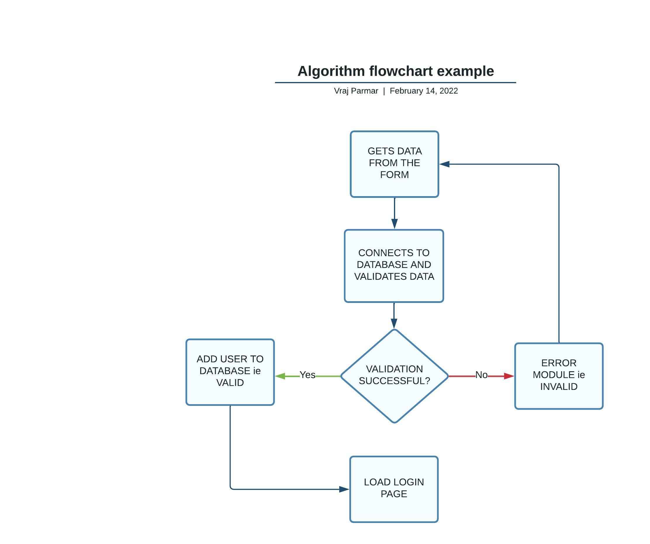

The above flowchart showing the algorithm works by getting all the data entered into the respective entry boxes and validates them. It first checks if a valid, unique username has been entered, then if a valid password has been entered and finally notifies the user on the final outcome guiding them on what to do next.

Layout

**X**

Menu

▼

STOCK FORECASTING

Create a New Account

Username

Password

Sign Up

A new account is registered

There has been an error

Drop down menu

Usability Feature: large page titles to make it very visible to user which page they are on

Usability Feature: large page titles which doesn’t change no matter what page go (just to remind what you are doing)

Allows user to register as per #2 in success criteria allowing for a tailored experience for the user in the upcoming programs

Usability Feature: I will have a simple colour scheme of white, grey, and black for clear and professional look as per Q7 from the client interview

Pressing ‘Sign Up’ will create a new user after valid inputs as per #2 in success criteria

Usability Feature: there will be a clear acceptance label when a new account has been created or an error label here if the user enters a repeated username as per #3 and #13 in the success criteria

Usability Feature: large buttons to make them easier to see and click as per #13 in the success criteria

Usability Feature: sidebar which is retractable allowing for more screen real-estate when using the app

Usability Feature: large clear headings for accessing the 3 main pages of the web app - welcome page, login page and registration page as per #13 in the success criteria

Usability Feature: drop down menu makes the user experience more interactive and allows user to see the 3 main pages only when required increasing the screen real-estate when not in use

Usability Feature: a logical form which the user should be used to from other programs or websites to make the sign-up process easier

**Login Page**

* This page will allow user to login
* They will have to enter their username and password and will be notified if there is a problem with the entered credentials
* The user cannot retrieve their username or password if they have forgotten it for security reasons and it is not very helpful even if possible as the password stored in the database will be hashed
* The page will be handled within a single module

Database Structure

The database will be queried to see if the data the user has entered matches a record in the database; the variables that will be compared in this process is the username and the hashed password.

|  |  |
| --- | --- |
| Username | Hashed Passwords |
| username | hashed_password |
| … | … |

|  |  |  |  |  |
| --- | --- | --- | --- | --- |
| **Field Name** | **Variable Type** | **Validation** | **Location** | **Use** |
| username | String (possible alphanumeric) | Can’t already exist in the table | User table | Stores the username |
| hashed_password | Alphanumeric string | Must be alphanumeric | User table | Store the password |

Variables

|  |  |  |  |
| --- | --- | --- | --- |
| **Variable Name** | **Variable Description** | **Datatype** | **Validation** |
| username | Taken from the form and will be compared to all usernames in the users table for a match. If there is no match the user will be alerted | String | Cannot already be present in user table (presence check) |
| hashed_ password | Taken from the form - if the username is valid, the respective hashed password will be compared to this password being hashed through the same algorithm for a match. If there is no match the user will be alerts | Alphanumeric string | Must be alphanumeric (the length of the password is irrelevant because the hashed password that is stored is always of fixed length) |

How this page will work

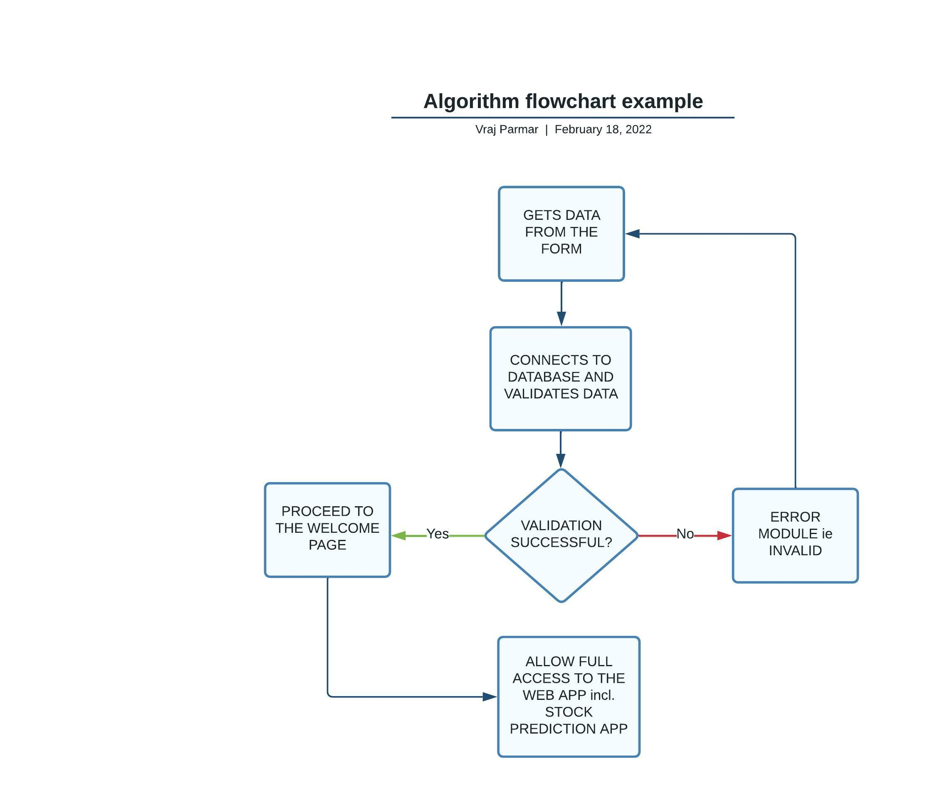

The algorithm (which is called when the submit button is pressed) checks if a user with the entered details exists in the table. If it does, the welcome is loaded allowing the user to access the stock forecasting app and other pages, otherwise, an error is displayed.

Layout

Usability Feature: large clear headings for accessing the 3 main pages of the web app - welcome page, login page and registration page as per #13 in the success criteria

Usability Feature: drop down menu makes the user experience more interactive and allows user to see the 3 main pages only when required increasing the screen real-estate when not in use

**X**

Menu

▼

STOCK FORECASTING

Login

Please login using the space provided

Username

Password

**LOGIN**

Drop down menu

Usability Feature: sidebar which is retractable allowing for more screen real-estate when using the app

Usability Feature: large page titles which doesn’t change no matter what page go (just to remind what you are doing)

Usability Feature: large page titles to make it very visible to user which page they are on

Usability Feature: I will have a simple colour scheme of white, grey, and black for clear and professional look as per Q7 from the client interview

Pressing ‘Login’ will allow user to sign in after valid inputs as per #2, 3 and 5 in success criteria

Usability Feature: large buttons to make them easier to see and click as per #13 in the success criteria

Usability Feature: there will be a clear acceptance label when a new account has been created or an error label here if the user enters a repeated username as per #3 and #13 in the success criteria

Usability Feature: a logical form which the user should be used to from other programs or websites to make the sign-up process easier

Allows user to sign in as per #2, 3 and 5 in success criteria allowing for a tailored experience for the user in the upcoming programs

**Welcome Page**

* This page is where the user will come to after successfully logging in through the login page
* There will be a drop-down menu for selecting which of the 3 tailored services the user would like to use
* These serves are separate pages themselves however will be built into the existing page

As this page has no functionality purposes besides redirecting the user to their chosen page, there are no ‘variables’ as such. However, the option selected via the drop-down menu will be tested and display the interactive page below. The reason is to allow the user to swich between the pages as fluently as possible.

How the page will work

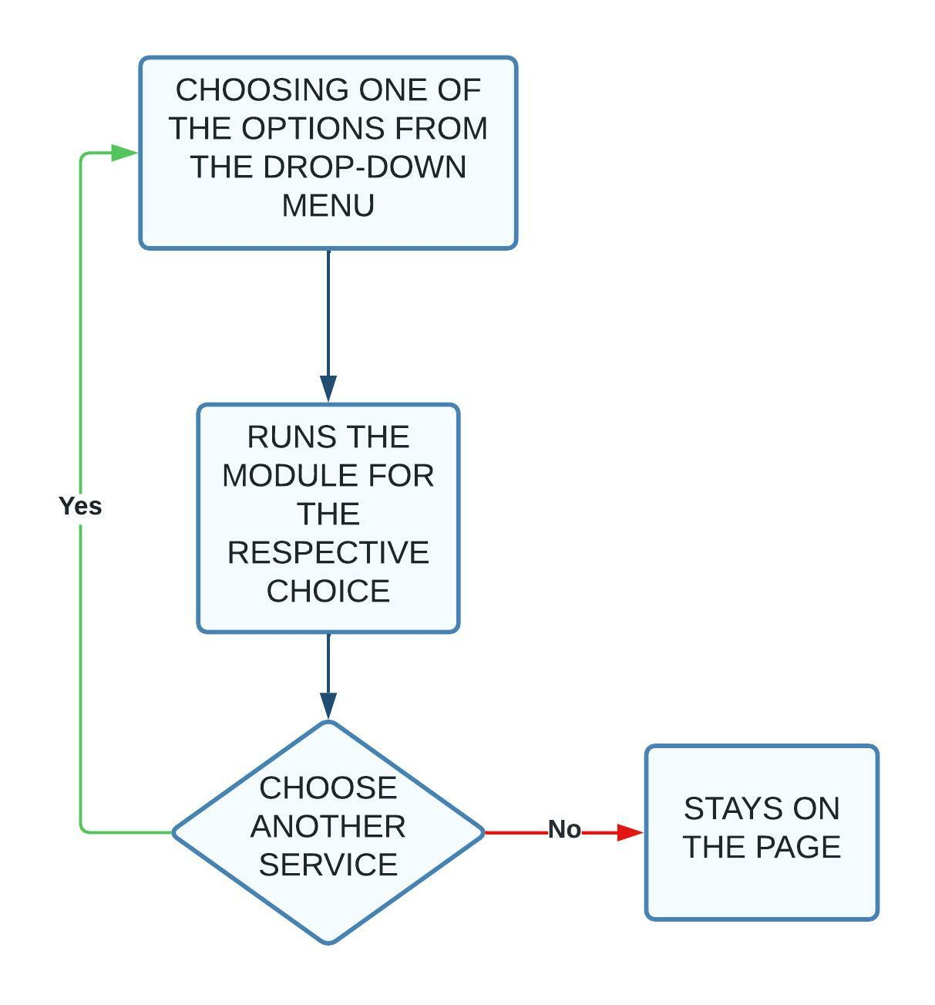

Layout

**X**

Menu

▼

STOCK FORECASTING

Welcome!!!!!!!!!!!!!!!!!

Please select from one of the below:

Drop down menu

Usability Feature: large page titles to make it very visible to user which page they are on

Usability Feature: large page titles which doesn’t change no matter what page go (just to remind what you are doing)

Usability Feature: I will have a simple colour scheme of white, grey, and black for clear and professional look as per Q7 from the client interview

Usability Feature: sidebar which is retractable allowing for more screen real-estate when using the app

Usability Feature: large clear headings for accessing the 3 main pages of the web app - welcome page, login page and registration page as per #13 in the success criteria

Usability Feature: drop down menu makes the user experience more interactive and allows user to see the 3 main pages only when required increasing the screen real-estate when not in use

Usability Feature: a logical form which the user should be used to from other programs or websites to make the sign-up process easier

Welcome message to the user to further inform they have logged in lets them know what to do next ie choose from one of the options below

This shaded region will be where the page for the selected option from the drop-down menu will appear

DISCLAIMER: it will not be shaded like shown; it is only to show region being used

Small message summarising how the stock market works

▼

Drop down menu

Drop down menu

**Stock Forecasting Page**

* This page will be loaded under the Welcome Page shown by the shaded region in the previous layout
* It will consist of a selection of stock markets, chosen via a drop-down menu, to use and a slider to vary the years of forecasting (e.g., 1 to 4 years); this will be a discrete value only
* A table for the Raw Data can also be displayed as per the user’s requirement however is not necessary
* The graph of the selected stock market will also be available with open and closing prices visible when hovered over the graph
* The Forecasted Raw Data can also be displayed as per the user’s requirements, and this will then be plotted to show the trend graphically
* More in-depth trends can also be shown graphically if required

Database Structure

As this page is displaying the stock market graphically, the prices for the chosen stock are cached as a table. This table will contain the following fields with an example below:

|  |  |  |  |  |  |  |  |
| --- | --- | --- | --- | --- | --- | --- | --- |
| **# of data** | **Date** | **Open** | **High** | **Low** | **Close** | **Adj Close** | **Volume** |
| 17797 | 2022-02-22T00:00:00 | 2022-02-22T00:00:00 | 2022-02-22T00:00:00 | 2022-02-22T00:00:00 | 2022-02-22T00:00:00 | 2022-02-22T00:00:00 | 2022-02-22T00:00:00 |
| … | ... | ... | ... | ... | ... | ... | ... |

Variables

As this data is obtained from web scraping, the data does not have to validated.

| **‘Variable’ Name** | **Variable Description** | **Datatype** |
| --- | --- | --- |
| # of data | This the number which represents with n’th data for that stock | Integer |
| Date | This shows the data and time at which the stock was a certain price. This will then be used to plot the stock as time will run along the horizonal axis | Date-Time |
| Open | This shows the price at which the stock market opened at on the day for each date | Float |
| High | This shows the price at which the stock market reached its highest value at on the day for each date | Float |
| Low | This shows the price at which the stock market reached its lowest value at on the day for each date | Float |
| Close | This shows the price at which the stock market closed at on the day for each date | Float |
| Adj Close | This shows the price at which the stock market closed at on the day for each date | Float |
| Volume | This shows the number of shares between its daily open and close | Integer |

How this page will work

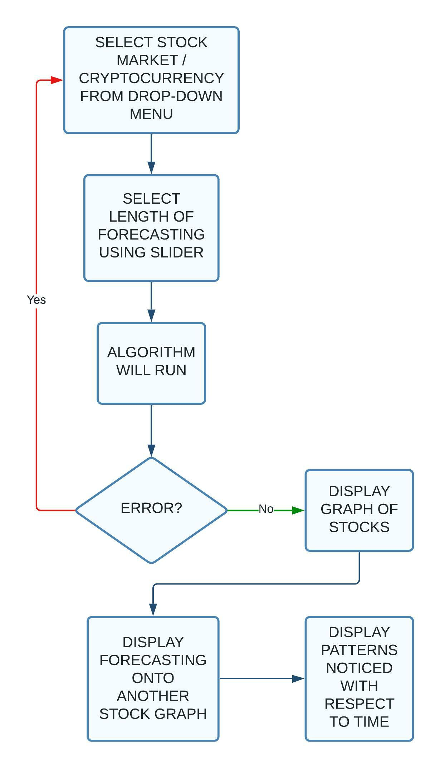

Layout

**X**

Menu

▼

STOCK FORECASTING

Please select from one of the below:

Selected Stock / Cryptocurrency:

Forecasting Time in years:

1 4

Stock Graph:

Stock Forecasting Graph

Patterns

Drop down menu

Usability Feature: sidebar which is retractable allowing for more screen real-estate when using the app

▼

Drop down menu

Usability Feature: drop down menu makes the user experience more interactive and allows user to see the 3 main pages and stocks/ cryptocurrencies respectively only when required increasing the screen real-estate when not in use

This shaded region will display the stock chosen in above drop-down menu graphically with the ability to zoom in and also have other features available, which can be added according to the user’s needs

This shaded region will display the forecasted stock chosen in above drop-down menu graphically with the ability to zoom in and also have other features available, which can be added according to the user’s needs

This shaded region will display the patterns the algorithm has spotted and implemented to create the forecasted data as per Q4 in the client interview

Usability Feature: whenever the stock / cryptocurrency selected or the forecasting time is altered, the page should automatically refresh displaying the revised / new data

▼

Drop down menu

Usability Feature: large page titles to make it very visible to user which page they are on

Usability Feature: slider option menu makes the user experience more interactive and as per Q2 in the client interview

**Analytics Page**

* This page will allow the user to observe 2 stocks / cryptocurrencies or both on the same graph; to minimise confusion, only the stock opening prices will be plotted as open and close prices for each stock will result in 4 lines on the graph in the same area which many be a hindrance to the user than an advantage
* As a result, this makes the process of comparing two different stocks and how they vary with time; this will further help the user understand how each market is interlinked with others
* For selecting two stock markets, there will be two separate drop-down menus for each stock to be selected and clearly titled with for example, ‘Stock 1’ and ‘Stock 2’
* All the other features such as zooming in on the main Stock Forecasting Page will also be present

Database Structure

As this page is displaying the stock market graphically, the prices for the chosen stock are cached as a table. As there are two stocks being compared, there will be two tables. Each table will contain the following fields with an example below:

|  |  |  |  |  |  |  |  |
| --- | --- | --- | --- | --- | --- | --- | --- |
| **# of data** | **Date** | **Open** | **High** | **Low** | **Close** | **Adj Close** | **Volume** |
| 17797 | 2022-02-22T00:00:00 | 2022-02-22T00:00:00 | 2022-02-22T00:00:00 | 2022-02-22T00:00:00 | 2022-02-22T00:00:00 | 2022-02-22T00:00:00 | 2022-02-22T00:00:00 |
| … | ... | ... | ... | ... | ... | ... | ... |

Variables

As this data is obtained from web scraping, the data does not have to validated.

| **‘Variable’ Name** | **Variable Description** | **Datatype** |
| --- | --- | --- |
| # of data | This the number which represents with n’th data for that stock | Integer |
| Date | This shows the data and time at which the stock was a certain price. This will then be used to plot the stock as time will run along the horizonal axis | Date-Time |
| Open | This shows the price at which the stock market opened at on the day for each date | Float |
| High | This shows the price at which the stock market reached its highest value at on the day for each date | Float |
| Low | This shows the price at which the stock market reached its lowest value at on the day for each date | Float |
| Close | This shows the price at which the stock market closed at on the day for each date | Float |
| Adj Close | This shows the price at which the stock market closed at on the day for each date | Float |
| Volume | This shows the number of shares between its daily open and close | Integer |

How this page will work

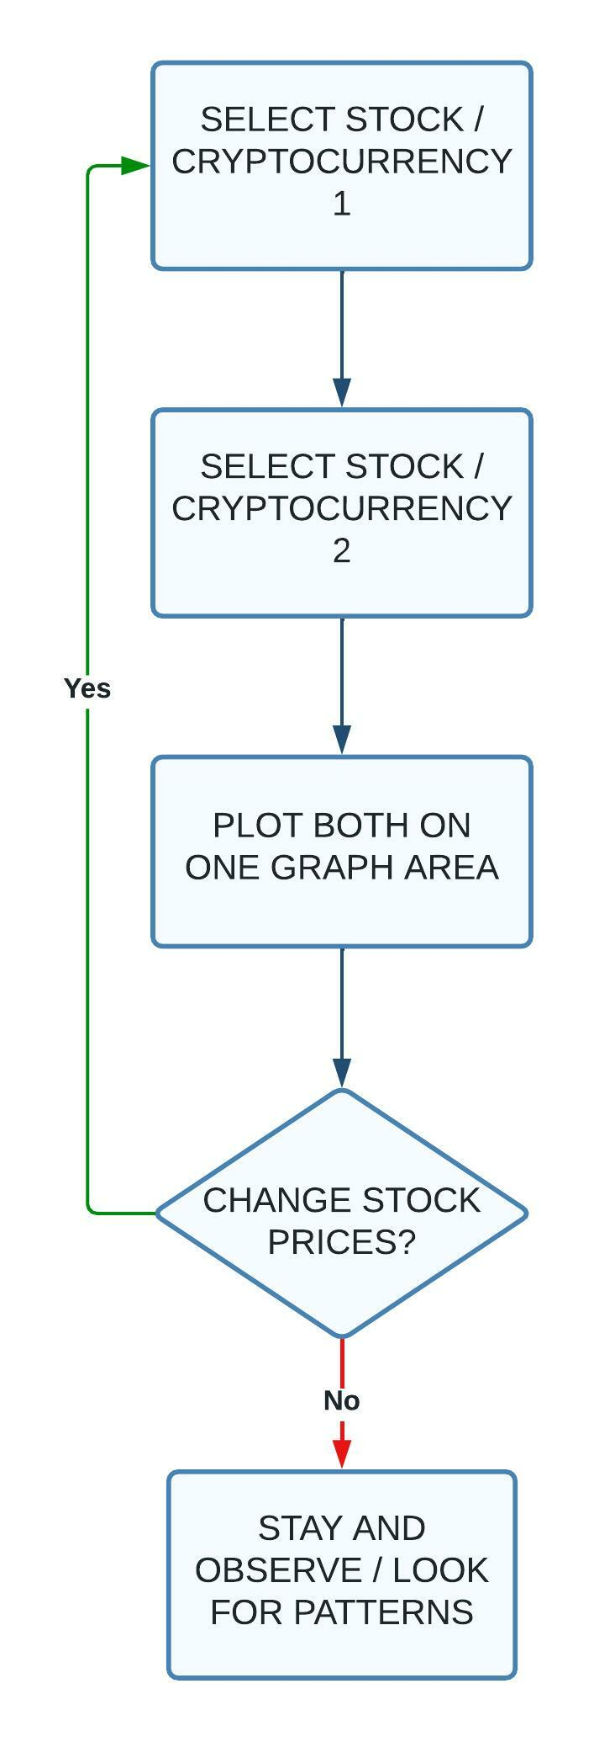

Layout

**X**

STOCK FORECASTING

Please select from one of the below:

Analytics

Selected Stock / Cryptocurrency 1:

Selected Stock / Cryptocurrency 2:

Stock Graph:

Menu

▼

Drop down menu

Usability Feature: sidebar which is retractable allowing for more screen real-estate when using the app

▼

Drop down menu

Usability Feature: drop down menu makes the user experience more interactive and allows user to see the 3 main pages and stocks/ cryptocurrencies respectively only when required increasing the screen real-estate when not in use

This shaded region will display the stocks / cryptocurrencies chosen in above drop-down menus graphically with the ability to zoom in and also have other features available, which can be added according to the user’s needs

Usability Feature: whenever the stock / cryptocurrency selected or the forecasting time is altered, the page should automatically refresh displaying the revised / new data

▼

Usability Feature: large page titles to make it very visible to user which page they are on

Drop down menu

Drop down menu

▼

Usability Feature: as two different markets are on the same graph, there will definitely be a colour coded key in the corner to indicate which market is which

Usability Feature: the stock displayed will only be the opening prices of each market to reduce confusion and aid readability to increase productivity and clarity of the suer as this one of the key requirements as per #13 in success criteria and Q3 in the client interview

**Profiles Page**

* This page will be used for me as the programmer to check whether or not new users has been added according to the inputs in the fields as per provided in the registration page without using any external apps to monitor or observe changes
* This will aid me in the development process and will be a good idea to keep on only my login as one the restricted areas of the web app only available for the developer to see

Database Structure

This is the database that will store the login data and as you can see, the password is hashed so one downside would be that you cannot update or change your password, it will have higher levels of security which is a trade-off worth it due to highly secretive investment decisions being protected.

|  |  |  |
| --- | --- | --- |
| **#** | **Username** | **Password** |
| 1 | 20parmarv@stdoms.ac.uk | 7a2d297b0d79f2a82eb210a514c2d9… |
| … | … | … |

|  |  |  |  |  |
| --- | --- | --- | --- | --- |
| **Field Name** | **Variable Type** | **Validation** | **Location** | **Use** |
| username | String (possible alphanumeric) | Can’t already exist in the table | User table | Stores the username |
| hashed_password | Alphanumeric string | Must be alphanumeric | User table | Store the password |

Variables

|  |  |  |  |
| --- | --- | --- | --- |
| **Variable Name** | **Variable Description** | **Datatype** | **Validation** |
| username | Taken from the form and will be compared to all usernames in the users table for a match. If there is no match the user will be alerted | String | Cannot already be present in user table |
| hashed_ password | Taken from the form - if the username is valid, the respective hashed password will be compared to this password being hashed through the same algorithm for a match. If there is no match the user will be alerts | Alphanumeric string | Must be alphanumeric |

How this page works

This page is just for visualising the database so has no algorithm.

Layout

**X**

Menu

▼

STOCK FORECASTING

Please select from one of the below:

User Profiles

|  |  |  |  |
| --- | --- | --- | --- |
|  | **Username** | **Password** | **Name** |
| 1 | … | … | … |
| … | … | … | … |
| … | … | … | … |
| … | … | … | … |
| … | … | … | … |

Drop down menu

Usability Feature: sidebar which is retractable allowing for more screen real-estate when using the app

▼

Drop down menu

Usability Feature: large page titles to make it very visible to user which page they are on

Usability Feature: drop down menu makes the user experience more interactive and allows user to see the 3 main pages and stocks/ cryptocurrencies respectively only when required increasing the screen real-estate when not in use

Usability Feature: this is the database storing all the user’s login details

Usability Feature: for security reasons, the password will be stored as in hashed format so even the developer cannot access the sensitive information

**Validation**

Below are all the inputs that require validation

|  |  |  |
| --- | --- | --- |
| **Inputs** | **Validation** | **Justification of Validation** |
| username (registration page) | Must have some length of inputs i.e., cannot be blank  Must be unique when making a new account through the registration page. | For security reasons I have to prevent users from creating usernames which already exist to prevent them access other accounts |
| username (login page) | Must have a matching username in the database with a matching password to get access to the account | For security reasons I have to prevent users from creating usernames which already exist to prevent them access other accounts |
| password (registration page) | Must have some length of input i.e., cannot be blank | This means user can enter whatever length and character password they would like without any constraints but have to have some form of input; they just can’t leave it black because the hashing algorithm takes an input and outputs an encrypted version of fixed length |
| name (registration page) | Must have some length of inputs i.e., cannot be blank | This is going to be used for the personalised welcome message |

To reduce the amount of validation required in my program, I have given specific options via some form of menu to choose from such as a drop-down menu or slider; these additions also provide some interactivity for the user when using the web app, which keeps them interested rather than boring them out with inputs and written text. It also splits up to web app to look more pleasing compared to a block of text and graphs throughout the pages.

**Usability Features**

1. The colour scheme is such that it ensures all text is clearly visible and doesn’t clash. This should make the text easier to spot and read.
2. Retractable navigation sidebar in program to allow user to easily navigate across all necessary pages before logging in; after successfully logging in, the user will be navigating through a drop-down menu which is always fixed in the same position throughout all the pages. It will distinguishably compared to the other text with a clear sub-title above it and since it is also a drop-down menu, it will stand out compared to the other aspects of the web app.
3. During testing, I will make sure there are no broken links so that the user can access all necessary pages.
4. All buttons will be clearly labelled so that the user can easily see what each button is for.
5. Large buttons to make it easier to click.
6. Page specific features such as drop-down menu and sliders for adjusting and more personalised experience for viewing the stock market graphically.
7. I will design each page in a logical manner so that it flows naturally to aid the initial process of getting used to the web app.
8. Big page titles will also be in cooperated so the user can see what page they are on at all times.
9. I will be using sub-sections for each page so when choosing an option for another page from the drop-down menu, the new page selected will appear in its own ‘frame’ as such without affecting the main page; this will aid the process of debugging if any errors occur as it will notify me exactly which section the error occurs in; then I can fix it swiftly.

**Development Cycle**

For the Analysis and Design, I will be taking the waterfall life cycle approach as I will consult with the test user first and then continue to create the Analysis and Design.

For the development, I will be taking the agile development approach as I will create a prototype / part of the program, ask the user for feedback, improve program based on the improvements given, and then carry on to the next part of the program. This will continue until the program is done.

**Test Plan**

These are the tests that I will conducting during the development.

Registration Page

**VALIDATION**: Tests 3 - 12 is the validation for the inputs on the registration page and if authorised, the authentication of the user takes place to log them in to their personal account.

| **Test #** | **Description** | **Inputs** | **Expected Outputs** |
| --- | --- | --- | --- |
| **1** | Will need to see if all drop-down-menu and buttons are working and correctly displaying | N/A | Screen with ‘Stock Forecasting’ title and then ‘Sign-Up’ as a sub-title, the registration form, ‘Login’ button |
| **2** | Will need to check if each module works | Will be specific to each module | For testing, I will use print statements to ensure the modules have and output correct information |
| **3** | Testing what will happen when you first enter a valid username, password, and name | Username: username  Password: password  Name: name | “Successfully Created New Account” and then informs you to do to the login page and login from there |
| **4** | Testing what will happen when you enter the same username, password, and name twice | Username: username  Password: password  Name: name  Username: username  Password: password  Name: name | “Successfully Logged in” and then informs you to do to the login page and login from there (new record should be added to the database)  Then for second entry, “Invalid username/password” |
| **5** | Testing what will happen when you enter the username, password, and name. Then entering the same username, different password, and name | Username: username  Password: password  Name: name  Username: username  Password: something  Name: name | “Successfully Logged in” and then informs you to do to the login page and login from there (new record should be added to the database)  Then for second entry, “Invalid username/password” |
| **6** | Testing what will happen when you enter nothing for username, password, and name | Username:  Password:  Name: | “Invalid username/password” |
| **7** | Testing what will happen when you enter username but no password and name | Username: username  Password:  Name: | “Invalid username/password” |
| **8** | Testing what will happen when you enter password but no username and name | Username:  Password: password  Name: | “Invalid username/password” |
| **9** | Testing what will happen when you enter a name but no username and password | Username:  Password:  Name: name | “Invalid username/password” |
| **10** | Testing what will happen if username and password is entered but no name | Username: username  Password: password  Name: | “Invalid username/password” |
| **11** | Testing what will happen when you enter username and name but no password | Username: username  Password:  Name: name | “Invalid username/password” |
| **12** | Testing what will happen when you enter password and name but no username | Username:  Password: password  Name: name | “Invalid username/password” |
| **13** | Test if after successfully signing up, instructions to what to do next appears | N/A | “Successfully Logged in” and then informs you to do to the login page and login from there (new record should be added to the database)  “Go to the Login Page to use the web app” |
| **14** | Test if varying the width of the page results in the page automatically adapting to full the full width available | N/A | Should use the full width to page to display the contents |

Login Page

**VALIDATION**: Tests 3 - 8 is the validation for the login page which when authorised, authenticates the user, and logs them in to their personal account.

| **Task #** | **Description** | **Inputs** | **Expected Outputs** |
| --- | --- | --- | --- |
| **1** | Will need to see if all drop-down menus and buttons are working and displaying correctly | N/A | Screen with ‘Stock Forecasting’ title and then ‘Login’ as a sub-title, the login form in the sidebar, ‘Login’ button |
| **2** | Will need to check if each module works | Will be specific to each module | For testing, I will use print statements to ensure the modules have and output correct information |
| **3** | Testing what will happen when you first enter a valid username and password | Username: username  Password: password | “Successfully Logged in” and then loads the stock prediction app within a ‘frame’ of the main page |
| **4** | Testing what will happen when you enter nothing for both username and password | Username:  Password: | “Invalid username/password” |
| **5** | Testing what will happen when you enter only username and no password | Username: username  Password: | “Invalid username/password” |
| **6** | Testing what will happen when you enter only password without username | Username:  Password: password | “Invalid username/password” |
| **7** | Testing what happens when you enter a genuine username and password but don’t press the login button | Username: username  Password: password | Nothing should take place until the button for submitting the login details are submitted |
| **8** | Test what happens when the username and password are entered which are not in the present in the database | Username: test_username  Password: test_password | “Invalid username/password” |
| **9** | Testing if home page loads from drop-down menu in the sidebar | N/A | Home page should load in the area next to the sidebar |
| **10** | Testing if login page loads from drop-down menu in the sidebar | N/A | Login page should load in the area next to the sidebar |
| **11** | Testing if sign up page loads from drop-down menu in the sidebar | N/A | Sign up page should load in the area next to the sidebar |
| **12** | Testing if the sidebar is retractable | N/A | Sidebar should retract giving more space to the contents on the main page |
| **13** | Testing if the sidebar is retracted, the main page should readjust to full up the space provided | N/A | The main page should use as much of the available space from the retracted sidebar (ideally, filling the entire screen if in full screen view) |
| **14** | Test if varying the width of the page results in the page automatically adapting to full the full width available | N/A | Should use the full width to page to display the contents |

Welcome Page

| **Task #** | **Description** | **Inputs** | **Expected Outputs** |
| --- | --- | --- | --- |
| **1** | Will need to see if all drop-down menus and buttons are working and displaying correctly | N/A | Screen with ‘Stock Forecasting’ title and then ‘Welcome’ as a sub-title |
| **2** | Test if after logging in successfully, it come to this welcome page | N/A | Should load the welcome page in the main page |
| **3** | Test if a personalised welcome message appears under the main title | N/A | “Welcome Name” |
| **4** | Test whether the drop-drop menu can successfully redirect to another page through clearing the sub-page below and refreshing it with the desired content | N/A | Displays the content correctly depending on which option is chosen from the drop-down menu |
| **5** | Testing if the sidebar is retractable | N/A | Sidebar should retract giving more space to the contents on the main page |
| **6** | Testing if the sidebar is retracted, the main page should readjust to fill up the space provided | N/A | The main page should use as much of the available space from the retracted sidebar (ideally, filling the entire screen if in full screen view) |
| **7** | Test if varying the width of the page results in the page automatically adapting to fill the full width available | N/A | Should use the full width to page to display the contents |

Stock Forecasting Page

**VALIDATION**: In this page, validation is limited by the use of drop - down menus for selecting the stock / cryptocurrency that is graphically displayed rather than the user entering a typed input which could have some spelling errors causing the program to not work, or worse even crash. Having drop - down menus fixes this problem and also provides for an intuitive experience.

| **Task #** | **Description** | **Inputs** | **Expected Outputs** |
| --- | --- | --- | --- |
| **1** | Will need to see if all drop-down menus, buttons, and sliders are working and displaying correctly | N/A | Screen with ‘Stock Forecasting’ title and then ‘The Actual Ting’ as a sub-title |
| **2** | Test if the drop-down menu contains the stocks / cryptocurrencies required by the user | N/A | Drop-down menu should contain all the required stock the user wants (can be updated through a quick interview again later on in the development process) |
| **3** | Test if the chosen stock / cryptocurrency from the drop-down menu has its data retrieved and put in a table that the graphing sub-program will use | Chosen via the drop-down menu | The raw data of the respective stock / cryptocurrency should be represented in a tabular format |
| **4** | Test if the chosen stock / cryptocurrency from the drop-down menu is graphed | Chosen via the drop-down menu | The graph of the respective stock / cryptocurrency should be represented graphically |
| **5** | Test if the chosen stock / cryptocurrency has different coloured line graphs for open and close prices | N/A | Two different line graphs should be overlayed on one set of axes clearly labelled what they represent respectively |
| **6** | Test if the scale of the graph maximises the use of the available screen real-estate for a graph | N/A | The stock / crypto graph should be as large as possible in the given space to aid ease for spotting trends and general clarity |
| **7** | Test if hovering over the graph shows the correct information in a more legible manner | N/A | Should provide the stock / cryptocurrency value at a specific date detailing: day, month, year, and price |
| **8** | Test if the forecasting algorithm produces an output using the stock / cryptocurrency prices from 1 Jan 2015 onwards | Stock / Cryptocurrency prices from 1 Jan 2015 to present day automatically sent in | The raw forecasted data of the respective stock / cryptocurrency should be represented in a tabular format |
| **9** | Test if the period for the forecasted data is as selected from the slider | 1,2,3 or 4 year(s) is selected from slider | The forecasted data should end on respective numbers of year(s), which can be observed from the raw forecasted data |
| **10** | Test if the forecasted data is then overlayed over existing data | Stock / Cryptocurrency forecasted prices | The graph of the respective forecast of the stock / cryptocurrency should be represented graphically |
| **11** | Test if the scale of the forecasted graph maximises the use of the available screen real-estate for a graph | N/A | The stock / crypto graph should be as large as possible in the given space to aid ease for spotting trends and general clarity |
| **12** | Test if the graph has a generally correct trend | N/A | If the stock / cryptocurrency is generally increasing in price, the trend should reflect this and vice versa |
| **13** | Test if the areas of uncertainties overlayed on the forecasted graph increase with greater periods of forecasting | N/A | As predicting is never 100% accurate and stock market / cryptocurrencies depend on many other factors besides past trends, there is always a level of fluctuation and volatility; this indicates the user of the best and worst case sicarios for a wiser decision |
| **14** | Test if the patterns used to create the forecasted data is displayed graphically with variations in price against a time axis. | N/A | A set of some graphs showing general trends spotted from 2015 onwards with time axes being years, months, and days of the week |
| **15** | Testing if the sidebar is retractable | N/A | Sidebar should retract giving more space to the contents on the main page |
| **16** | Testing if the sidebar is retracted, the main page should readjust to fill up the space provided | N/A | The main page should use as much of the available space from the retracted sidebar (ideally, filling the entire screen if in full screen view) |
| **17** | Test if varying the width of the page results in the page automatically adapting to fill the full width available | N/A | Should use the full width to page to display the contents |
| **18** | Test if the stock / cryptocurrency graph of recorded prices changes its width according to the width of the page | N/A | The stock / crypto graph should be as large as possible in the given space to aid ease for spotting trends and general clarity |
| **19** | Test if the stock / cryptocurrency graph of forecasted prices changes its width according to the width of the page | N/A | The stock / crypto graph should be as large as possible in the given space to aid ease for spotting trends and general clarity |
| **20** | Testing if the sidebar is retractable | N/A | Sidebar should retract giving more space to the contents on the main page |
| **21** | Testing if the sidebar is retracted, the main page should readjust to fill up the space provided | N/A | The main page should use as much of the available space from the retracted sidebar (ideally, filling the entire screen if in full screen view) |

Analysis Page

**VALIDATION:** In this page, validation is limited by the use of drop - down menus for selecting the stocks / cryptocurrencies that is graphically displayed rather than the user entering a typed input which could have some spelling errors causing the program to not work, or worse even crash. Having drop - down menus fixes this problem and also provides for an intuitive experience.

| **Task #** | **Description** | **Inputs** | **Expected Outputs** |
| --- | --- | --- | --- |
| **1** | Will need to see if all drop-down menus and buttons are working and displaying correctly | N/A | Screen with ‘Stock Forecasting’ title and then ‘Analysis’ as a sub-title |
| **2** | Test if the drop-down menus contain the stocks / cryptocurrencies required by the user | N/A | Drop-down menu should contain all the required stock the user wants (can be updated through a quick interview again later on in the development process) |
| **3** | Test if the chosen stock / cryptocurrency from the drop-down menu is graphed | Chosen via the drop-down menu | The graph of the respective stock / cryptocurrency should be represented graphically |
| **4** | Test if the chosen stock / cryptocurrency has different coloured line graphs for different stocks / cryptocurrencies selected from the drop-down menus | N/A | Two different line graphs should be overlayed on one set of axes clearly labelled what they represent respectively |
| **5** | Test if the scale of the graph maximises the use of the available screen real-estate for a graph | N/A | The stock / crypto graph should be as large as possible in the given space to aid ease for spotting trends and general clarity |
| **6** | Test if hovering over the graph shows the correct information in a more legible manner | N/A | Should provide the stock / cryptocurrency value at a specific date detailing: day, month, year, and price |
| **7** | Test if TASKS 3,4,5,6 and 7 work for the overlayed graphs of the two stock / cryptocurrencies | N/A | Should do all tasks respectively as mentioned above |
| **8** | Test if varying the width of the page results in the page automatically adapting to fill the full width available | N/A | Should use the full width to page to display the contents |
| **9** | Testing if the sidebar is retractable | N/A | Sidebar should retract giving more space to the contents on the main page |
| **10** | Testing if the sidebar is retracted, the main page should readjust to fill up the space provided | N/A | The main page should use as much of the available space from the retracted sidebar (ideally, filling the entire screen if in full screen view) |

Profiles Page

| **Task #** | **Description** | **Inputs** | **Expected Outputs** |
| --- | --- | --- | --- |
| **1** | Will need to see if all drop-down menus are working and displaying correctly | N/A | Screen with ‘Stock Forecasting’ title and then ‘Profiles’ as a sub-title |
| **2** | Test if all the usernames, hashed passwords and names are displayed in a tabular format | N/A | Should display the database of users and their information respectively in table format |
| **3** | Test if varying the width of the page results in the page automatically adapting to fill the full width available | N/A | Should use the full width to page to display the contents |
| **4** | Testing if the sidebar is retractable | N/A | Sidebar should retract giving more space to the contents on the main page |
| **5** | Testing if the sidebar is retracted, the main page should readjust to fill up the space provided | N/A | The main page should use as much of the available space from the retracted sidebar (ideally, filling the entire screen if in full screen view) |

Post Implementation Test Plan

| **Task #** | **Description** | **Inputs** | **Expected Outputs** |
| --- | --- | --- | --- |
| 1 | Should load the Login page at start | N/A | The login page should load as the first thing when program is run |
| 2 | Should allow users to go from Login page to Sign Up page if they don’t have an account | N/A | Using the drop-down menu, the user should be able access the sign-up page if they don’t have an account |
| 3 | Should validate inputs on Sign Up page | Username: username  Password: password  Name: Vraj | The user should be notified if there are any issues but if not, let them know the account has been created and where to go next |
| 4 | Database system | Above | Checks if the new details have been added to the database |
| 5 | Validate inputs on Login page | As seen on the testing images | The user should be notified if there are any issues but if not, log them in |
| 6 | If a user registers their account should be created and added to the database | As seen on the testing image | The user should be notified if there are any issues but if not, let them know the account has been created and where to go next |
| 7 | Main page should not be loaded till user has logged in or signed up | N/A | The main page shouldn’t load until the user successfully enters their username and password and presses the button |
| 8 | Once a user logs in or creates an account, the stock forecasting page should be loaded | As seen on the testing | The stock forecasting page should load when the user logs in successfully |
| 9 | Navigation bar | Select from the drop-down menu to navigate through the web app | The respective pages should open and display under the bar |
| 10 | Should be able to predict data | Stock / Cryptocurrency selected from the drop-down menu | The data should be shown as well as the graphical representation of it |
| 11 | Graphical representation | Stock / Cryptocurrency selected from the drop-down menu | The data should be represented graphically below the raw data |
| 12 | Allow user to log out | Press the log out button | Should log the user out and remove anything on the screen to and return to the welcome page |

User Evaluation Test Plan

|  |  |
| --- | --- |
| **Task #** | **Description** |
| 1 | Create an account with a unique username, password, and name |
| 2 | Login to the web app |
| 3 | Locate to the stock forecasting page, and analytics page |
| 4 | Scroll down to the stock forecasting page and understand the information displayed |
| 5 | Scroll down to the analytics page and use this to show how the markets compare to each other |
| 6 | Select the stock you want to compare in the analytics page |
| 7 | Reading the values from a graph from the stock forecasting page |
| 8 | Logout of your account |

**DEVELOPMENT**

**Stock Forecasting Page**

I first wanted to make the actual stock forecasting page first so I can imbed it into my pages under the drop-down menu.

All this will be run through Terminal as shown in STOCK 12.

* Creating window and drop-down menu and slider for required inputs

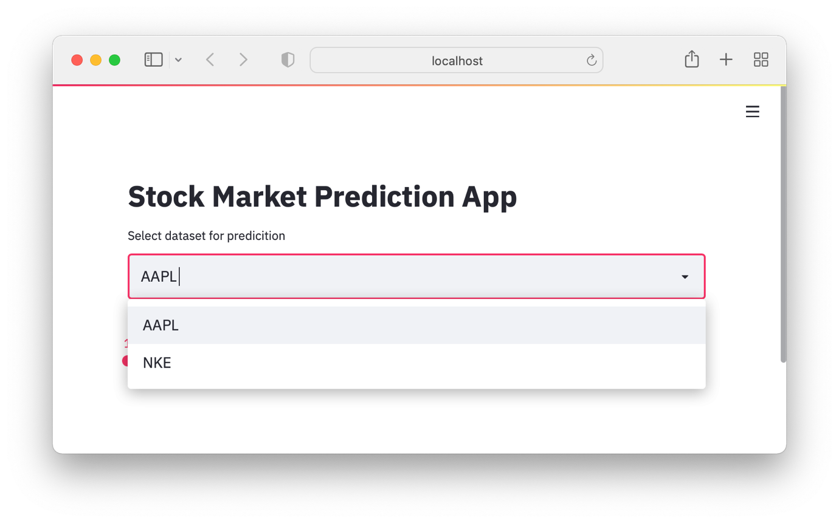

STOCK 1

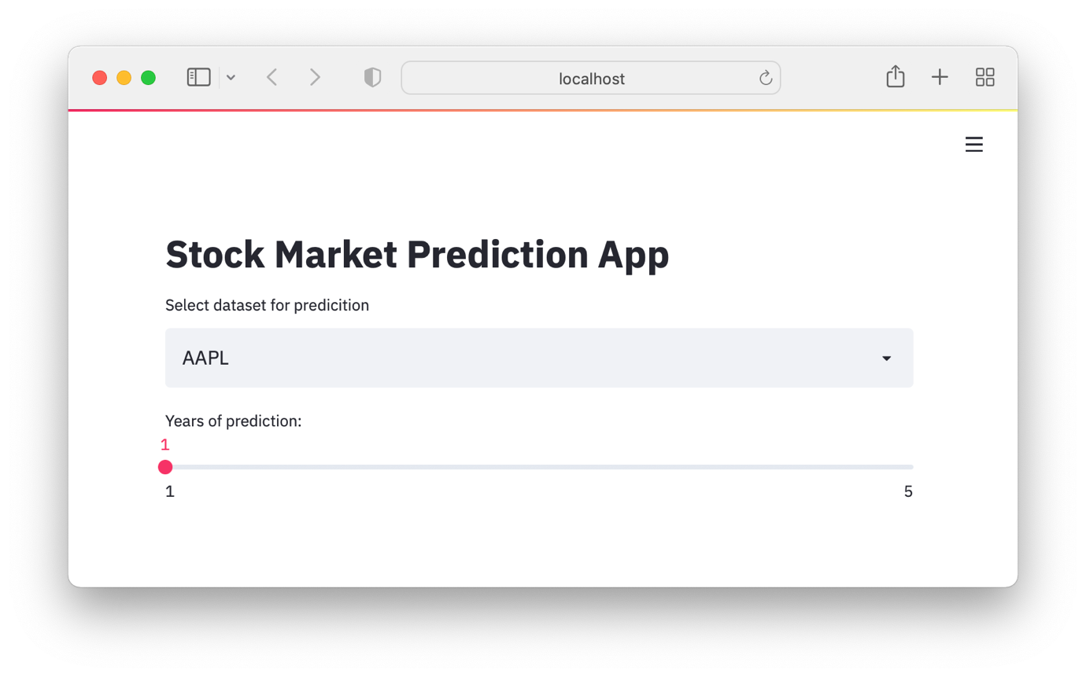

STOCK 2

I first imported all the libraries that I require to create this page which includes the streamlit and datetime for loading and displaying the page and using dates for the prices to be displayed later on respectively.

There was no error and for future sustenance, I added line 4 in my code to adapt to the width of the page as per the user’s requirements that I obtained from Q3 in the client interview.

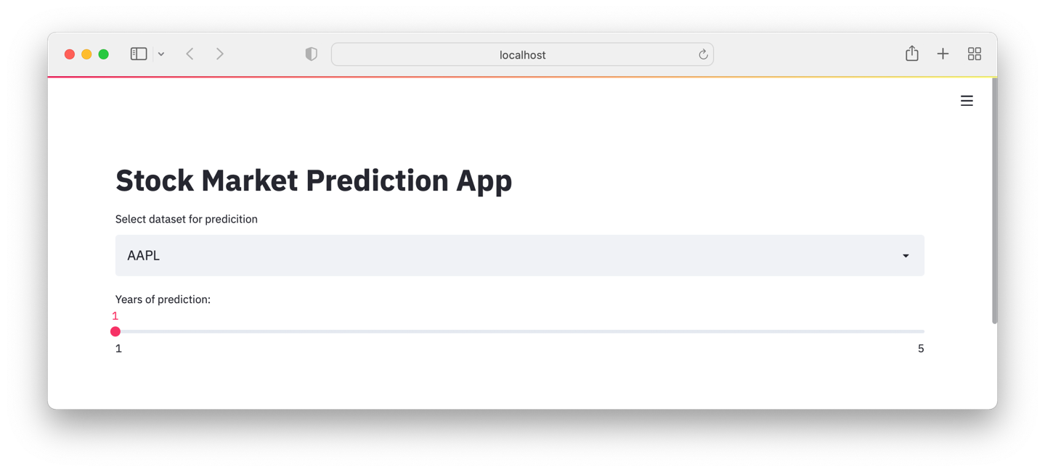

STOCK 3

Code:

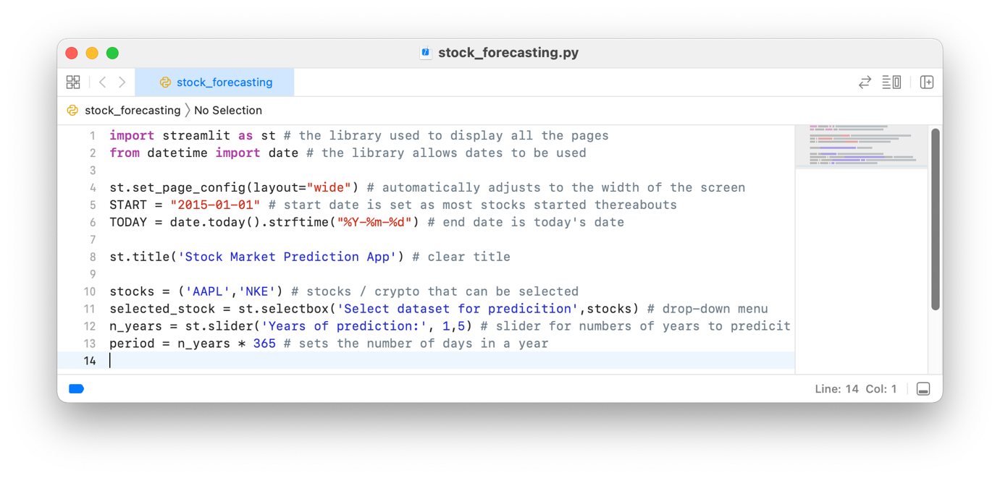

STOCK 4

* Adding in the stock / cryptocurrency graph with the raw data and other facilities.

I am now adding in the main way of viewing the stock / cryptocurrency prices as they vary with time. The features such as zooming in or viewing only over a certain period of time. There is also a clear labelling for the 2 different lines for stock open and close prices

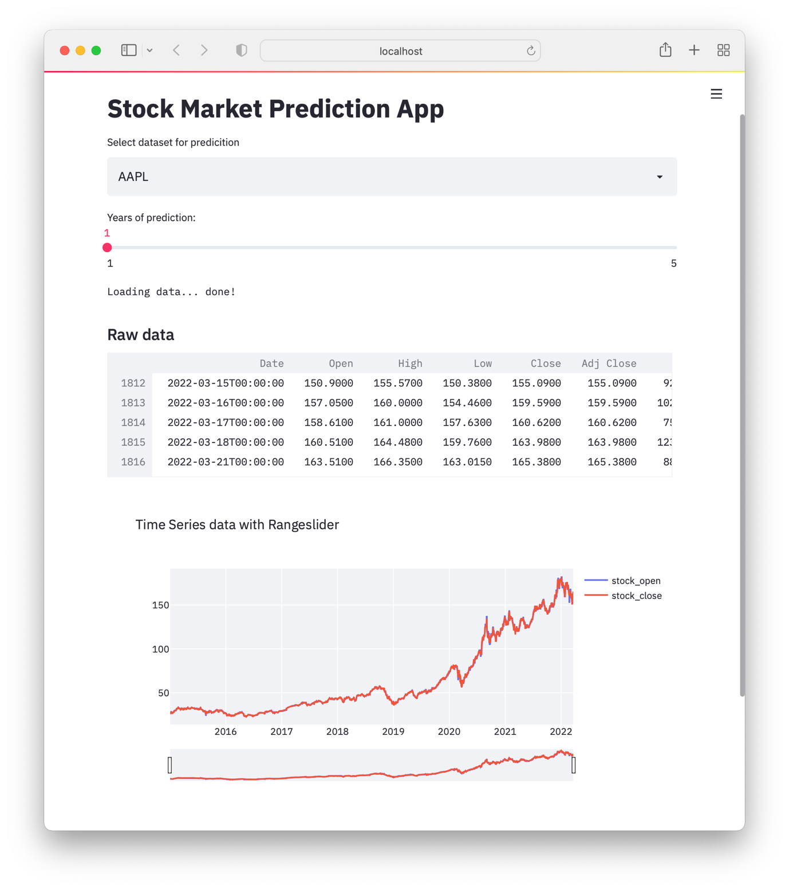

STOCK 5

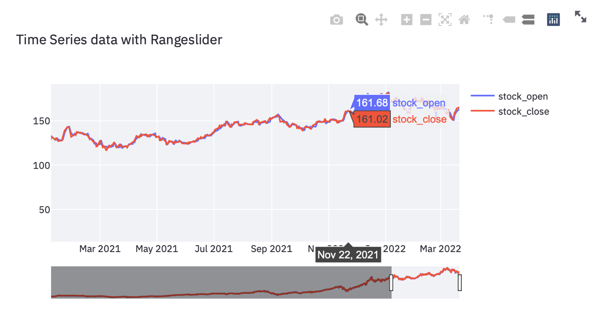Code:

STOCK 6

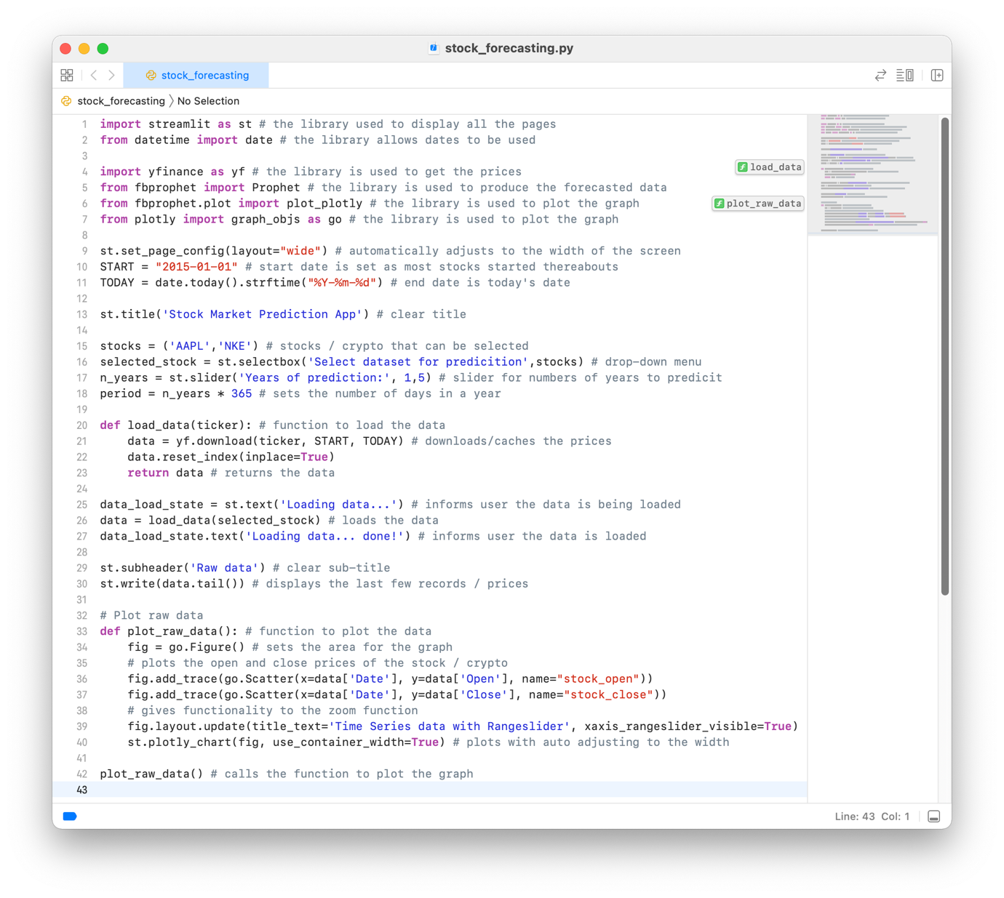

STOCK 7

* Below all the current and previous stock information, the forecasted graphs and patterns will be displayed

I am now adding in the forecasting algorithm and trends the algorithm notices. All the other functionality that came with the graph before also can apply here. (The red graph at the top is from the previous graph of the actual stock / cryptocurrency prices to show that it continues on the same page).

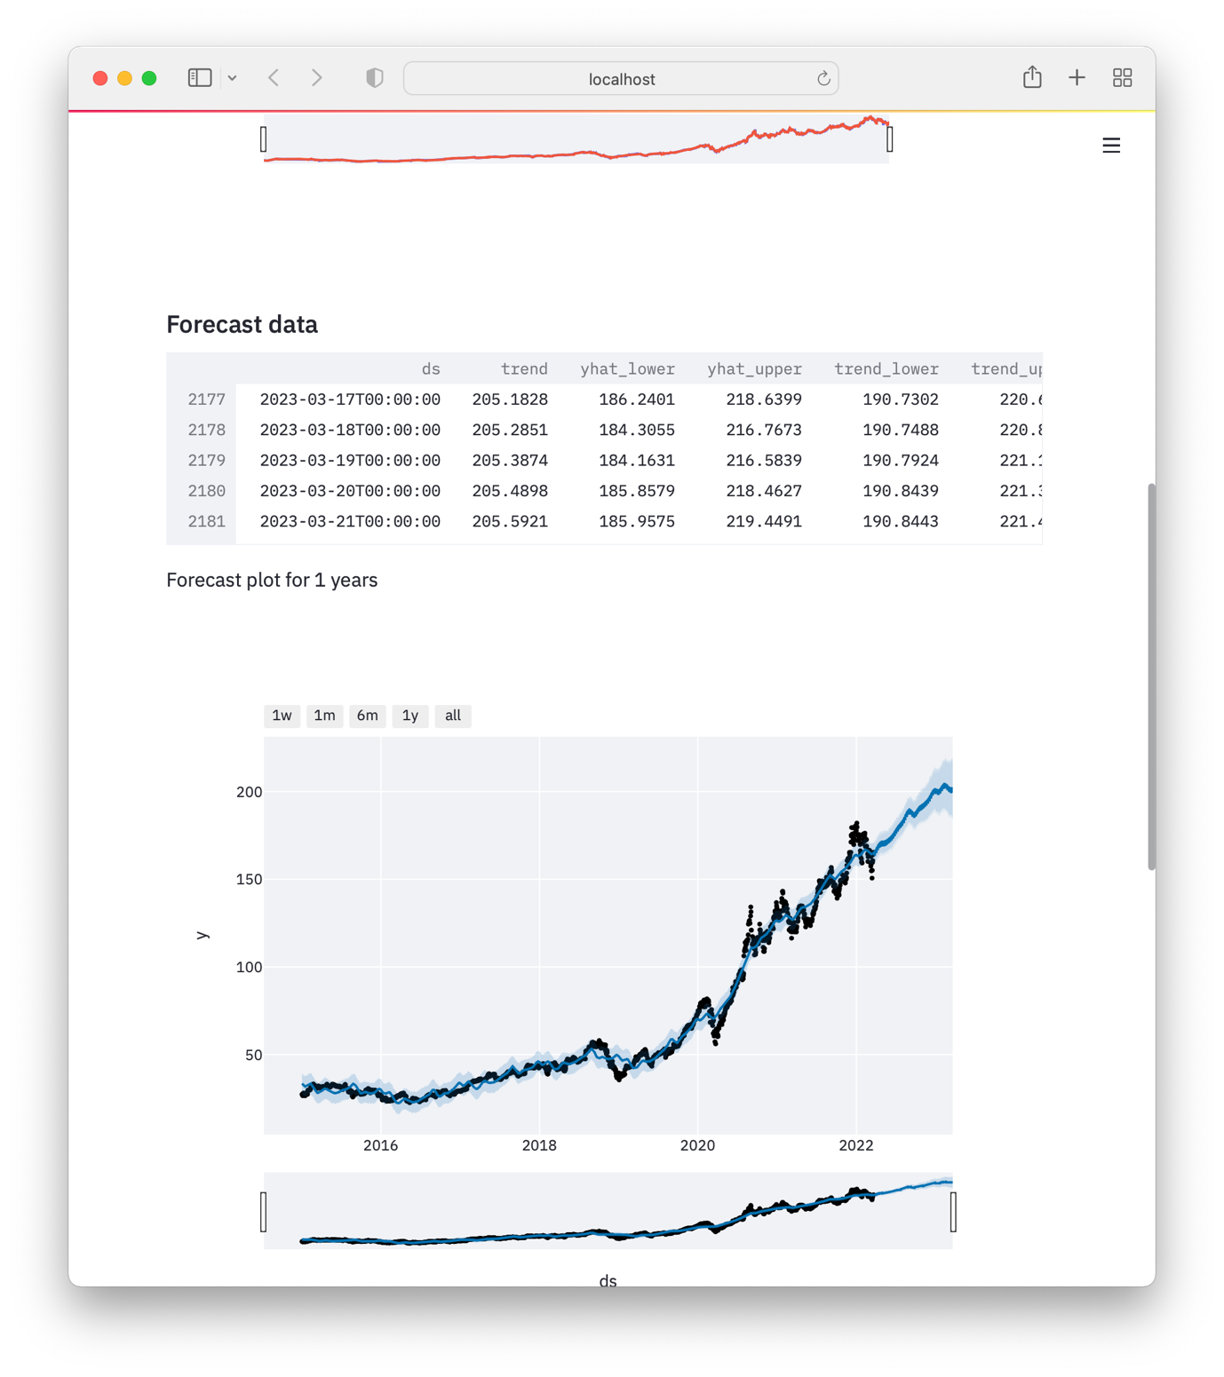The ‘ds’ at the top of the page is from the forecasting graph above.

STOCK 8

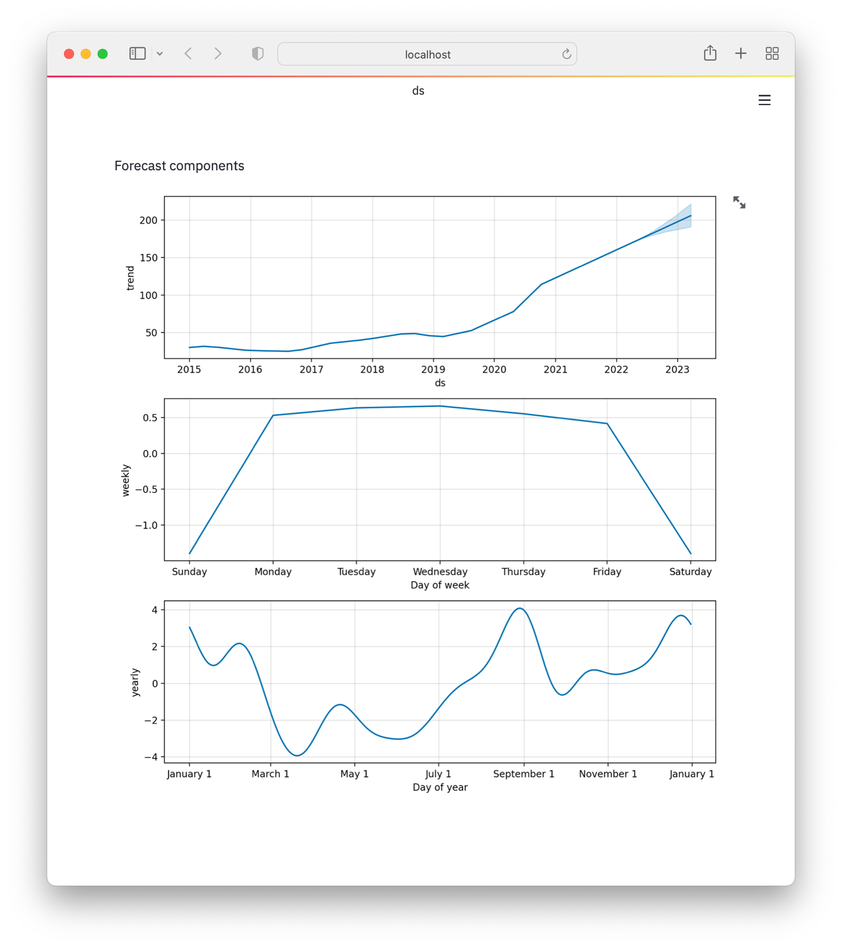

STOCK 9

Code:

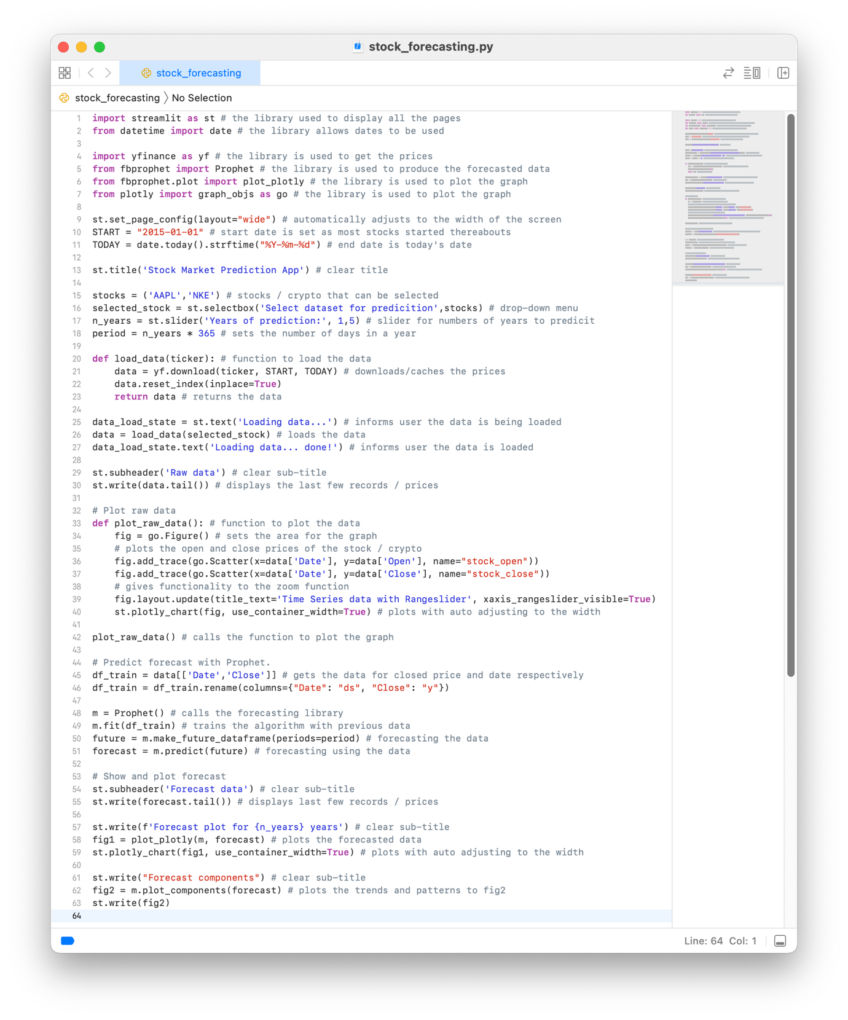

STOCK 10

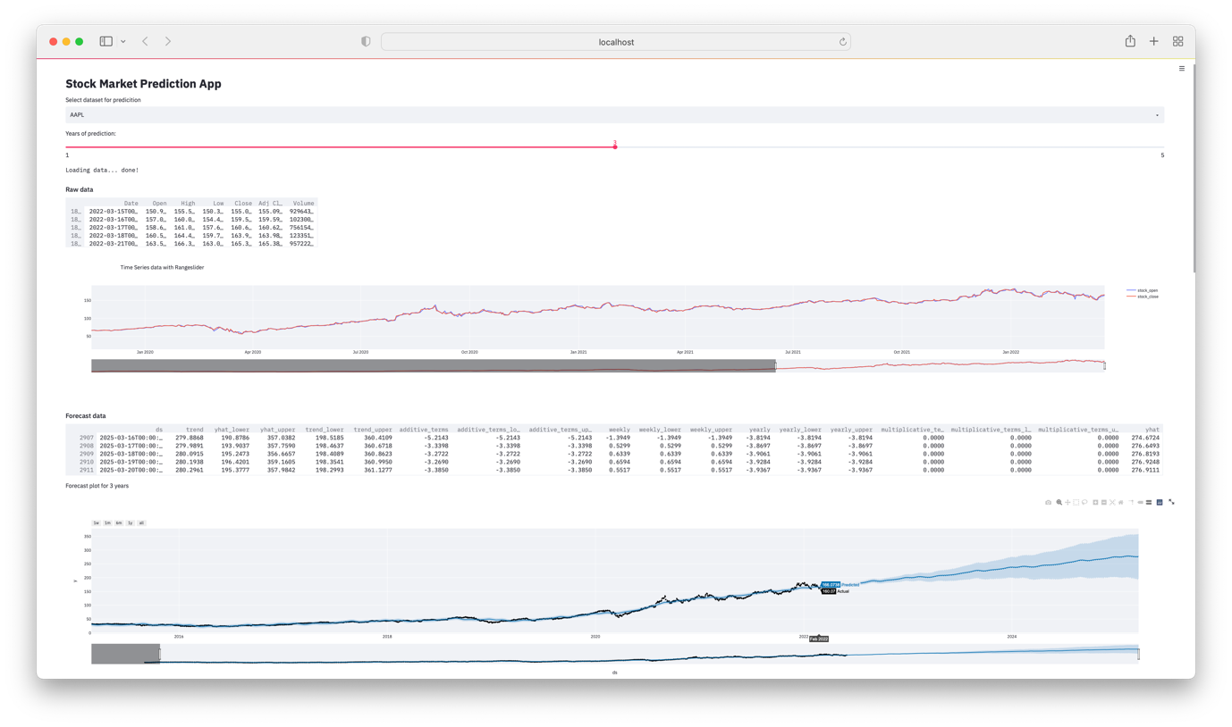

STOCK 11

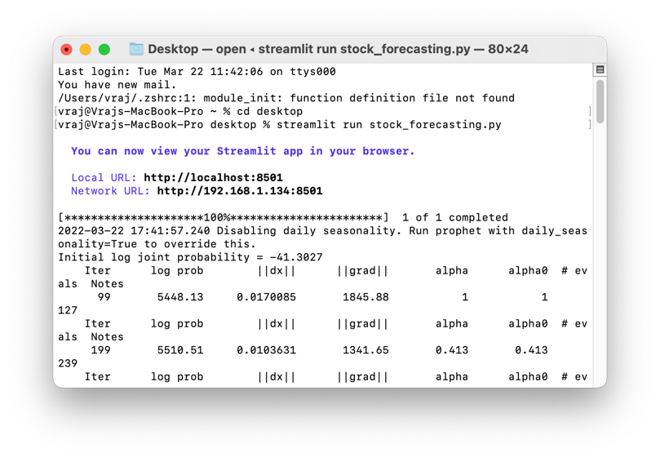

STOCK 12

All the calculations below in Terminal are done though the predicting algorithm which then transfer their results of applying the algorithm to the data to produce forecasted outputs. All this runs in the background and STOCK 8, 9 and 11 are the visible outputs.

| **TEST PLAN: STOCK FORECASTING PAGE** | | | |
| --- | --- | --- | --- |
| **Task #** | **Description** | **Inputs** | **Outputs** |
| **1** | Will need to see if all drop-down menus, buttons, and sliders are working and displaying correctly | N/A | STOCK 1, 5  **SUCCESS** |
| **2** | Test if the drop-down menu contains the stocks / cryptocurrencies required by the user | N/A | STOCK 1, 2, 3  **SUCCESS** |
| **3** | Test if the chosen stock / cryptocurrency from the drop-down menu has its data retrieved and put in a table that the graphing sub-program will use | Chosen via the drop-down menu | STOCK 5  **SUCCESS** |
| **4** | Test if the chosen stock / cryptocurrency from the drop-down menu is graphed | Chosen via the drop-down menu | STOCK 5, 6  **SUCCESS** |
| **5** | Test if the chosen stock / cryptocurrency has different coloured line graphs for open and close prices | N/A | STOCK 5, 6  **SUCCESS** |
| **6** | Test if the scale of the graph maximises the use of the available screen real-estate for a graph | N/A | STOCK 3  **SUCCESS** |
| **7** | Test if hovering over the graph shows the correct information in a more legible manner | N/A | STOCK 6  **SUCCESS** |
| **8** | Test if the forecasting algorithm produces an output using the stock / cryptocurrency prices from 1 Jan 2015 onwards | Stock / Cryptocurrency prices from 1 Jan 2015 to present day automatically sent in | STOCK 8  **SUCCESS** |
| **9** | Test if the period for the forecasted data is as selected from the slider | 1,2,3 or 4 year(s) is selected from slider | STOCK 11  **SUCCESS** |
| **10** | Test if the forecasted data is then overlayed over existing data | Stock / Cryptocurrency forecasted prices | STOCK 8  **SUCCESS** |
| **11** | Test if the scale of the forecasted graph maximises the use of the available screen real-estate for a graph | N/A | STOCK 11  **SUCCESS** |
| **12** | Test if the graph has a generally correct trend | N/A | STOCK 8, 11  **SUCCESS** |
| **13** | Test if the areas of uncertainties overlayed on the forecasted graph increase with greater periods of forecasting | N/A | STOCK 8, 11  **SUCCESS** |
| **14** | Test if the patterns used to create the forecasted data is displayed graphically with variations in price against a time axis. | N/A | STOCK 9  **SUCCESS** |
| **15** | Testing if the sidebar is retractable | N/A | LRW 13, 14, 15  **SUCCESS** |
| **16** | Testing if the sidebar is retracted, the main page should readjust to fill up the space provided | N/A | LRW 13, 14, 15  **SUCCESS** |
| **17** | Test if varying the width of the page results in the page automatically adapting to fill the full width available | N/A | LRW 13, 14, 15  **SUCCESS** |
| **18** | Test if the stock / cryptocurrency graph of recorded prices changes its width according to the width of the page | N/A | STOCK 11  **SUCCESS** |
| **19** | Test if the stock / cryptocurrency graph of forecasted prices changes its width according to the width of the page | N/A | STOCK 11  **SUCCESS** |
| **20** | Testing if the sidebar is retractable | N/A | LRW 13, 14, 15  **SUCCESS** |
| **21** | Testing if the sidebar is retracted, the main page should readjust to fill up the space provided | N/A | LRW 13, 14, 15  **SUCCESS** |

**VALIDATION**:

In this page, validation is limited by the use of drop - down menus for selecting the stock / cryptocurrency that is graphically displayed rather than the user entering a typed input which could have some spelling errors causing the program to not work, or worse even crash. Having drop - down menus fixes this problem and also provides for an intuitive experience.

**USER FEEDBACK:**

❝ The interface is very well laid out and in a logical order. The drop - down menu for selecting the stock provides some interactivity and also reduces the physical aspect of typing the stock / cryptocurrency name every time. The graphical representation is very nice, and the light colours make the whole page look professional in an addition with the simplicity. The forecasting graph has a nice touch the uncertainty areas in blue, which is much appreciated and shows the volatility, but also influences the investment decision I will make. Furthermore, the insight into to the patterns and trends found by the algorithm right at the bottom was one of my additional requirements which I believe was executed exceptionally well; I will definitely be influencing my investment and selling decisions ❞

This is the finished code for the stock forecasting page of this project which I can then imbed into the main page that I will develop alongside the login, registration, and welcome pages. As per the client interview, I have successfully accomplished all of the requirements mentioned by the client regrading this specific page and showing him the final look and feel for the page, was very pleased and so I can move on to the next page to design.

**Login Page, Registration page and Welcome Page**

Due to all the pages being tightly integrated with each other through the sidebar, all these will be built together for ease of following the process.

* Firstly, I will get the general layout of whereabouts the titles, text, input boxes and dropdown menus on the pages.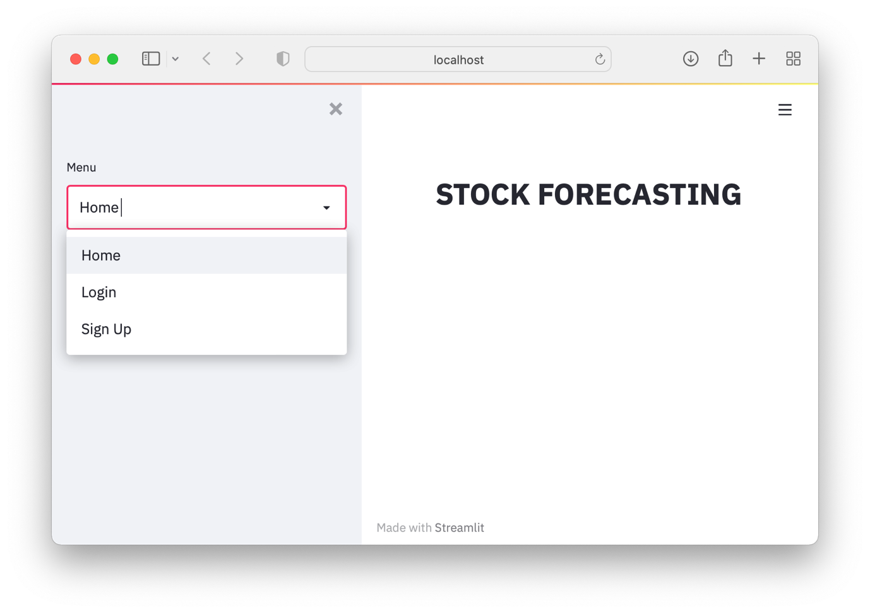

LRW 1

As you can see from the screenshot LRW1, I have successfully created the sidebar and a simple but clear title of ‘STOCK FORECASTING’. The sidebar consists of the 3 main pages via which the user experience will always begin: Home, Login and Sign Up. These are 3 main pages that I discussed with the user when I created the initial flowchart for how the user will navigate through the web app as seen on pg. 16.

Code:

For the code above, it is just the stock forecasting page code which I have put within a module called ‘stock_forecast()’ and also to remove repeating the imports of libraries used throughout the code such as streamlit, I have taken them out of the stock_forecast() module and placed them at the top as this is good programming practise.

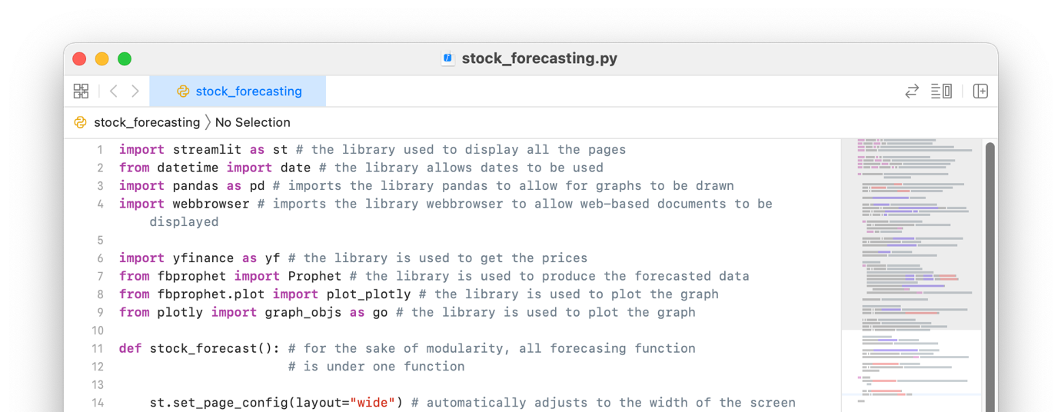

LRW 2

……

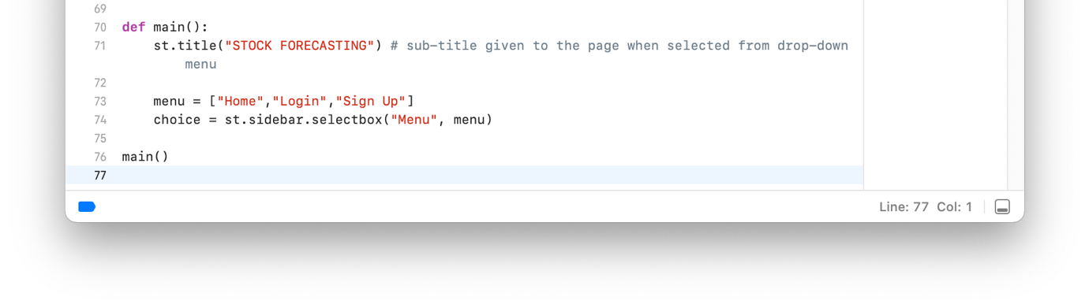

(The section with the section without comments above has been commented in LRW 3)

* I then added in a small introduction on the home page to welcome the user when it is selected on the sidebar from the drop-down menu

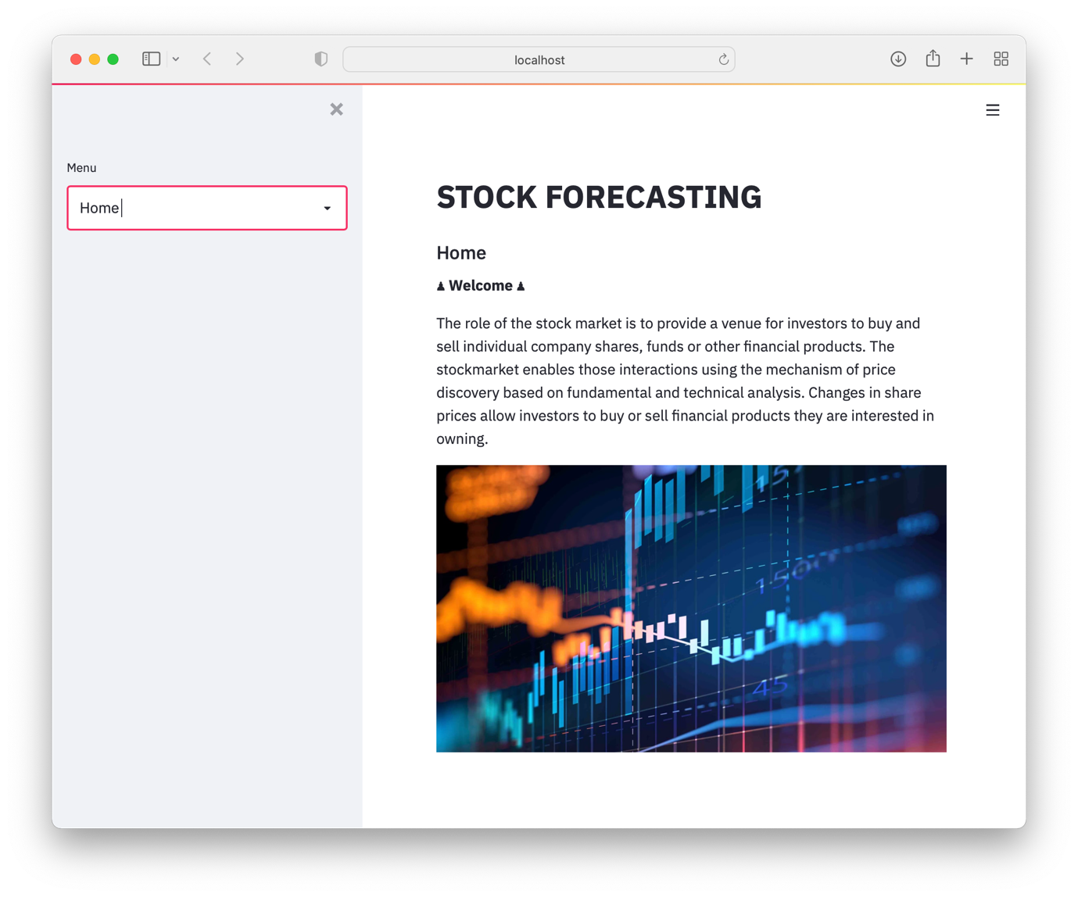

LRW 3

Code:

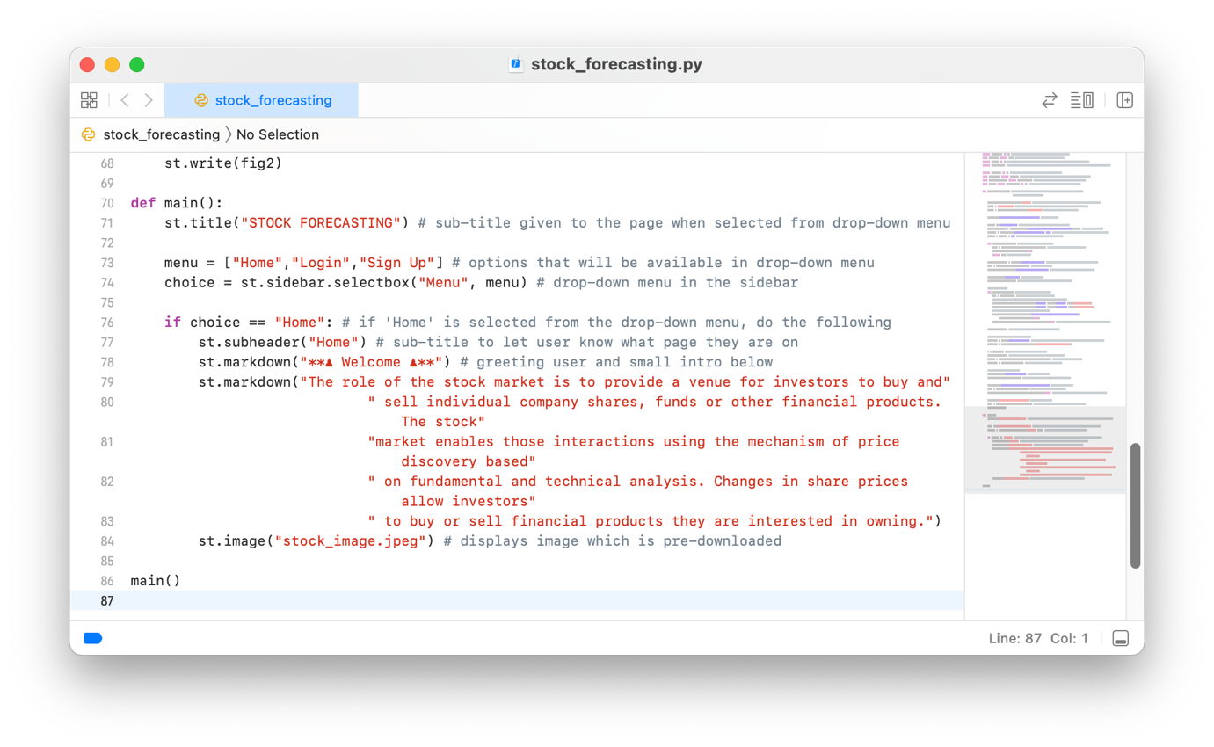

LRW 4

* Create a login page where the user can enter their redenials to log them in (cannot fully work yet as the registration page isn’t complete yet)

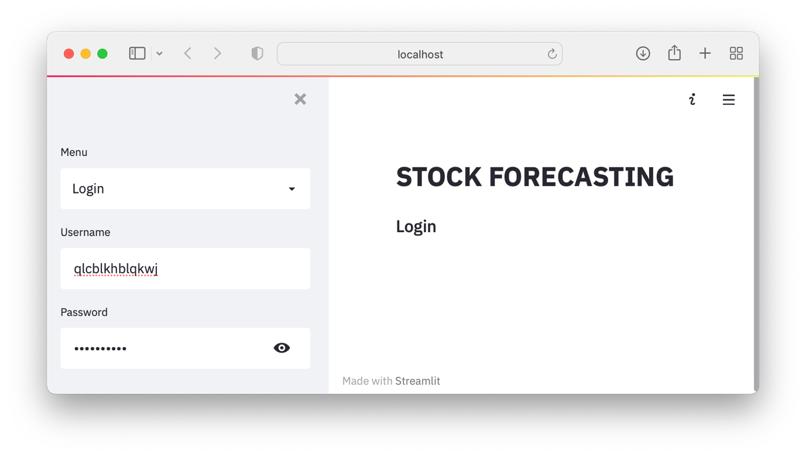

LRW 5

The ‘eye’ icon in the password entry box is where the user can check their input for their password so instead of the dots there would be the actual characters typed in by the user. This is possible due to telling streamlit the type of input as showing in the code on line 90.

Code:

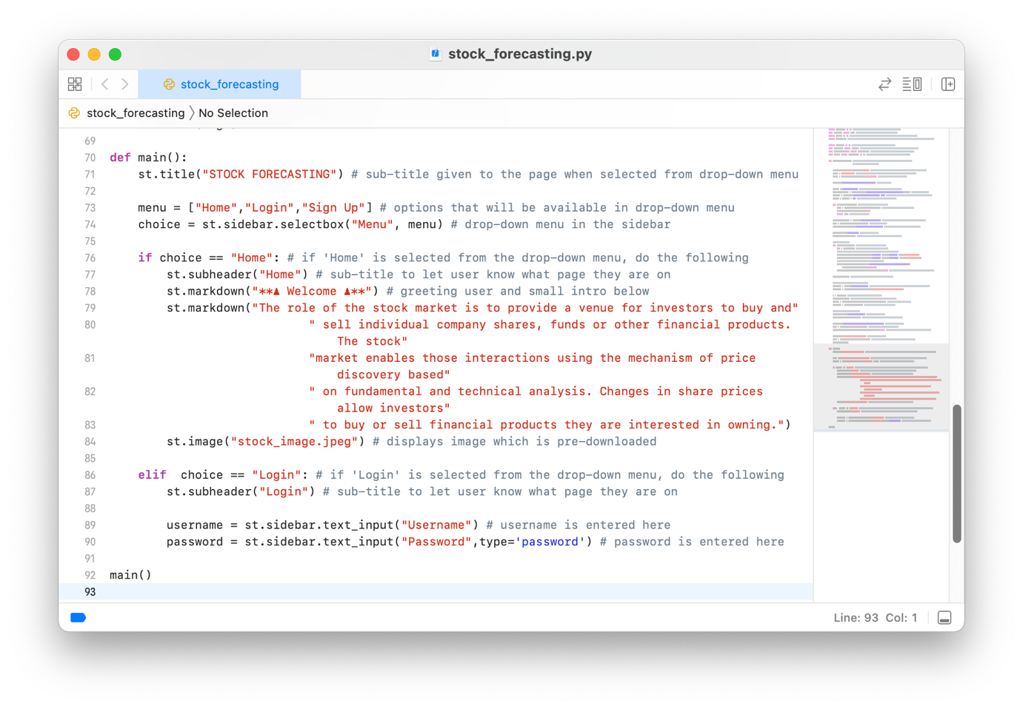

LRW 6

* Creating a registration page whereby the user can create an account and successfully log in

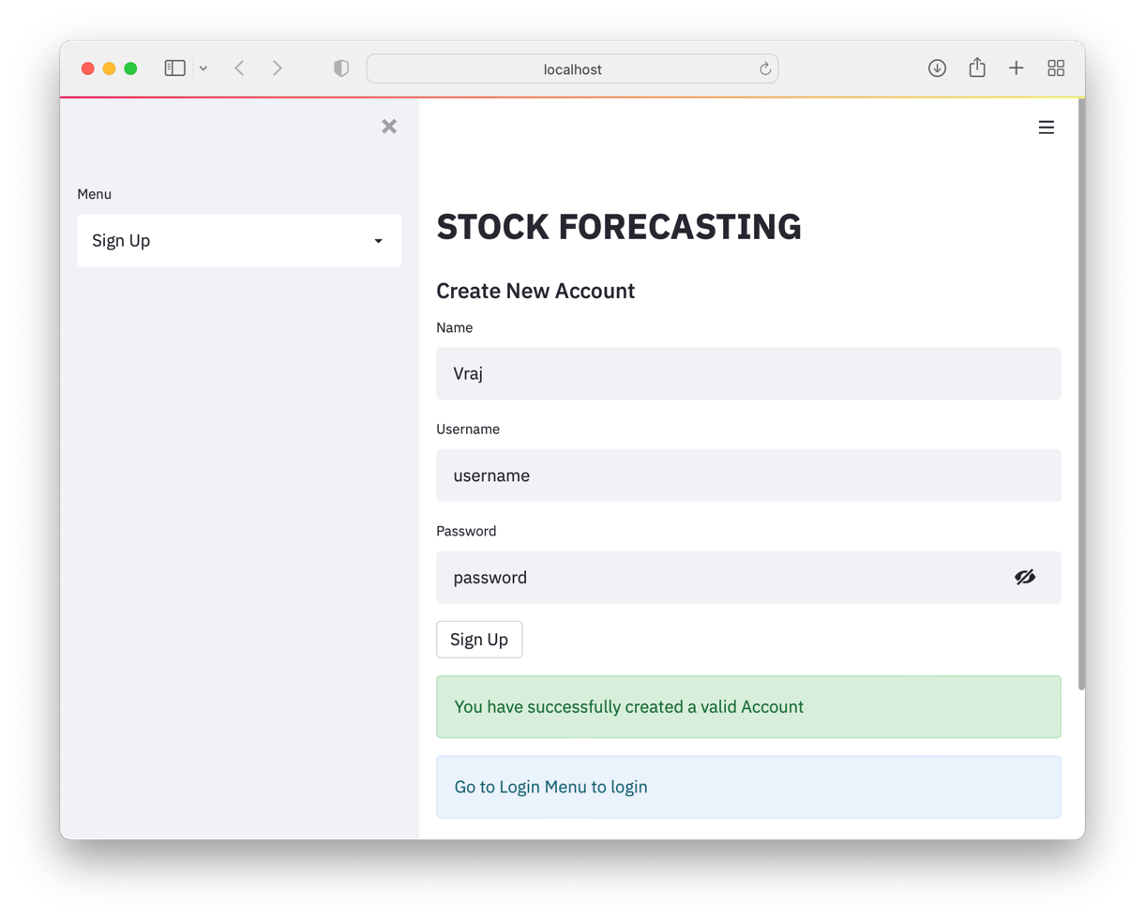

LRW 7

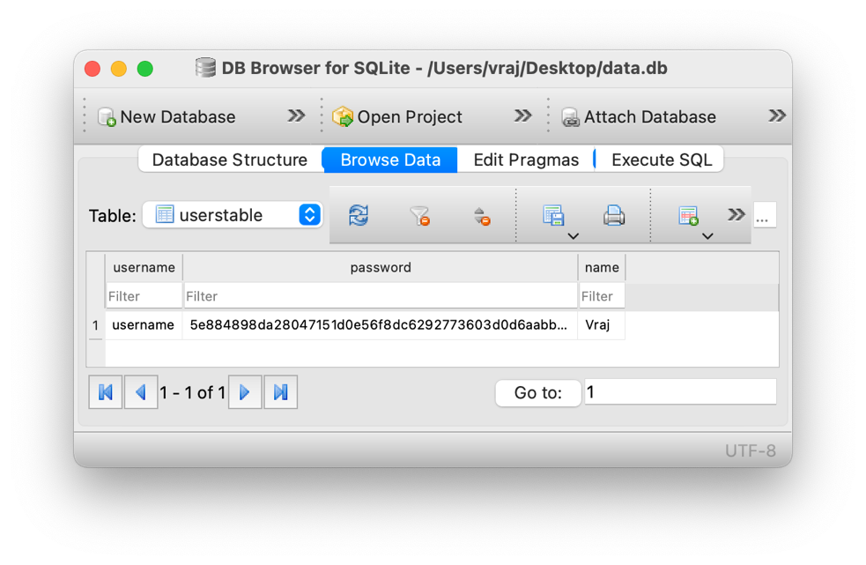

LRW 8

LRW 7 shows the successful addition of the new user to the table of users and then also directs the user through the web app below.

LRW 8 is the screenshot taken of DB Browser for the table called ‘usertable’ where the users’ login details are stored and shows the successful addition of the username and hashed password to the database.

**FAILURE TESTING:**

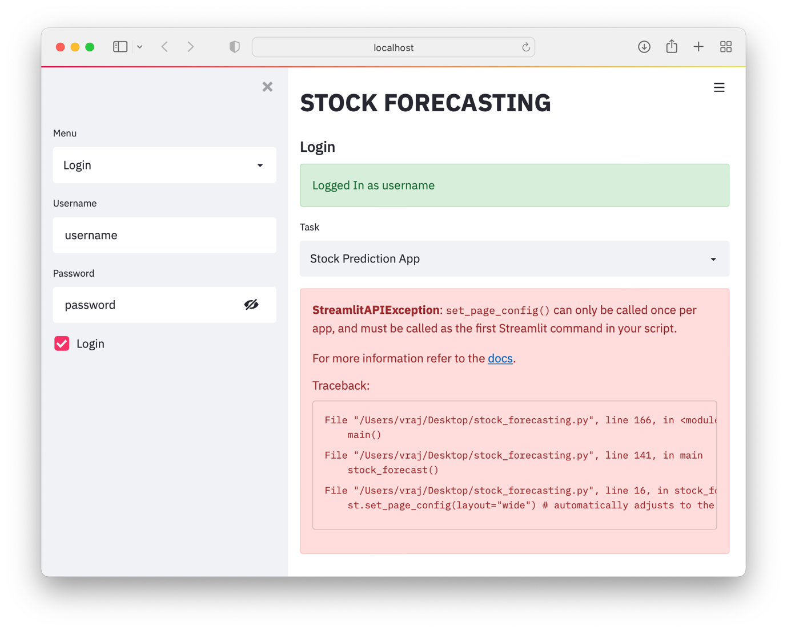

LRW 9

As you can see the successful login of the user is made with a personalised informative message of being logged in however the seems to be an error.

After looking at a little thoroughly, there seems to be a problem with the stock_forecast() method, however we have already proved that it works perfectly fine so what was the problem? I did a little bit of research on the streamlit library and found that the layout can only be set once on the page, and it applies itself automatically to all the content and sub-sections within itself. I set the layout as wide once already and cannot do it again.

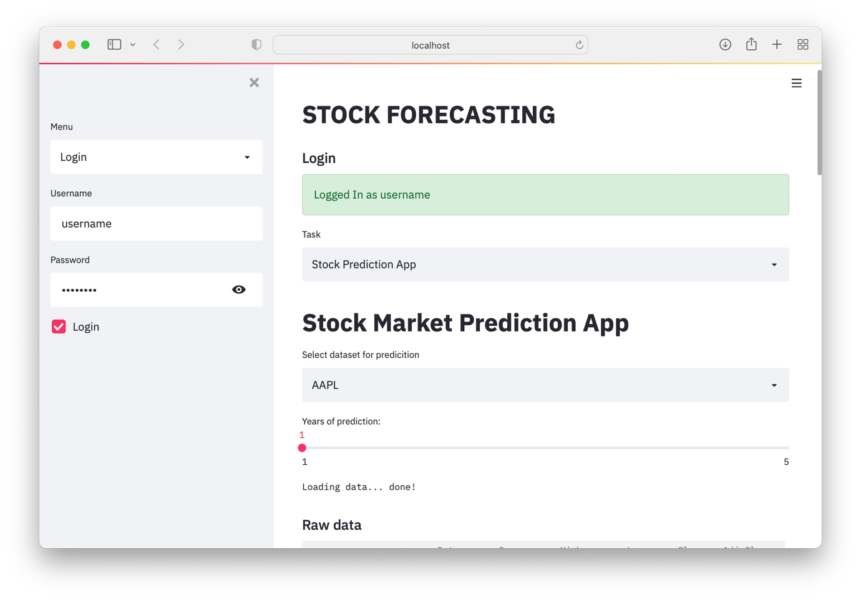

LRW 10

Changing the stock_forecast() module by removing line 9 from STOCK 10, the web app works perfectly well with the stock forecasting app working well within the main page and displays itself as default option from the tasks drop-down menu as the user asked for in the client interview in Q3.

When revising the code again to use the layout = “wide” feature to enable the full width of the page to be used for a more impressive experience, I realised there was no layout = “wide” mentioned above and I put in the line below and got an error (LRW 11)

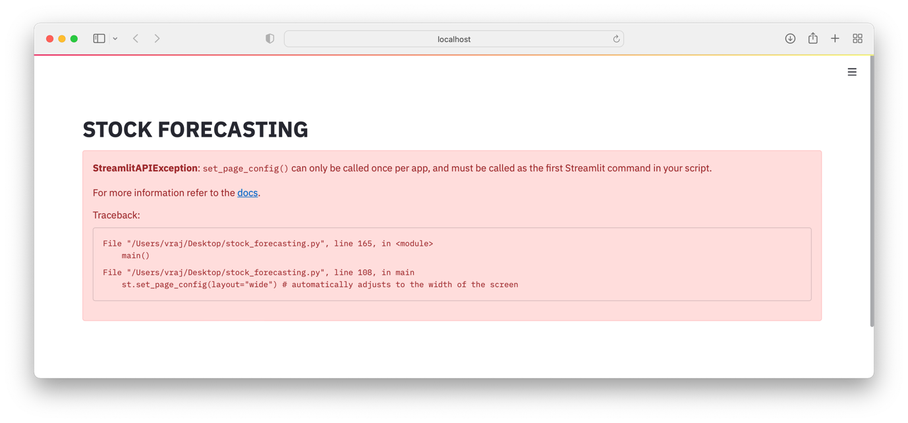

LRW 11

As the error message says, the set_page_config() has to first command executed to enable all the rest of the pages to be altered accordingly.



LRW 12

↓



This simple change made the code work again and also added the auto-adjusting feature of width to all the content in on go, which is very useful as a programmer. The web app now looks as shown in LRW 14 and 15.

LRW 13

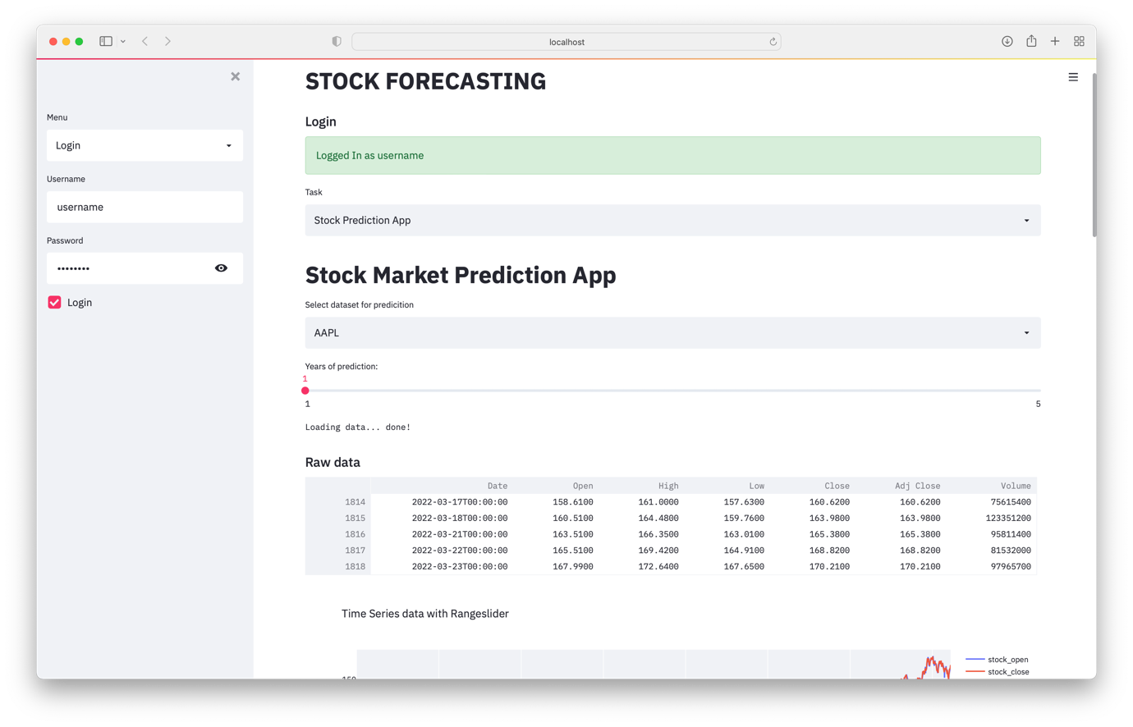

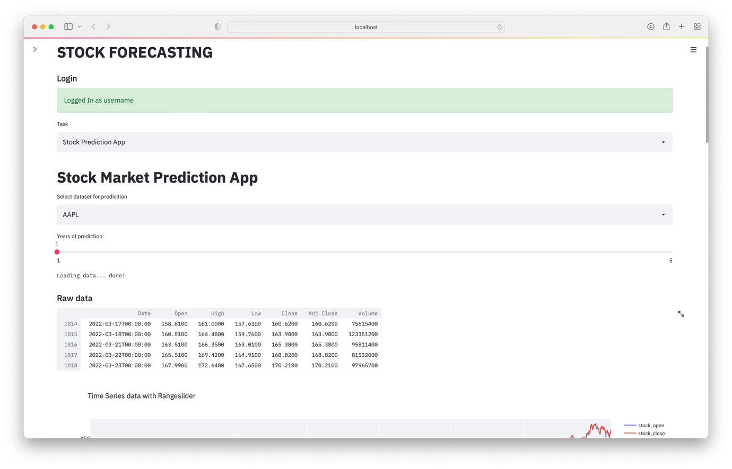

LRW 14

LRW 15 also shows the extra space available on the page for a larger, more detailed image of the stocks below. (The raw data doesn’t have the function of using the full width because it is not something the user wanted and is just there if the user wants the read the last few prices; the table will only use as much maximum width it needs and shrinks if it cannot to the width of the page.)

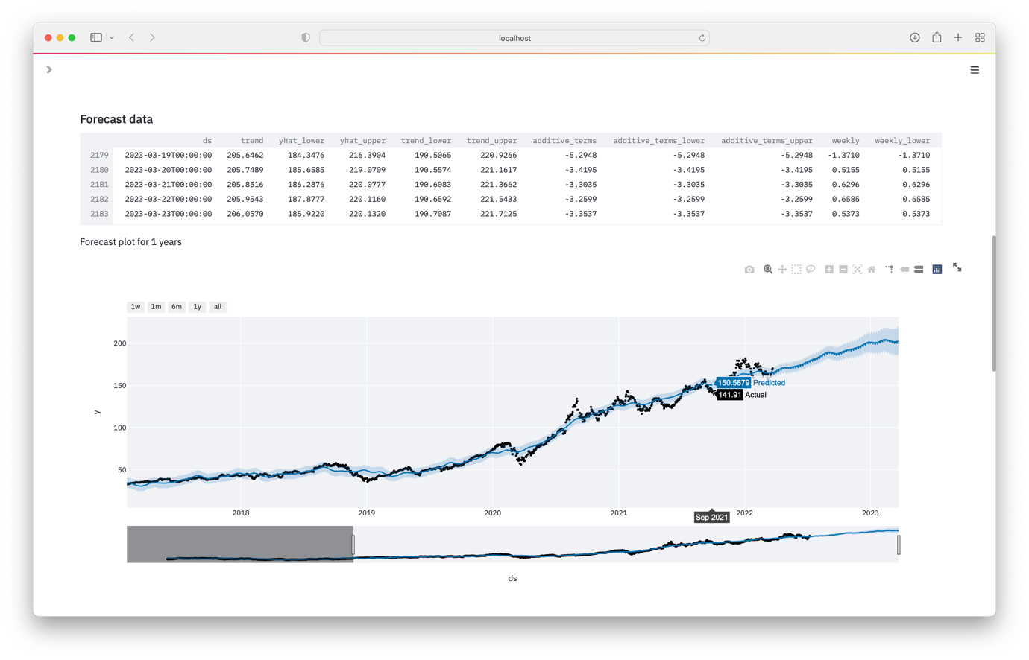

LRW 15

LRW 16 backs up the fact that more space on the screen can make a more legible and also reduces the need for the user to squint to read of the prices from the graph.

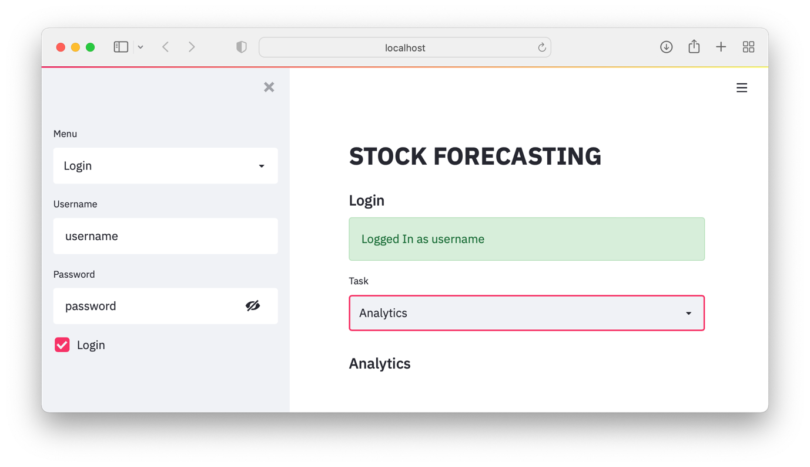

LRW 16

When selecting ‘Analytics’ from the task drop-down menu, the sub-heading appears showing that the analytics page can be inserted into here probably via a module which I will show the development through the analytic page selection later on.

Code:

I added some extra imports of libraries for the database aspect to work.

LRW 17

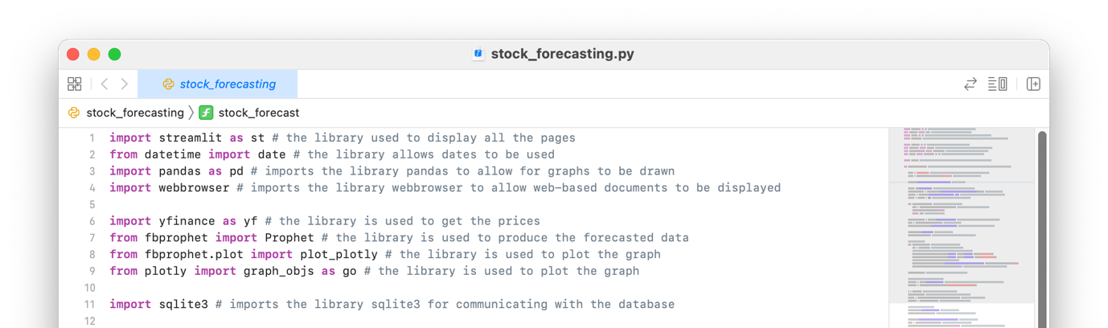

**…**

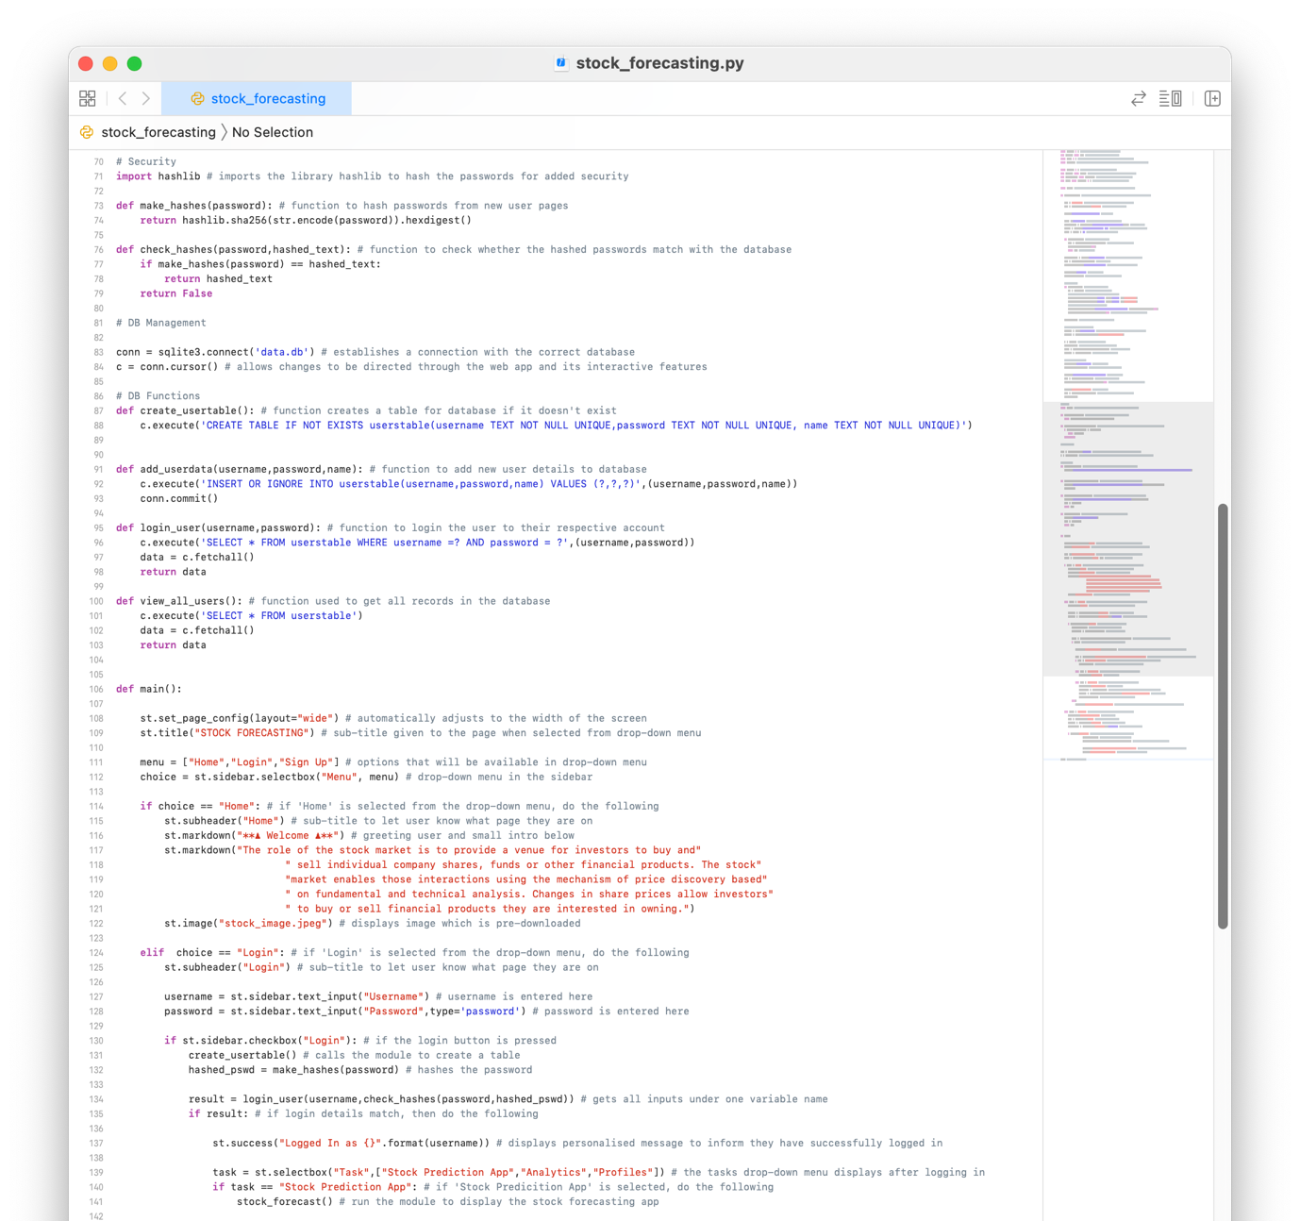

LRW 17

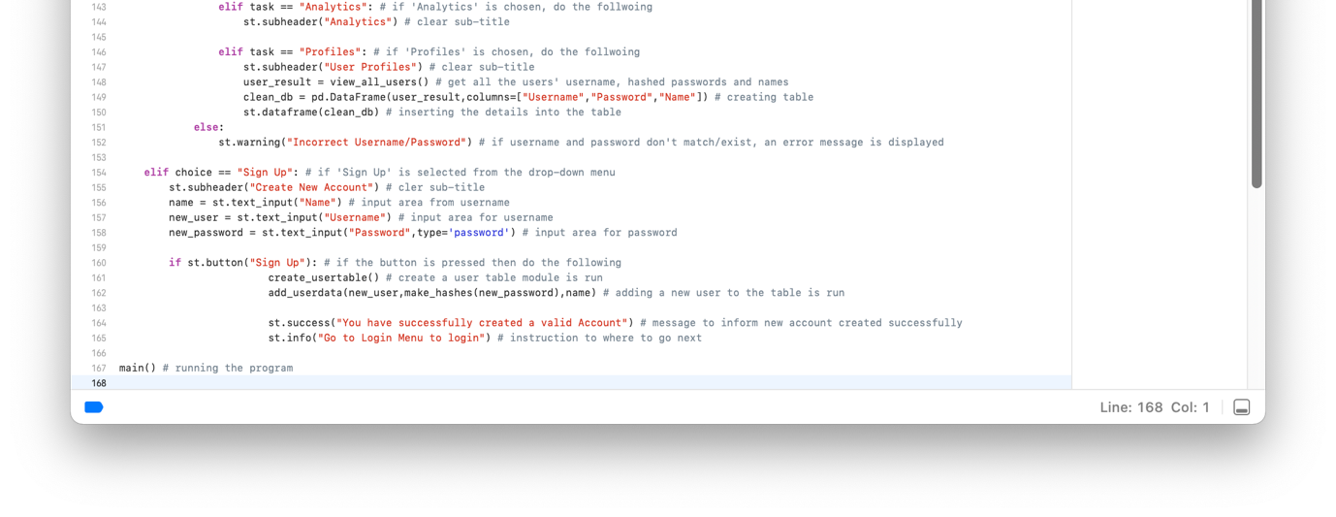

* Adding the analytics page contents

**FAILURE TESTING:**

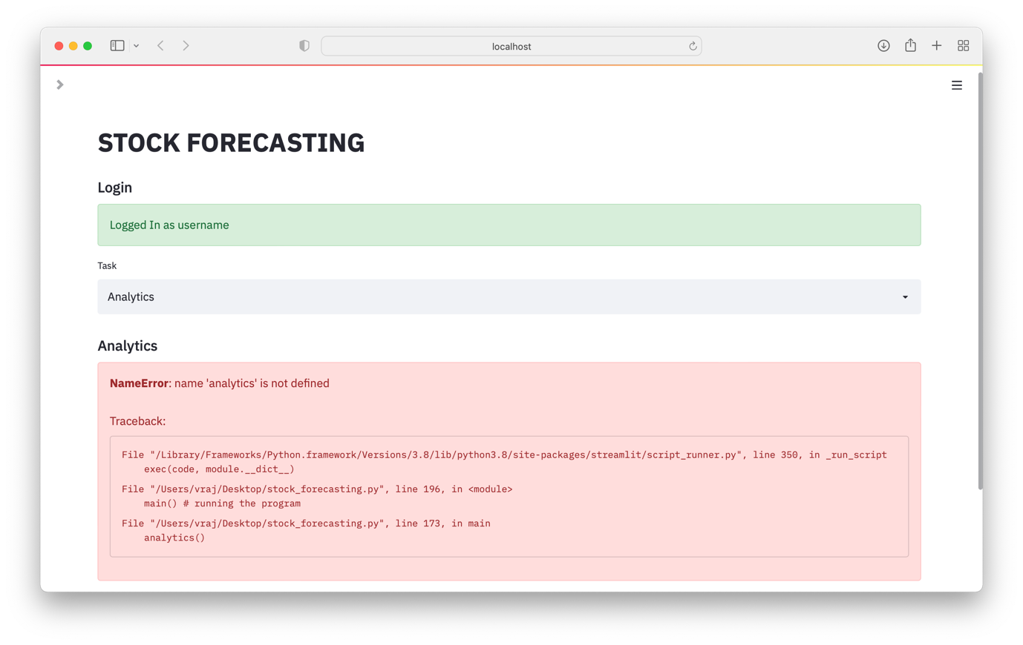

LRW 19

LRW 18

When first running the program, I got an error and going back to it, it turned out to be a simple typing error where I didn’t get the name of the module correct.



The error was changed, and the program works well now.

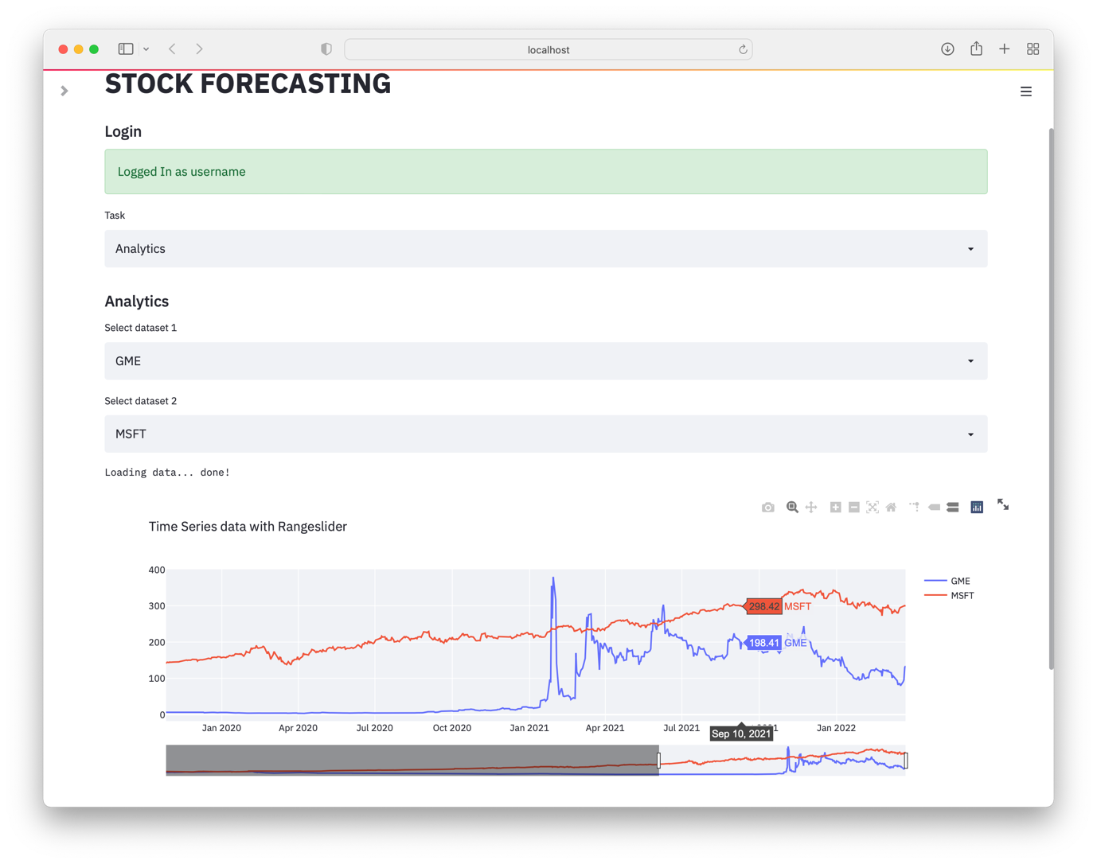

LRW 20

Code:

LRW 21

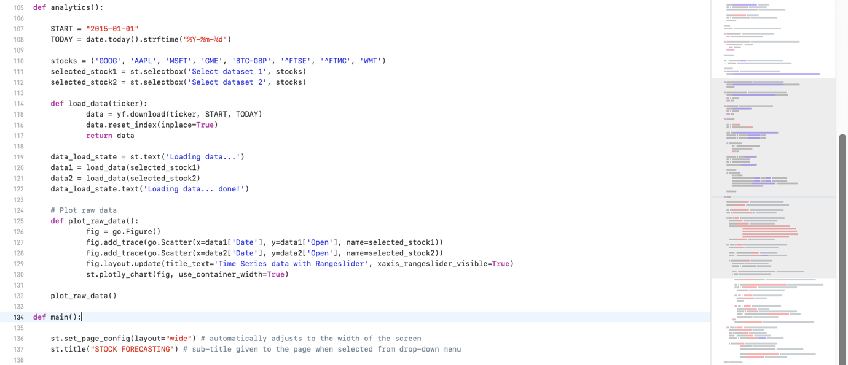

**…**

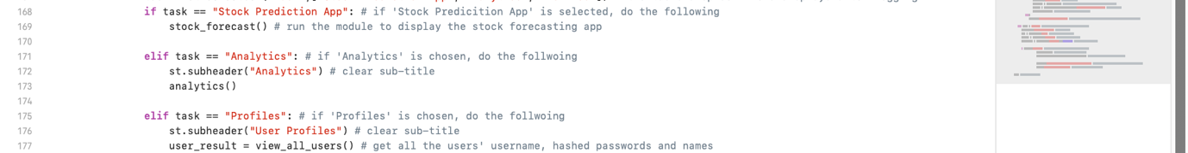

**TESTING IMAGES:**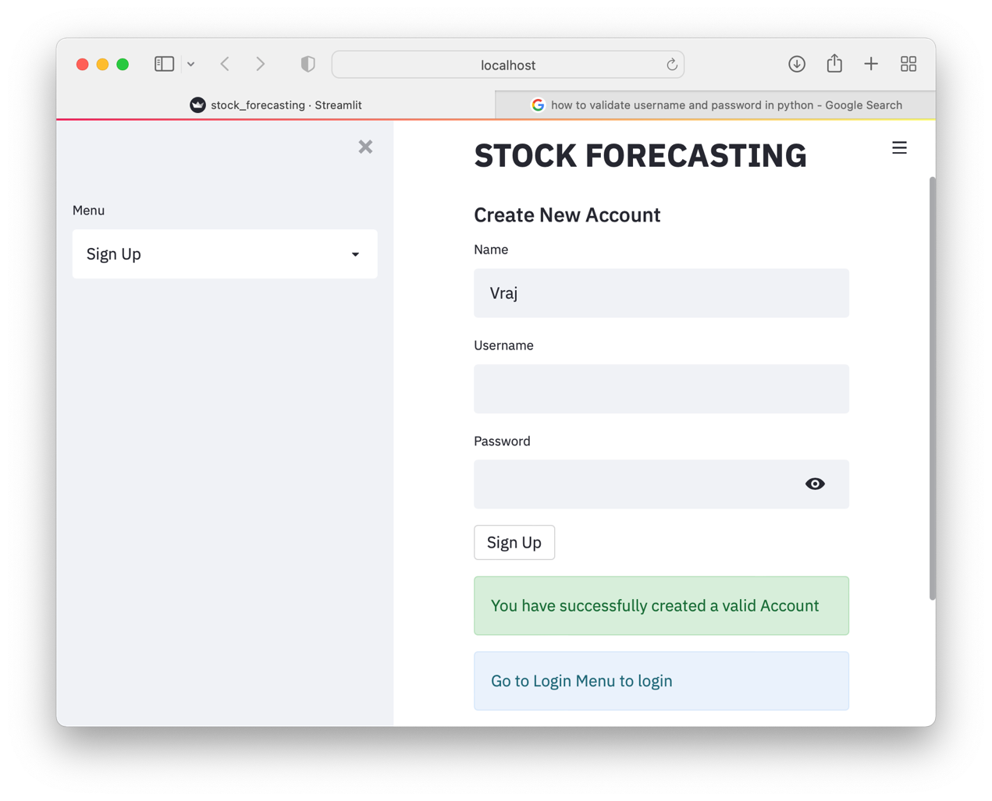

LRW 22

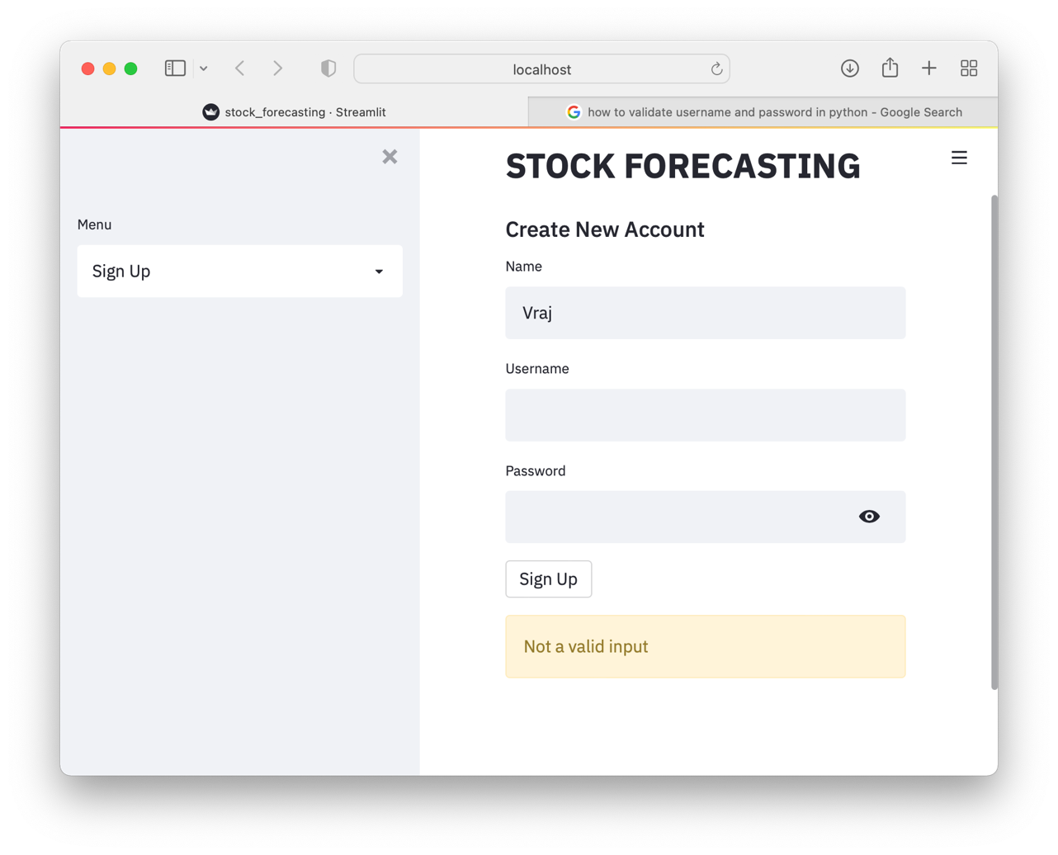

LRW 23

In LRW 23 to LRW 24, there was initially no validation of inputs of the username and password, however after editing the program, it no longer accepts blank space or no entry at all. It also prevents duplicate accounts from being created as seen in LRW 25.

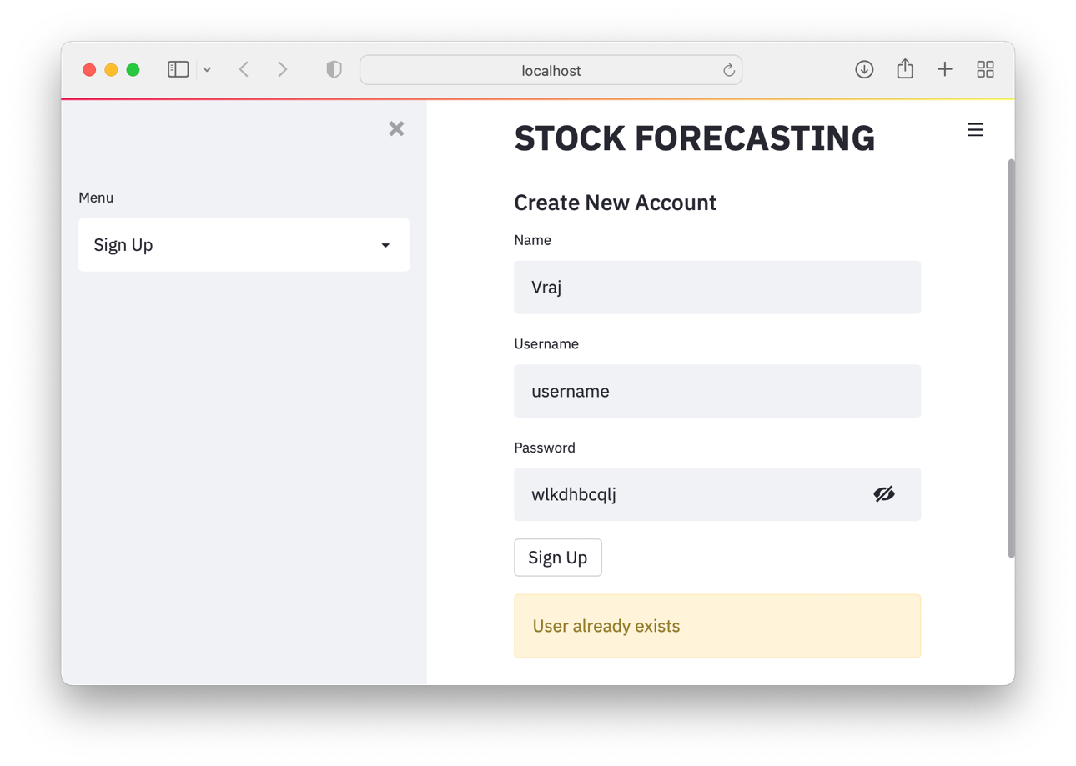

LRW 24

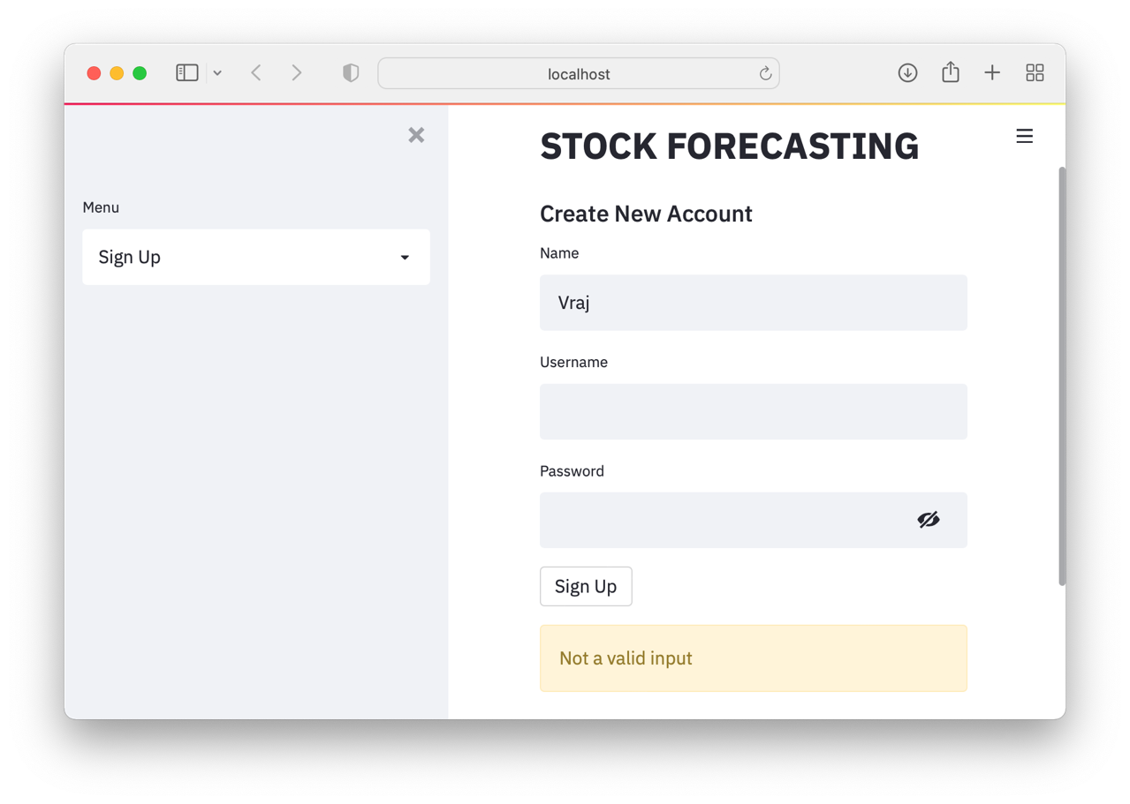

LRW 25

Code:

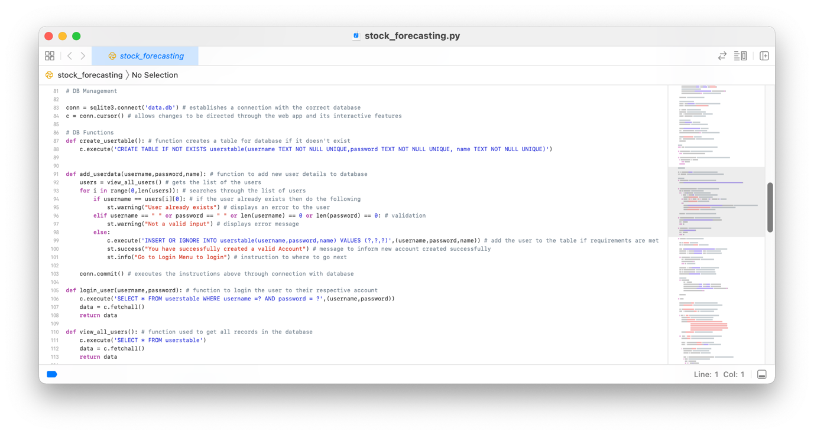

The module for adding a new user has the validation process done within it now making the login experience more refined and logical as previously as seen in LRW 22, the program can be seen accepting an invalid input.

In LRW 26, the inputs are very clear, however it is just pressing space and it has successfully declined it.

I have also amended the welcome statement, so it says the name of the user rather than their username as shown in LRW 26 as the revised version and LRW 10 as the older version. The user much appreciated this change as name being entered as part of the sign-up page seemed a bit pointless otherwise.

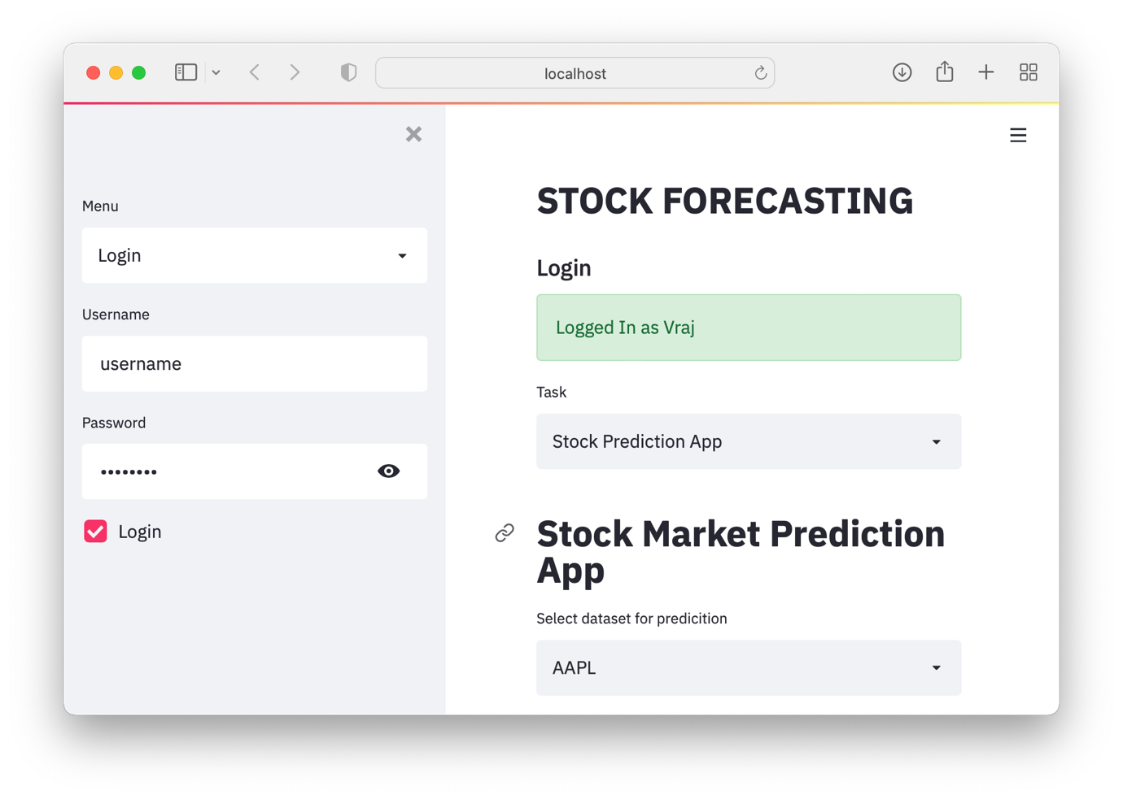

LRW 26

In LRW 26, I got the personalised welcome message to be displayed as I initially wanted it to, i.e. with the user’s name they entered when they created their account via the registration page, however for the sake of continuing with the project, I felt it how it was and came back to it after I had tested that all the other sections within the welcome page and all the other imbibed pages below it weren’t being affected.

LRW 27

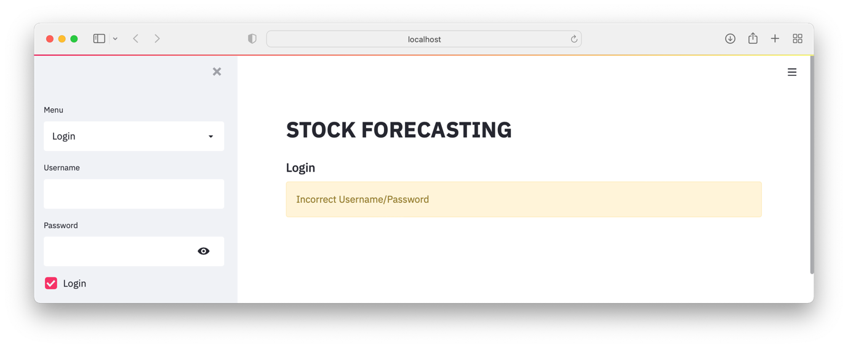

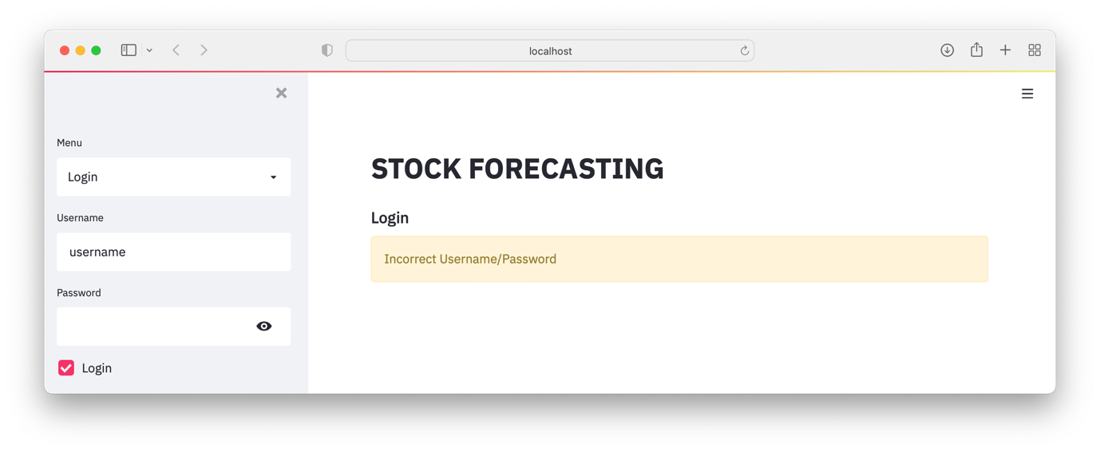

LRW 28

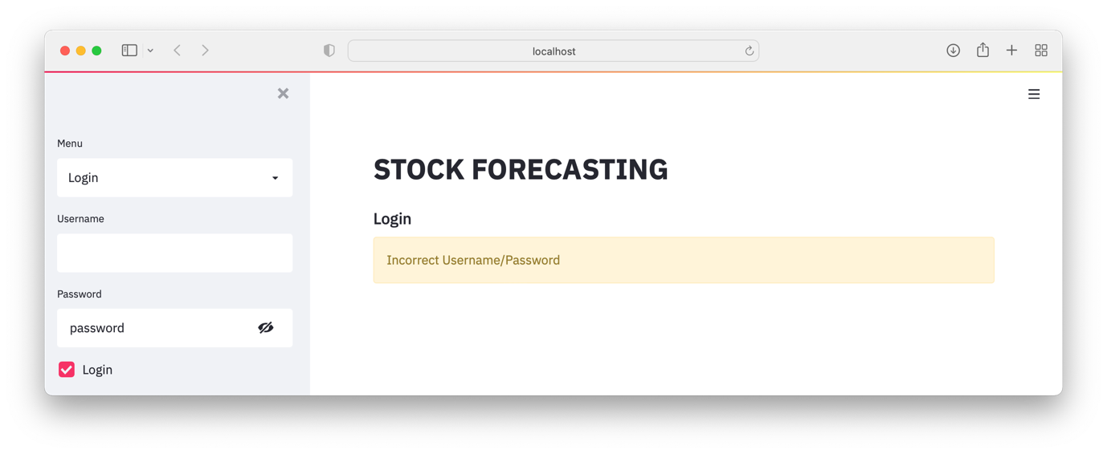

LRW 29

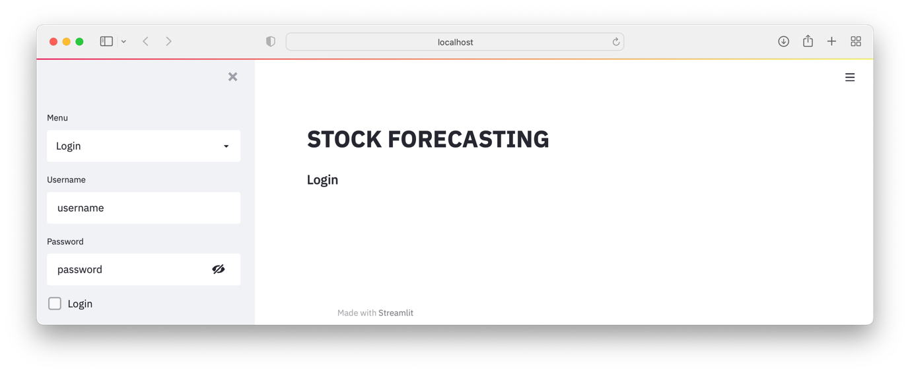

LRW 30

(Login Checkbox / Button hasn’t been checked)

In LRW 27, 28, 29, 30, and 31, the validation of the inputs of the username and password are carried out whereby it firstly checks if there is an input for the username and password and then authenticates if the user is existing.

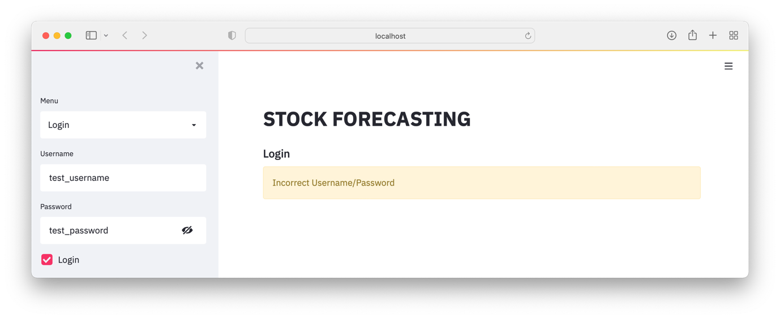

LRW 31

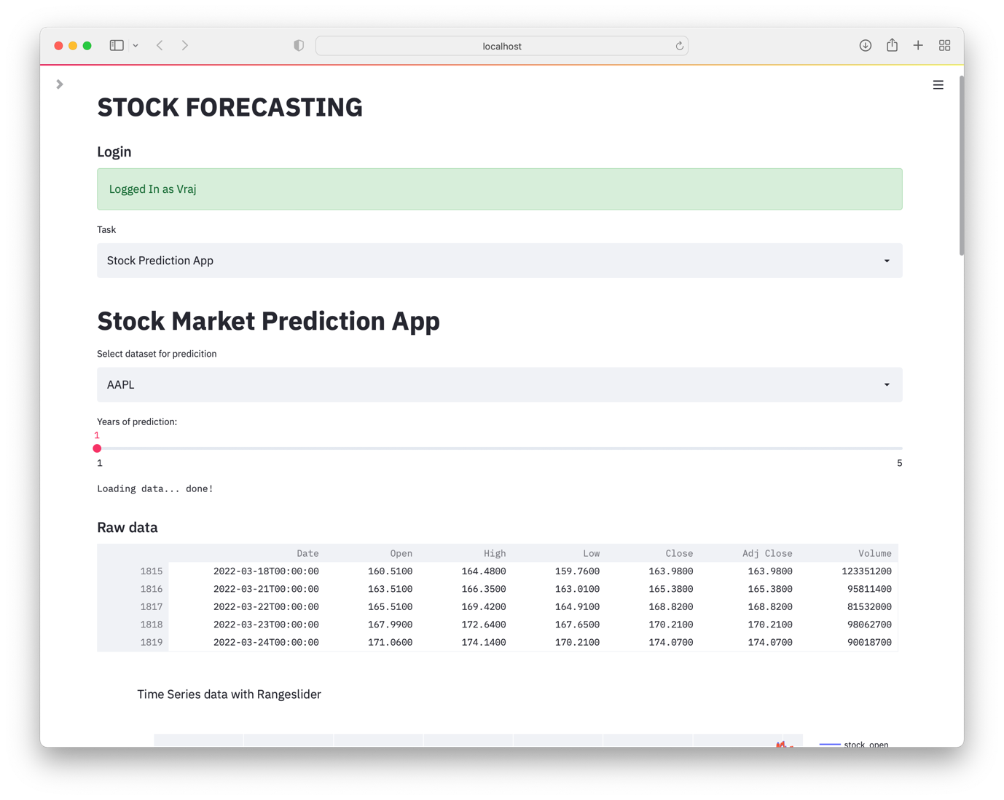

LRW 32

In LRW 33 - 50, the **validation** of the inputs from the user are carried out. It firstly checks if anything has been entered for all the fields, and then if the username doesn’t already exist, the new user is added to the database and there is a message to confirm this and directs the user to what to do next. If any one of the requirements is not met, an error message is displayed according to the error.

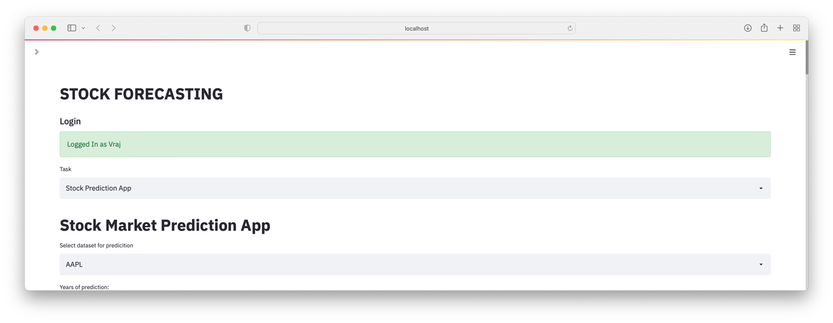

LRW 33

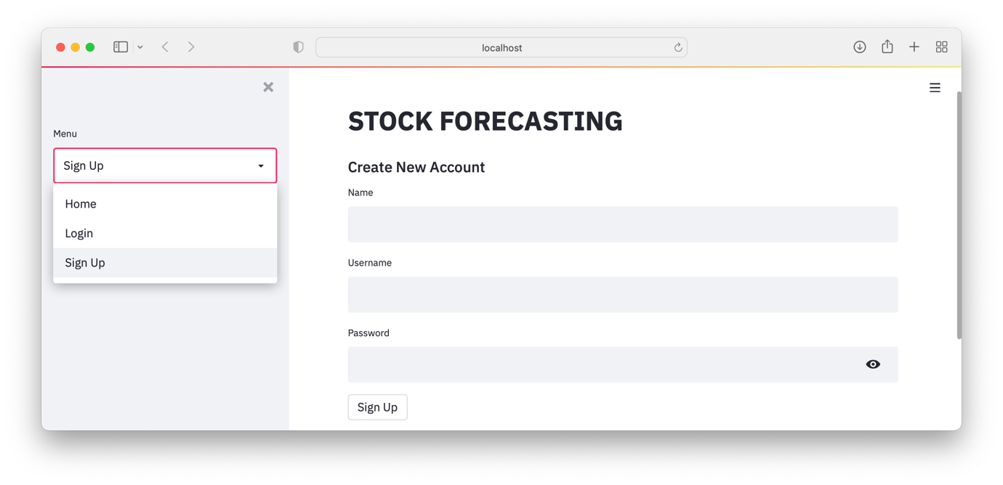

LRW 34

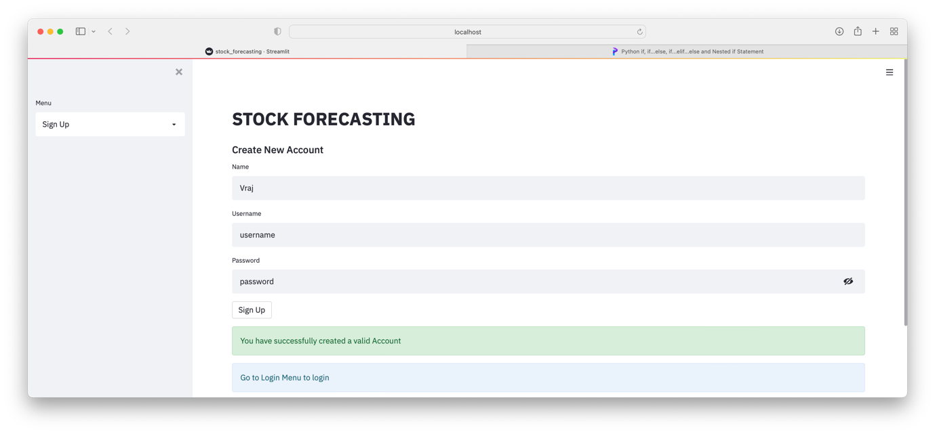

LRW 35

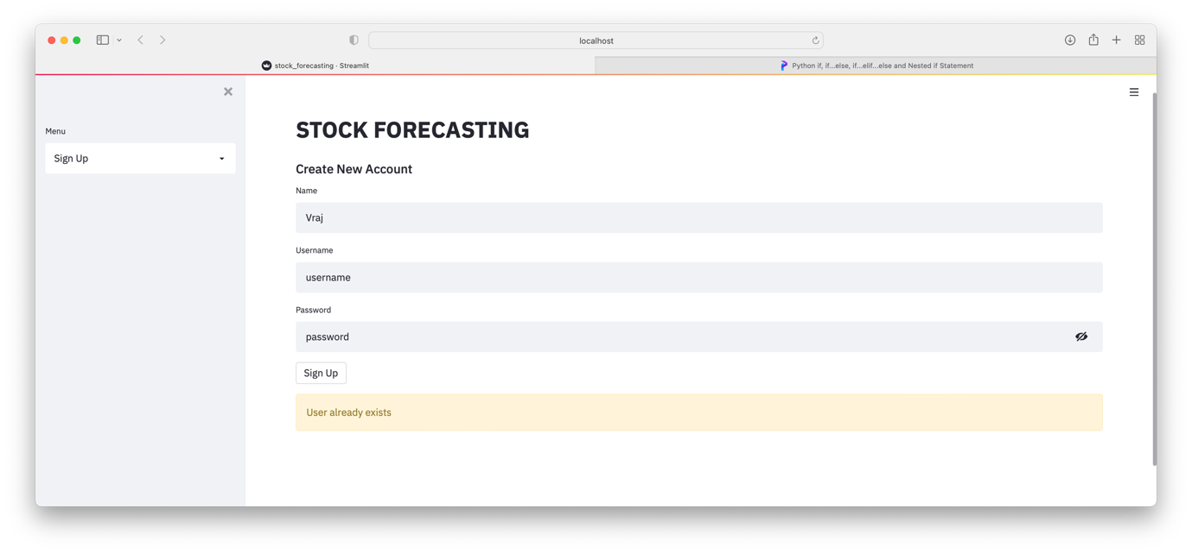

LRW 36

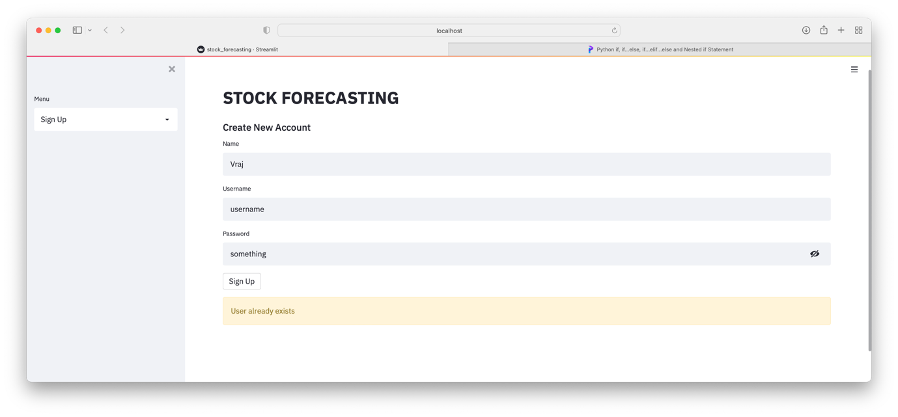

LRW 37

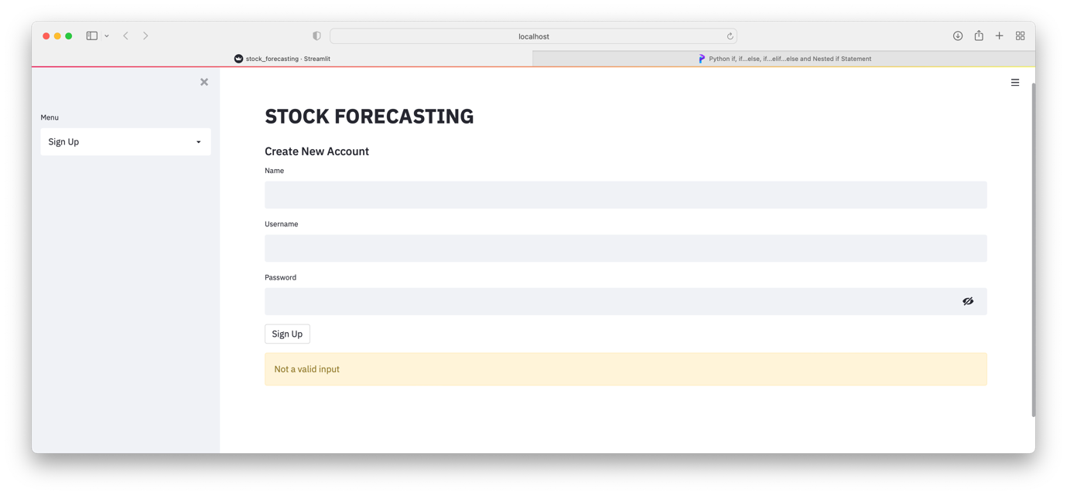

LRW 38

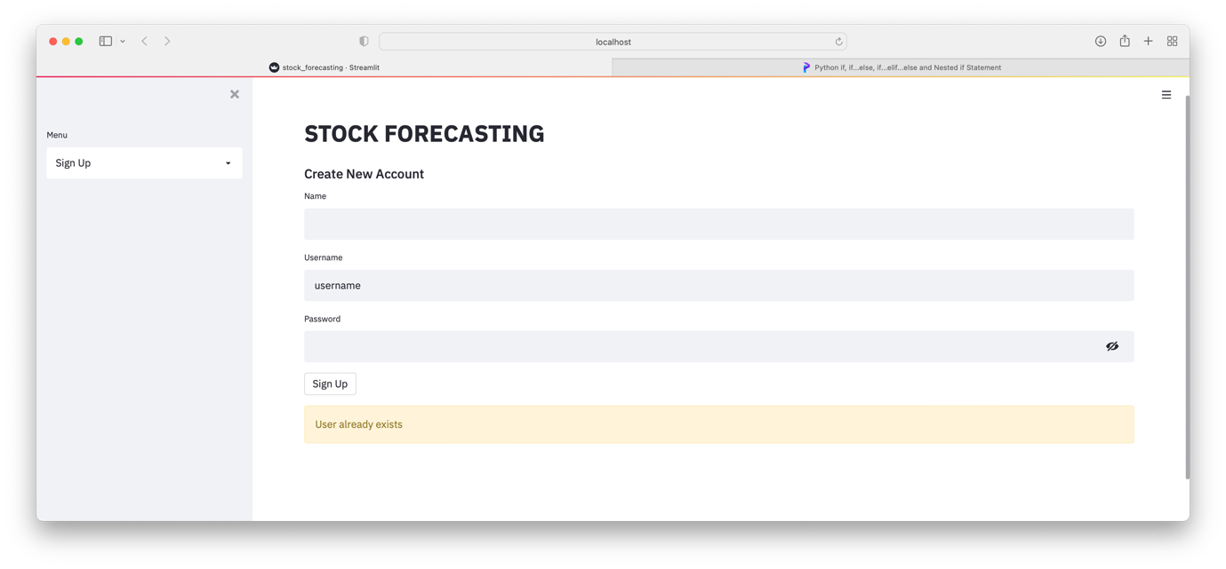

LRW 39

**FAILURE TESTING**

In LRW 42, I’m receiving the incorrect error message. This is because of the order of the elif statements; after the small alteration, the code was working perfectly well with the correct error messages.

LRW 40

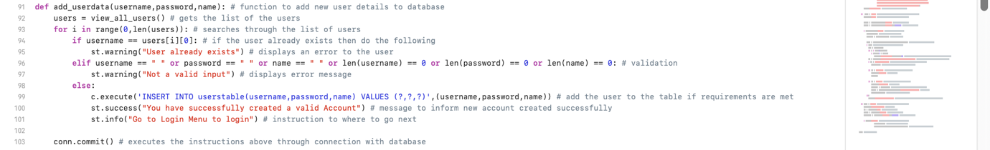

↓

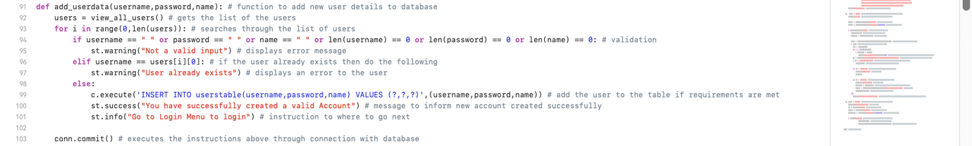

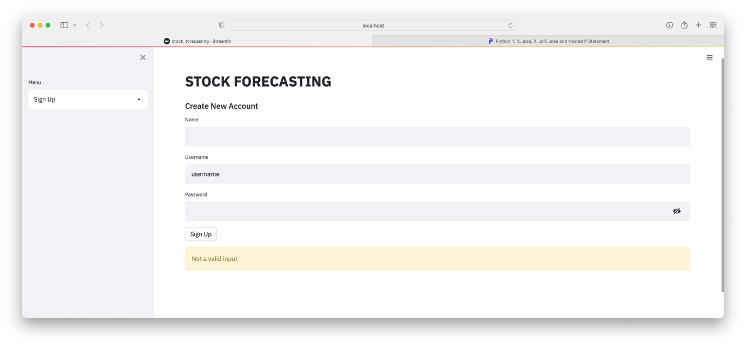

LRW 41

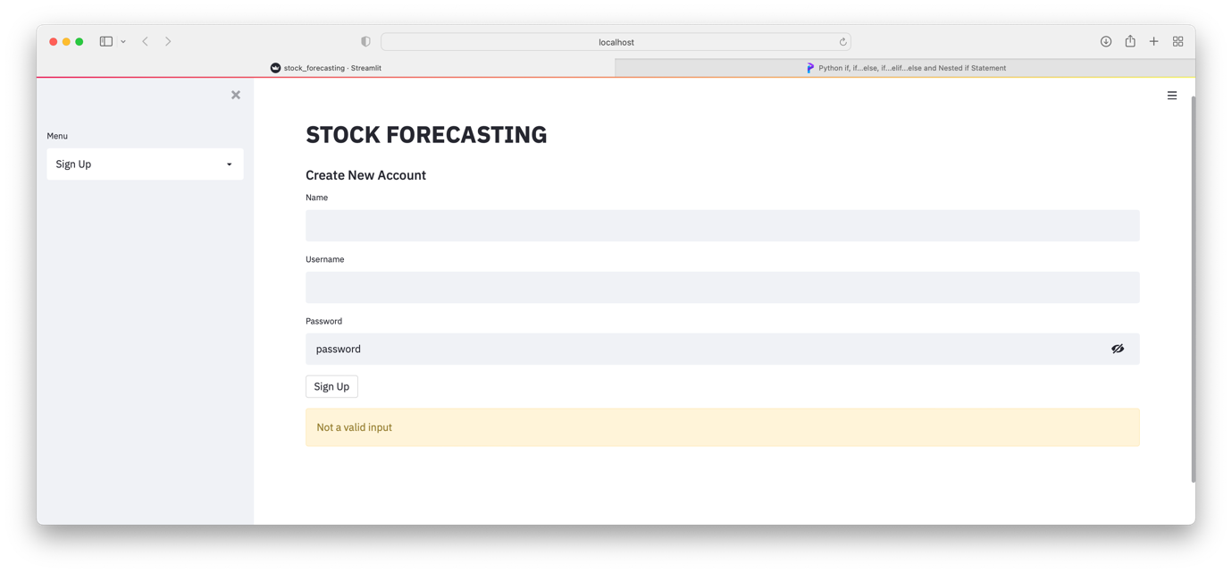

LRW 42

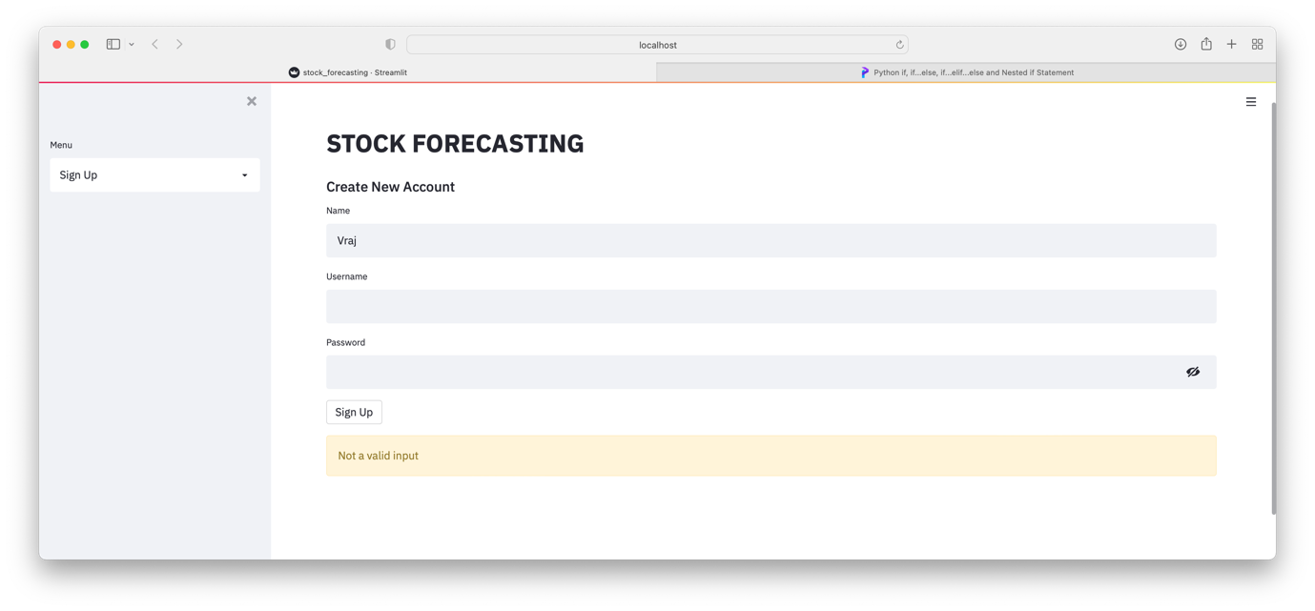

LRW 43

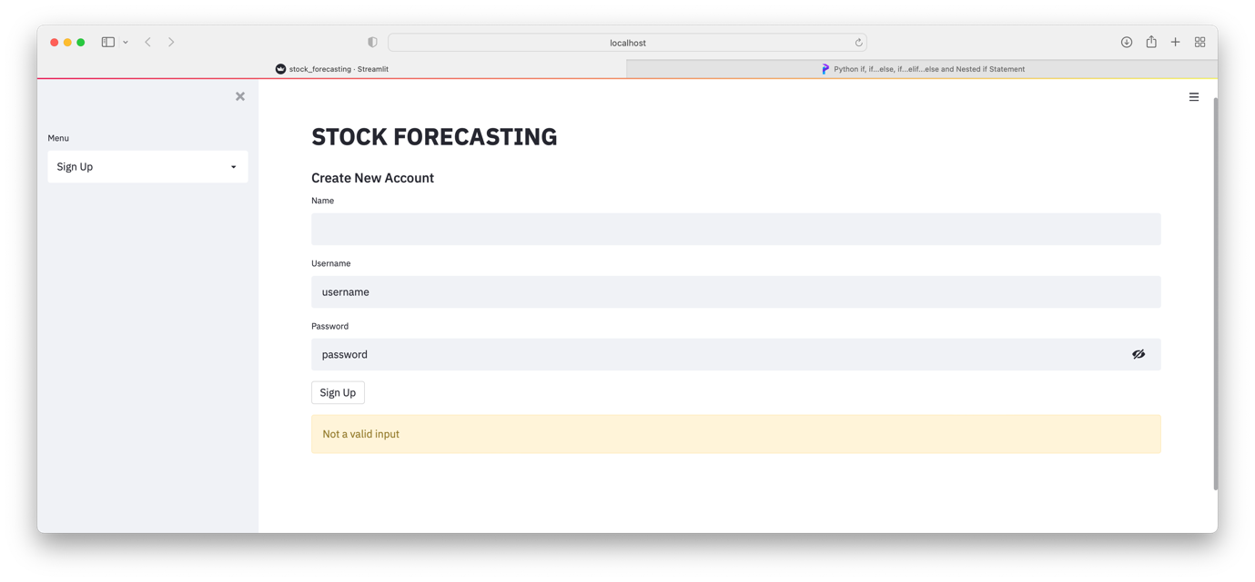

LRW 44

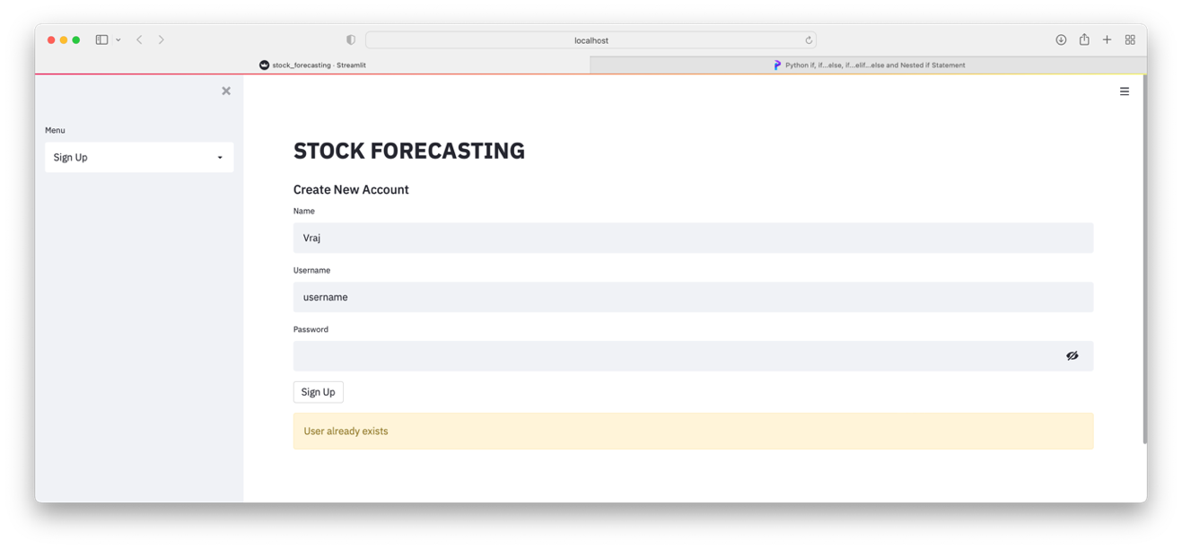

LRW 45

**FAILURE TESTING:**

Realising that the hashed password was being sent into the adding a new user module, I altered it from LRW 43 as shown in LRW 49 so that the password itself get sent in and then the hashed version is calculated upon adding it to the database. The changes have been made to line 99 as a consequence of the change to line 202 so that the hashed version of the password is stored on the database for the security of the users’ account. The output of these changes is shown in LRW 50.

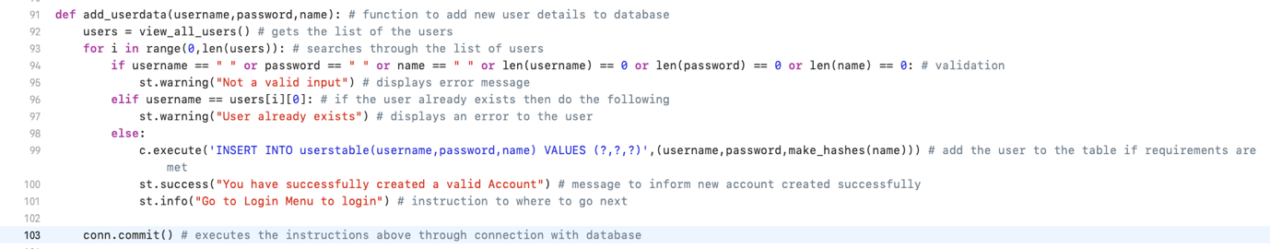

LRW 46

**…**

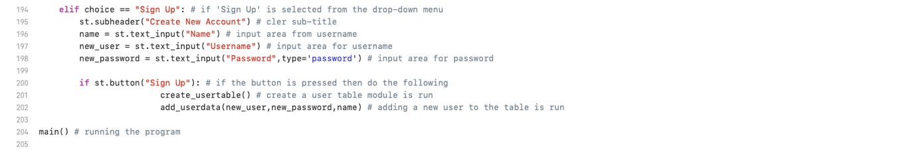

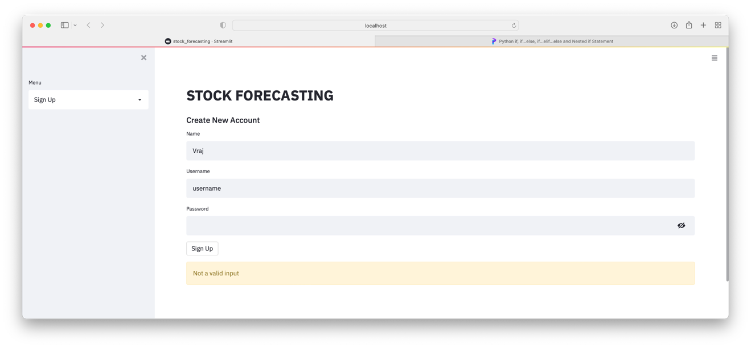

LRW 47

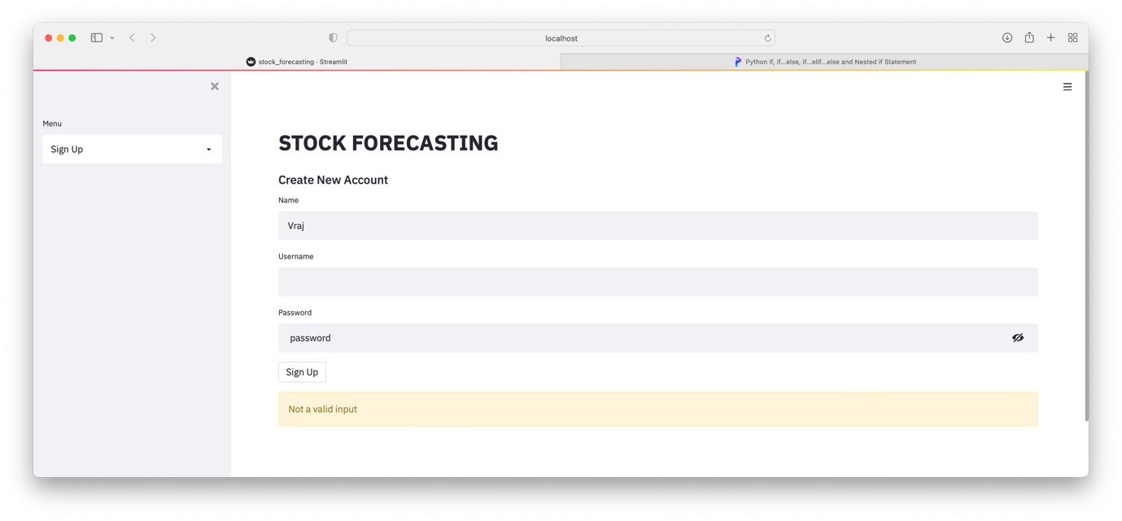

LRW 48

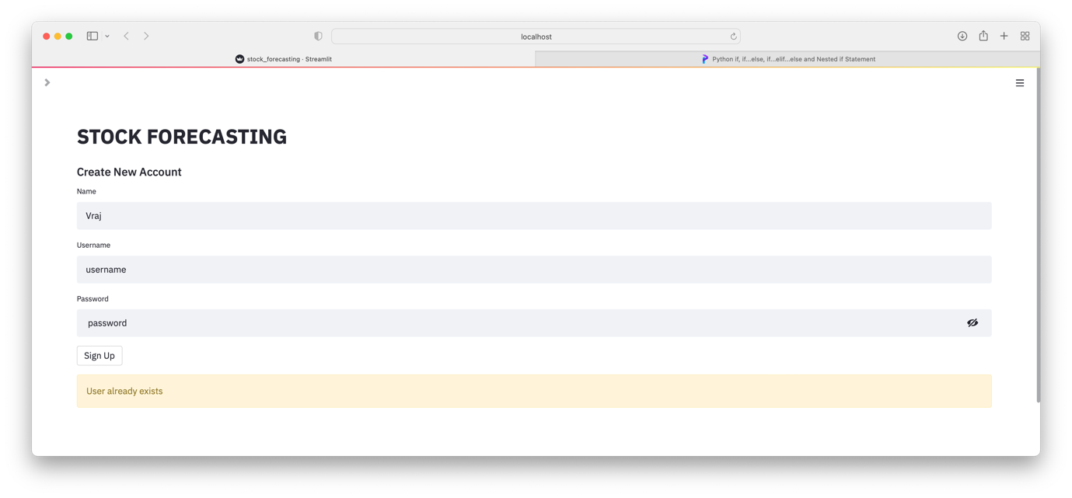

LRW 49



LRW 50

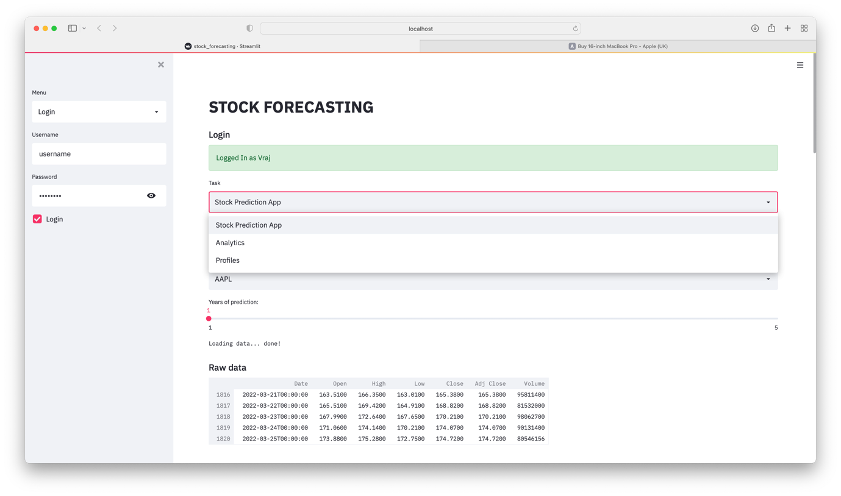

LRW 51

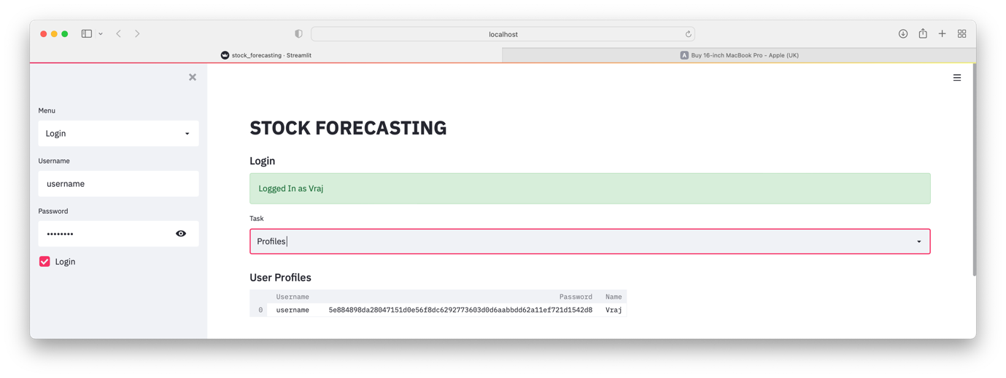

LRW 52

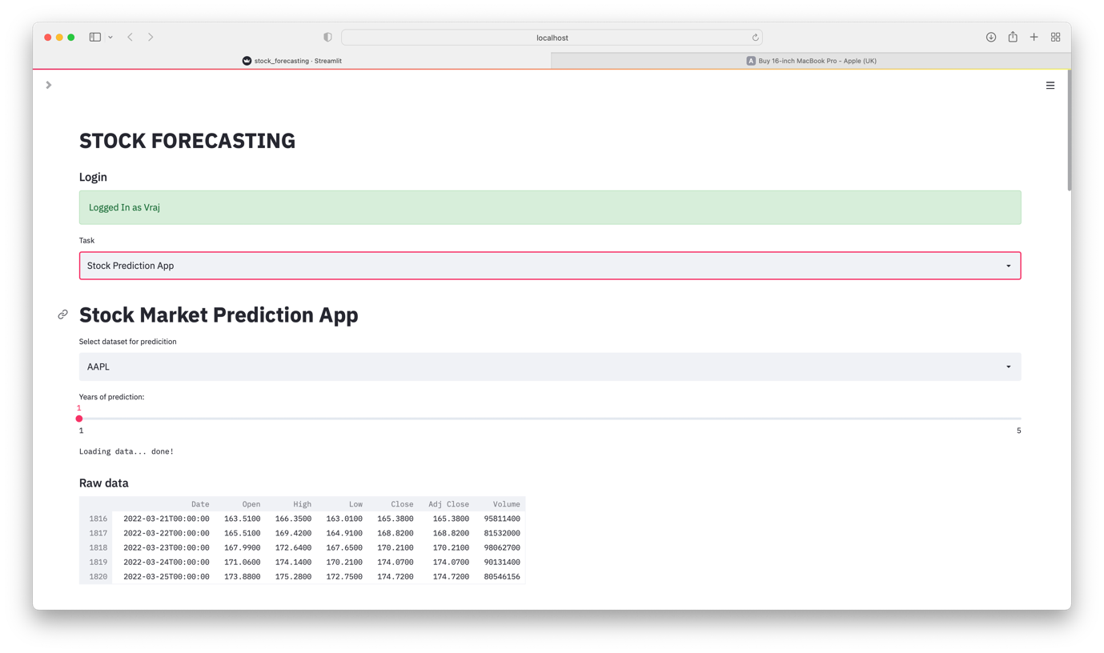

LRW 53

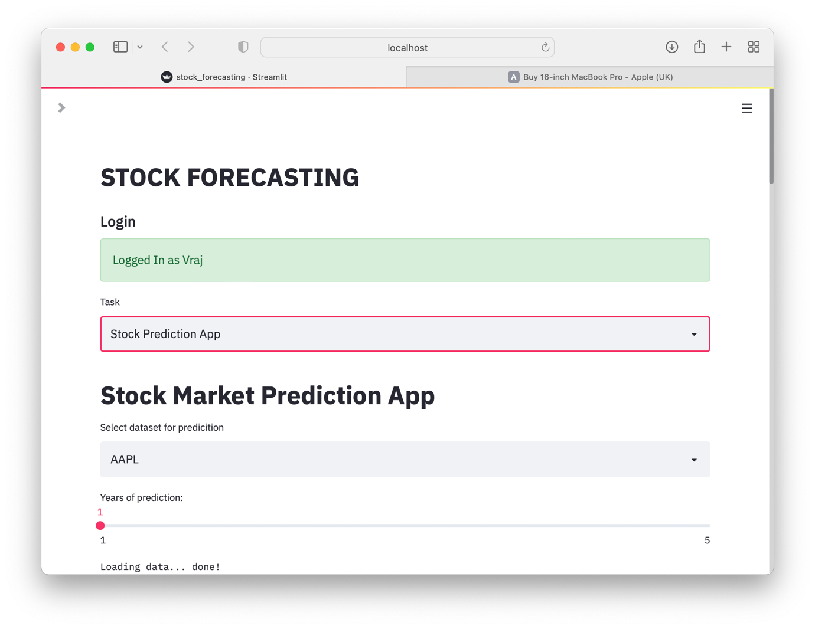

LRW 54

| **TEST PLAN: LOGIN PAGE** | | | | |
| --- | --- | --- | --- | --- |
|  | **Task #** | **Description** | **Inputs** | **Outputs** |
|  | **1** | Will need to see if all drop-down menus and buttons are working and displaying correctly | N/A | LRW 1, 5  **SUCCESS** |
| **2** | Will need to check if each module works | Will be specific to each module | LRW 1, 2, 3, 4, 5, 6, 9, 10, 11, 12, 13  **SUCCESS** |
| **VALIDATION** | **3** | Testing what will happen when you first enter a valid username and password | Username: username  Password: password | LRW 10, 26  **SUCCESS** |
| **4** | Testing what will happen when you enter nothing for both username and password | Username:  Password: | LRW 30  **SUCCESS** |
| **5** | Testing what will happen when you enter only username and no password | Username: username  Password: | LRW 31  **SUCCESS** |
| **6** | Testing what will happen when you enter only password without username | Username:  Password: password | LRW 32  **SUCCESS** |
| **7** | Testing what happens when you enter a genuine username and password but don’t press the login button | Username: username  Password: password | LRW 33  **SUCCESS** |
| **8** | Test what happens when the username and password are entered which are not in the present in the database | Username: test_username  Password: test_password | LRW 34  **SUCCESS** |
|  | **9** | Testing if home page loads from drop-down menu in the sidebar | N/A | LRW 3  **SUCCESS** |
| **10** | Testing if login page loads from drop-down menu in the sidebar | N/A | LRW 26  **SUCCESS** |
| **11** | Testing if sign up page loads from drop-down menu in the sidebar | N/A | LRW 7  **SUCCESS** |
| **12** | Testing if the sidebar is retractable | N/A | LRW 35  **SUCCESS** |
| **13** | Testing if the sidebar is retracted, the main page should readjust to full up the space provided | N/A | LRW 9, 10, 11, 12 are the **FAILURE** tests  But LRW 35 fixes it  **SUCCESS** |
| **14** | Test if varying the width of the page results in the page automatically adapting to full the full width available | N/A | LRW 36  **SUCCESS** |

**VALIDATION**:

Tests 3 - 8 is the validation for the login page which when authorised, authenticates the user, and logs them in to their personal account.

**USER FEEDBACK:**

❝ The login page was opened by default in the sidebar which is very convenient alongside the introduction to the web app next to it in the main page; this has a very professional aspect to it and the password being obscured provides privacy and security, which is important to me. One issue I did have for the first time is locating the login button, but after a bit of time, I did eventually find it, but I do recommend maybe having some text or some other way of making it clear that the tick box is the login button and also unticking it is also logs out, which is a bit misleading ❞

| **TEST PLAN: REGISTRATION PAGE** | | | | |
| --- | --- | --- | --- | --- |
|  | **Test #** | **Description** | **Inputs** | **Outputs** |
|  | **1** | Will need to see if all drop-down-menu and buttons are working and correctly displaying | N/A | LRW 37  **SUCCESS** |
| **2** | Will need to check if each module works | Will be specific to each module | LRW 22, 23, 24, 25  **SUCCESS** |
| **VALIDATION** | **3** | Testing what will happen when you first enter a valid username, password, and name | Username: username  Password: password  Name: name | LRW 38  **SUCCESS** |
| **4** | Testing what will happen when you enter the same username, password, and name twice | Username: username  Password: password  Name: name  Username: username  Password: password  Name: name | LRW 38, then LRW 39  **SUCCESS** |
| **5** | Testing what will happen when you enter the username, password, and name. Then entering the same username, different password, and name | Username: username  Password: password  Name: name  Username: username  Password: something  Name: name | LRW 38, then LRW 40  **FAILURE**  ↓  **SUCCESS** |
| **6** | Testing what will happen when you enter nothing for username, password, and name | Username:  Password:  Name: | LRW 41  **SUCCESS** |
| **7** | Testing what will happen when you enter username but no password and name | Username: username  Password:  Name: | LRW 44  **SUCCESS** |
| **8** | Testing what will happen when you enter password but no username and name | Username:  Password: password  Name: | LRW 45  **SUCCESS** |
| **9** | Testing what will happen when you enter a name but no username and password | Username:  Password:  Name: name | LRW 46  **SUCCESS** |
| **10** | Testing what will happen if username and password is entered but no name | Username: username  Password: password  Name: | LRW 47  **SUCCESS** |
| **11** | Testing what will happen when you enter username and name but no password | Username: username  Password:  Name: name | LRW 48, then LRW 49, 50  **FAILURE**  ↓  **SUCCESS** |
| **12** | Testing what will happen when you enter password and name but no username | Username:  Password: password  Name: name | LRW 51  **SUCCESS** |
|  | **13** | Test if after successfully signing up, instructions to what to do next appears | N/A | LRW 38  **SUCCESS** |
| **14** | Test if varying the width of the page results in the page automatically adapting to full the full width available | N/A | LRW 52  **SUCCESS** |

All passwords are shown in the images for sake of testing; however, the user will always be private if others look at their screen while typing their password as shown below.

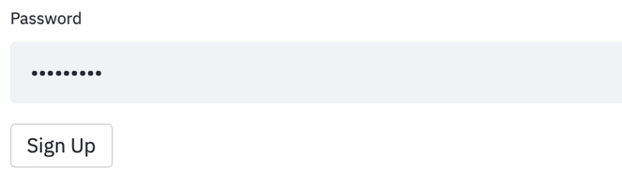

**VALIDATION**:

Tests 3 - 12 is the validation for the inputs on the registration page and if authorised, the authentication of the user takes place to log them in to their personal account.

**USER FEEDBACK:**

❝ The registration page was easy to access through the drop - down menu in the sidebar that redirected me to the registration page. The page was very simple to use and straight forward to use and enter my credentials. Considering I used the web app for the first time, I appreciated the fact that I am notified when a new account has been created successfully and also guides me to what to do next ❞

|  |  |  |  |
| --- | --- | --- | --- |
| **TEST PLAN: WELCOME PAGE** | | | |
| **Task #** | **Description** | **Inputs** | **Outputs** |
| **1** | Will need to see if all drop-down menus and buttons are working and displaying correctly | N/A | LRW 51  **SUCCESS** |
| **2** | Test if after logging in successfully, it come to this welcome page | N/A | LRW 51  **SUCCESS** |
| **3** | Test if a personalised welcome message appears under the main title | N/A | LRW 51  **SUCCESS** |
| **4** | Test whether the drop-drop menu can successfully redirect to another page through clearing the sub-page below and refreshing it with the desired content | N/A | LRW 51, 52  **SUCCESS** |
| **5** | Testing if the sidebar is retractable | N/A | LRW 53  **SUCCESS** |
| **6** | Testing if the sidebar is retracted, the main page should readjust to fill up the space provided | N/A | LRW 53  **SUCCESS** |
| **7** | Test if varying the width of the page results in the page automatically adapting to fill the full width available | N/A | LRW 54  **SUCCESS** |

**USER FEEDBACK:**

❝ The welcome page was pretty standard but as it has no functional purpose, it doesn’t matter too much. It would be nice if the welcome could be updated or change every few weeks or so to make it more relevant to the current situation ❞

**Analytics Page**

* Getting the general layout correct of all the drop-down menus

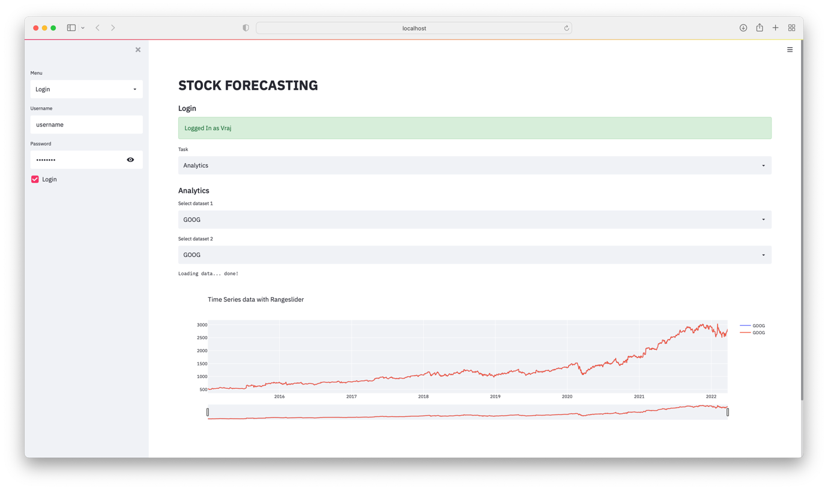

A 2

A 1

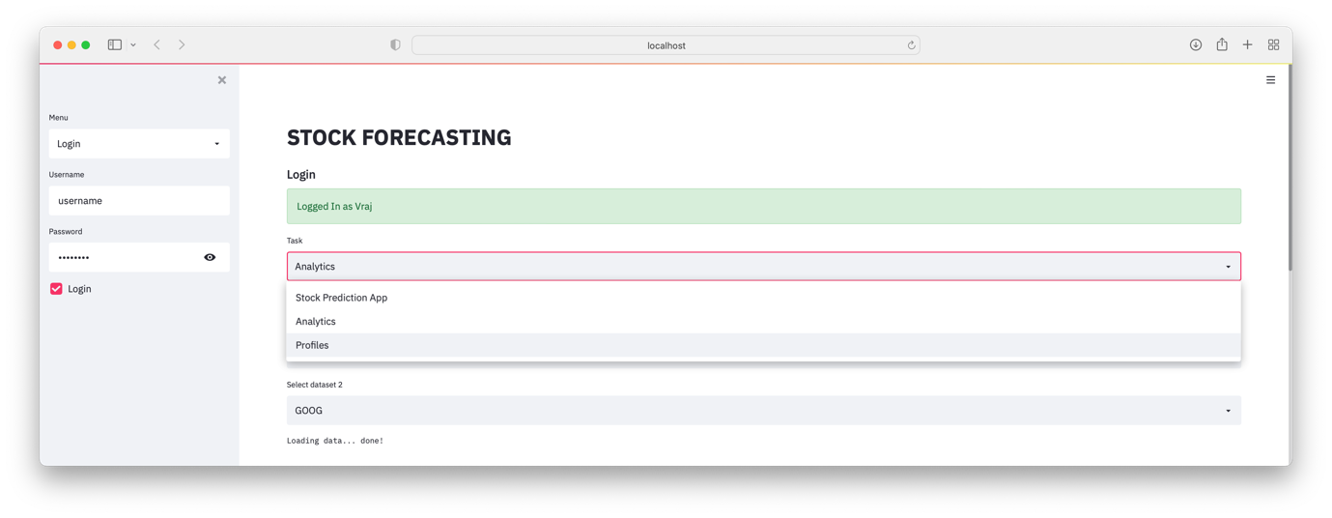

A 3

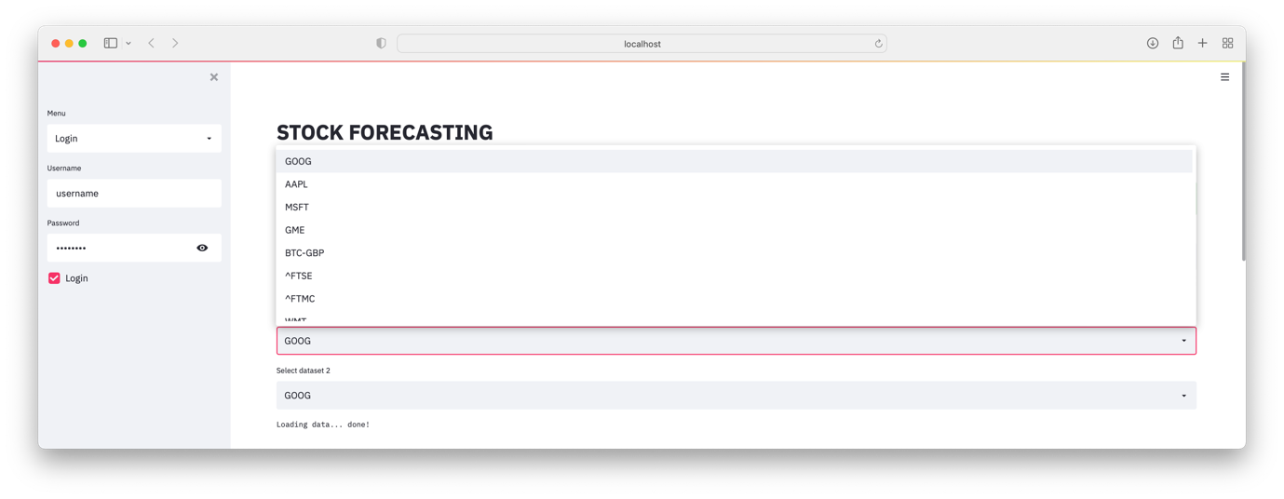

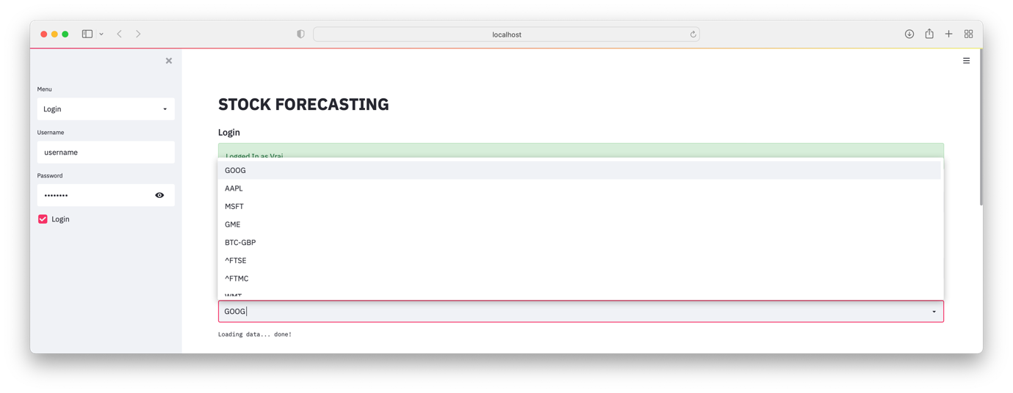

A 4

* Getting the graph functionality to work by displaying two stock / cryptocurrency prices on the same set of axes to compare them

As this page is very similar to stock forecasting page, it made logical sense to base this page on it with some alterations.

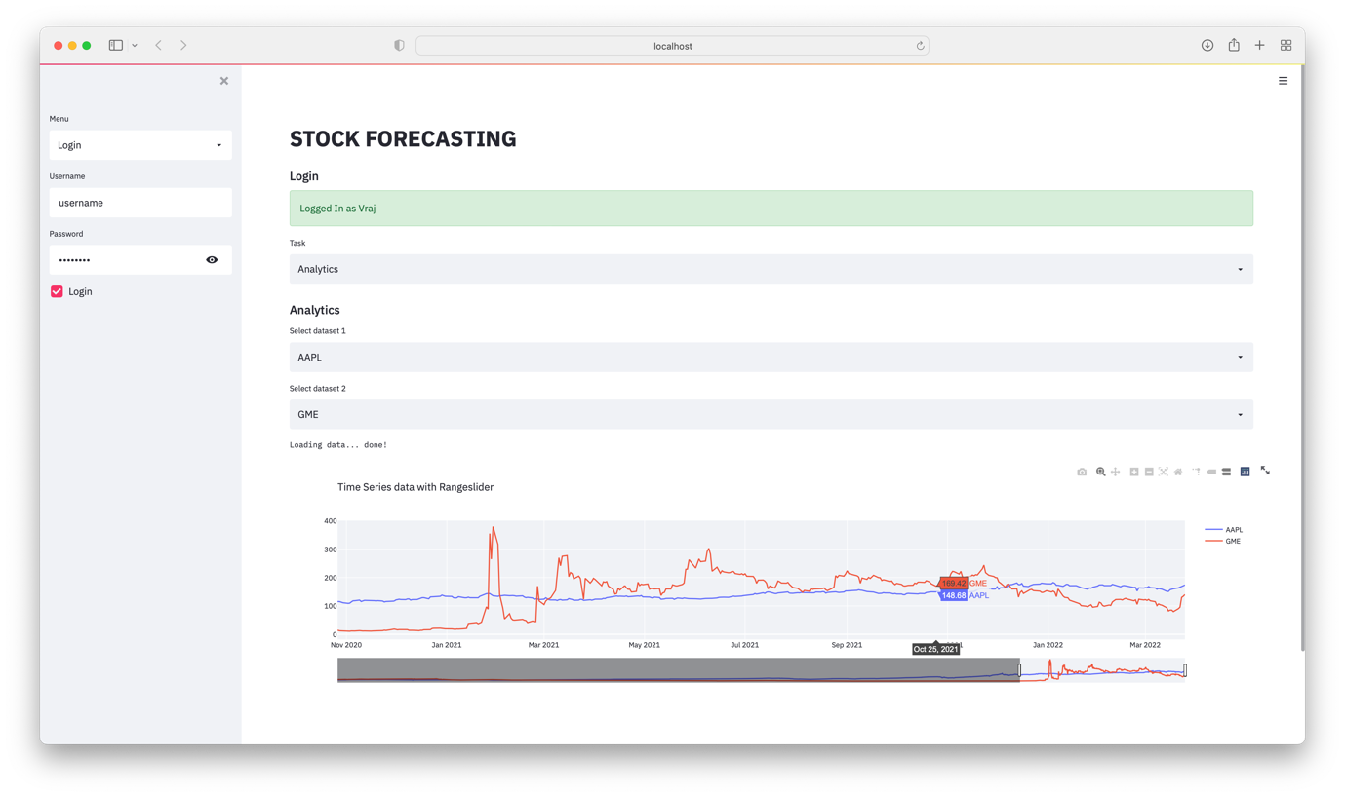

A 5

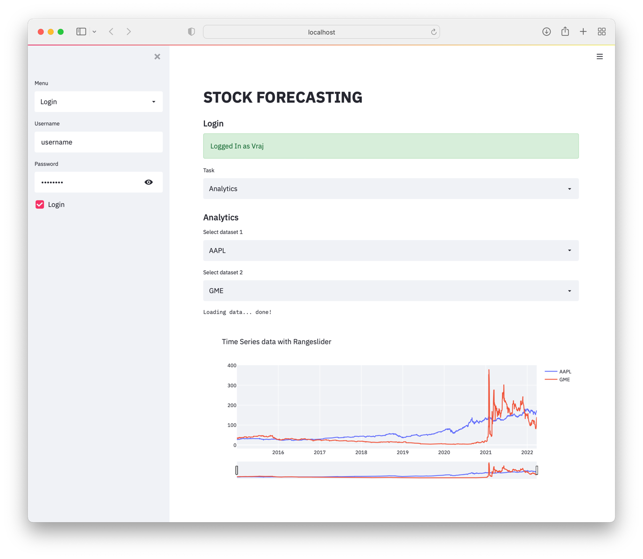

A 7

A 6

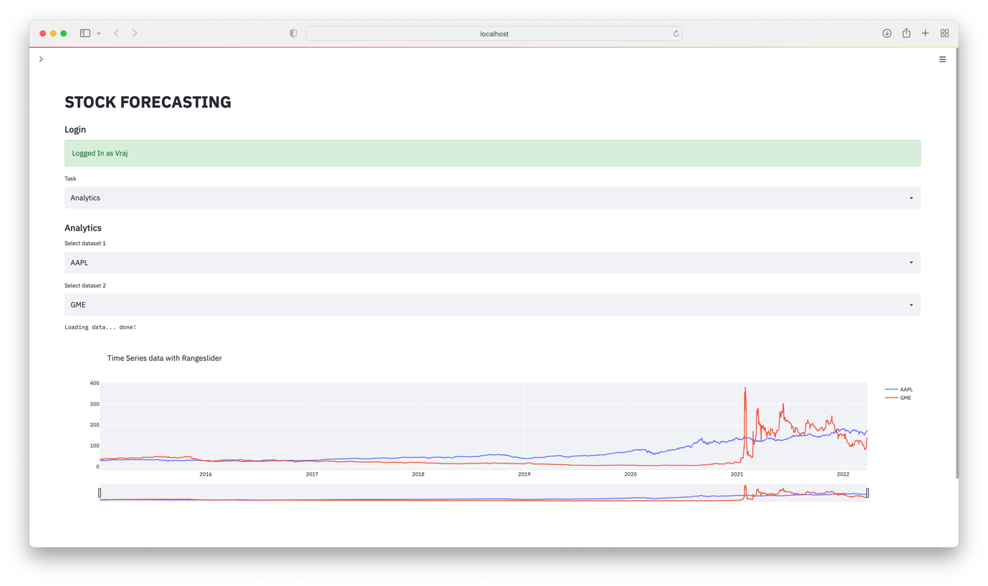

| **TEST PLAN: ANALYTICS PAGE** | | | |
| --- | --- | --- | --- |
| **Task #** | **Description** | **Inputs** | **Outputs** |
| **1** | Will need to see if all drop-down menus and buttons are working and displaying correctly | N/A | A1, 2, 3, 4  **SUCCESS** |
| **2** | Test if the drop-down menus contain the stocks / cryptocurrencies required by the user | N/A | A3, 4  **SUCCESS** |
| **3** | Test if the chosen stock / cryptocurrency from the drop-down menu is graphed | Chosen via the drop-down menu | A5  **SUCCESS** |
| **4** | Test if the chosen stock / cryptocurrency has different coloured line graphs for different stocks / cryptocurrencies selected from the drop-down menus | N/A | A5  **SUCCESS** |
| **5** | Test if the scale of the graph maximises the use of the available screen real-estate for a graph | N/A | A5  **SUCCESS** |
| **6** | Test if hovering over the graph shows the correct information in a more legible manner | N/A | A5  **SUCCESS** |
| **7** | Test if TASKS 3,4,5,6 and 7 work for the overlayed graphs of the two stock / cryptocurrencies | N/A | A5  **SUCCESS** |
| **8** | Test if varying the width of the page results in the page automatically adapting to fill the full width available | N/A | A6  **SUCCESS** |
| **9** | Testing if the sidebar is retractable | N/A | A6  **SUCCESS** |
| **10** | Testing if the sidebar is retracted, the main page should readjust to fill up the space provided | N/A | A6  **SUCCESS** |

**USER FEEDBACK:**

❝ Like with the stock forecasting page, it very nice but also with the added functionality of comparing stock / cryptocurrency which will definitely be used. The drop - down menu to get to this page was easily accessible and not very complicated in my opinion ❞

During this testing process, I realised that stock / cryptocurrencies of similar value display their data graphically very well according to the user’s requirements however, when they are of vastly different values per share, the graph seems a bit pointless as shown in A8.

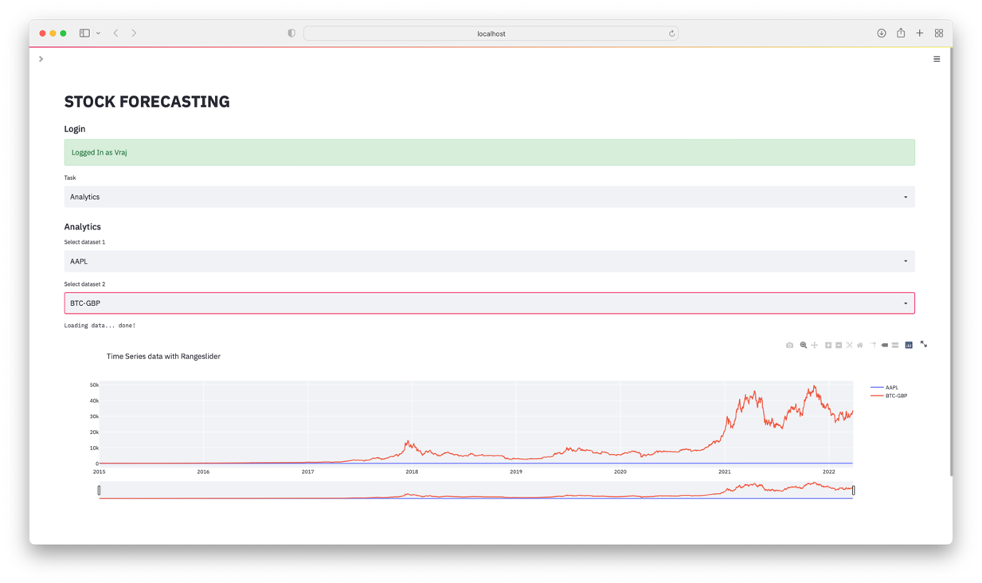

A 8

Final Code:

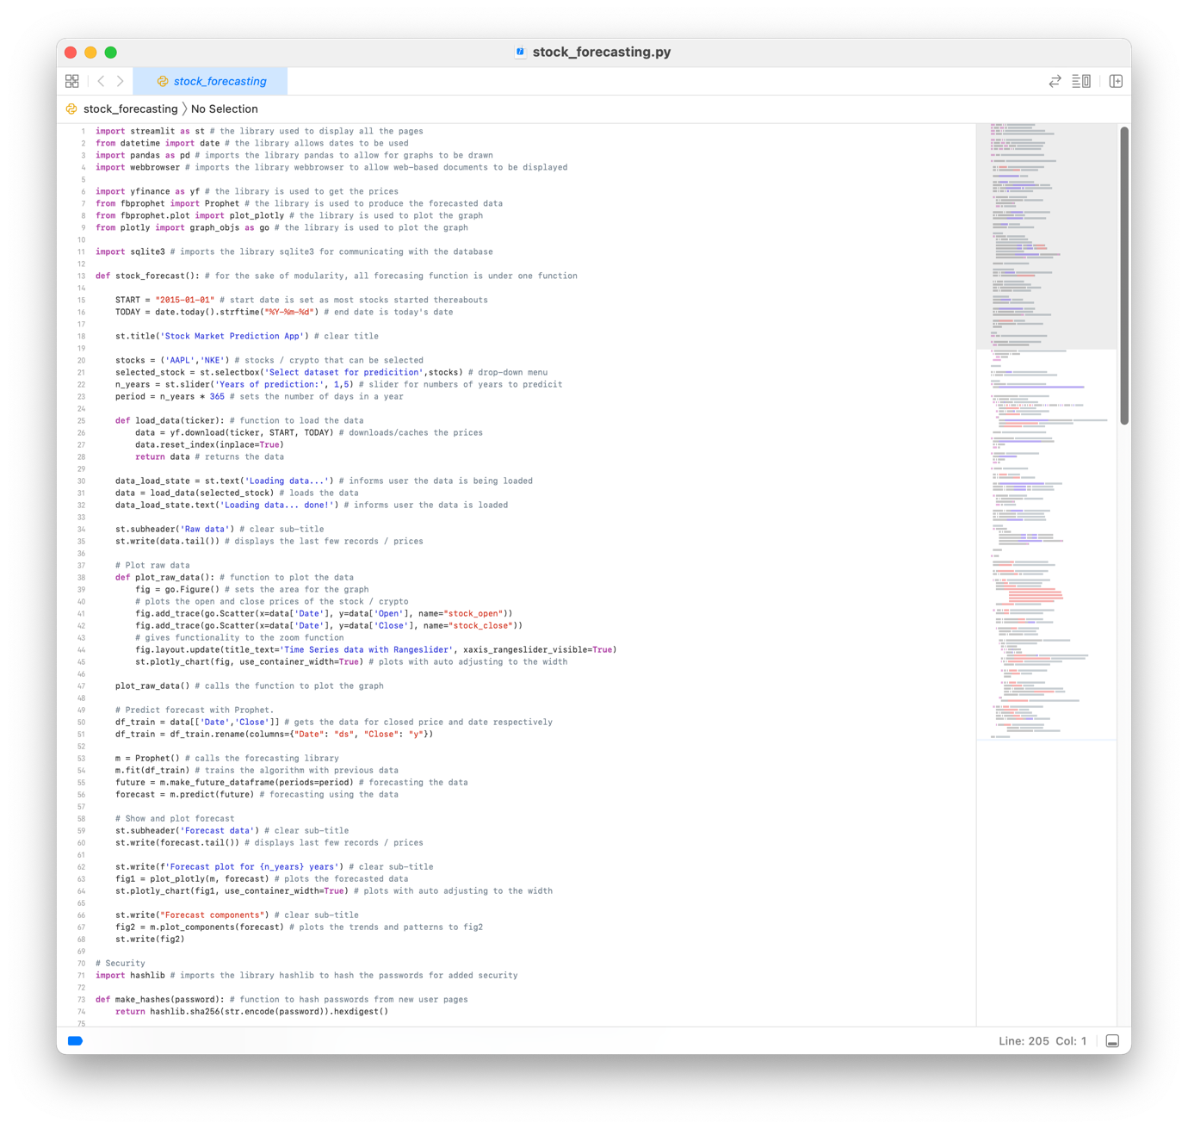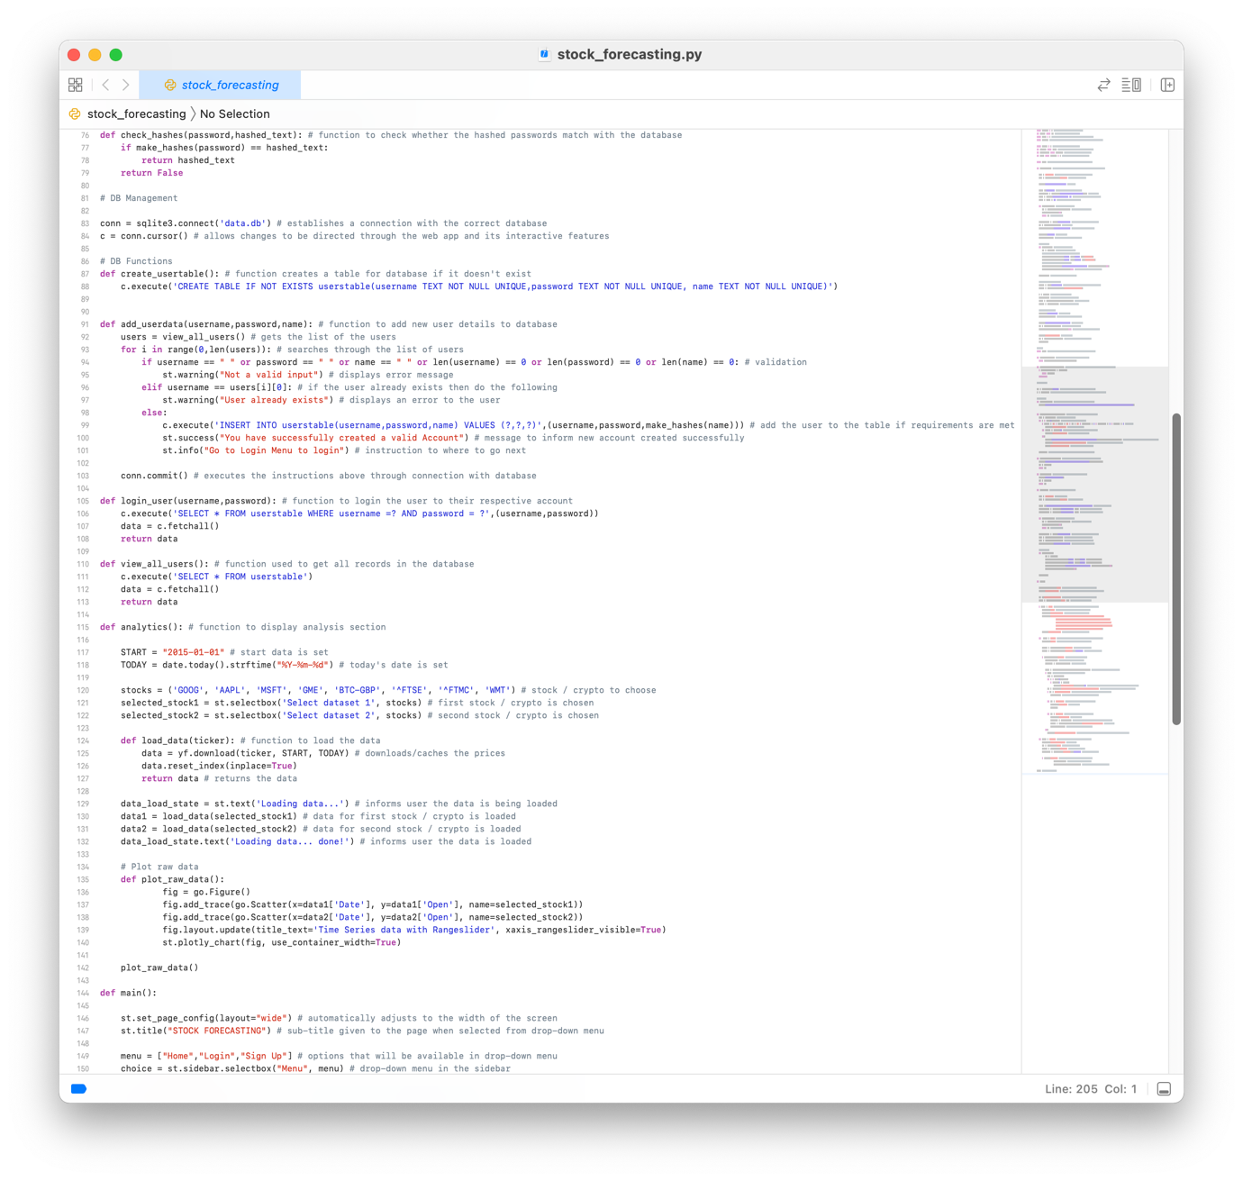

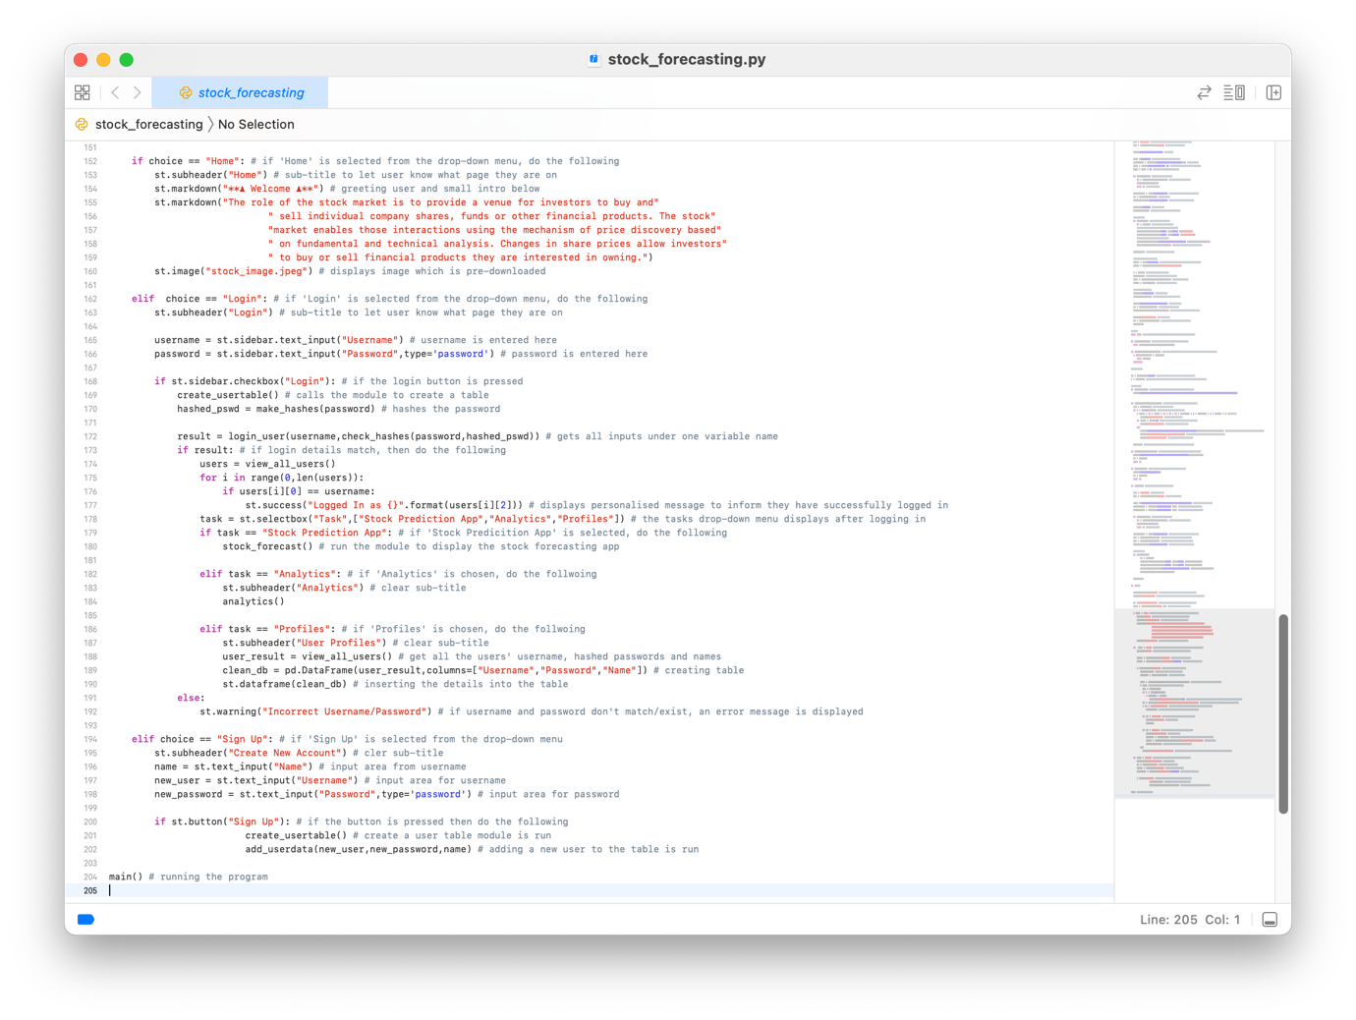

| **POST IMPLEMENTATION TEST PLAN** | | | | |
| --- | --- | --- | --- | --- |
|  | **Task #** | **Description** | **Inputs** | **Outputs** |
|  | 1 | Should load the Login page at start | N/A | LRW 3 - by putting Home at the top of the drop-down menu, the page is opened first by default  The login page is load as the first thing when program is run |
| **VALIDATION** | 2 | Should allow users to go from Login page to Sign Up page if they don’t have an account | N/A | LRW 34  Using the drop-down menu, the user is able access the sign-up page if they don’t have an account |
| 3 | Should validate inputs on Sign Up page | Username: username  Password: password  Name: Vraj | LRW 35  The user is notified if there are any issues but if not, let them know the account has been created and where to go next |
| 4 | Database system | Above | LRW 7, 8  Checks if the new details have been added to the database |
| 5 | Validate inputs on Login page | As seen on the testing images | Tests 3 - 8 in the login page test plan  The user is notified if there are any issues but if not, log them in |
|  | 6 | If a user registers their account should be created and added to the database | As seen on the testing image | LRW 7, 8  The user is be notified if there are any issues but if not, let them know the account has been created and where to go next |
|  | 7 | Main page should not be loaded till user has logged in or signed up | N/A | LRW 30  The main page isn’t load until the user successfully enters their username and password and presses the button |
|  | 8 | Once a user logs in or creates an account, the stock forecasting page should be loaded | As seen on the testing | LRW 10  The stock forecasting page is loaded when the user logs in successfully |
|  | 9 | Navigation bar | Select from the drop-down menu to navigate through the web app | LRW 10, A 2  The respective pages are opened and displayed under the bar |
|  | 10 | Should be able to predict data | Stock / Cryptocurrency selected from the drop-down menu | STOCK 15  The data is shown as well as the graphical representation of it |
|  | 11 | Graphical representation | Stock / Cryptocurrency selected from the drop-down menu | STOCK 15  The data is represented graphically below the raw data |
|  | 12 | Allow user to log out | Press the log out button | LRW 30  Logs the user out and remove anything on the screen to and return to the welcome page |

| **USER EVALUATION TEST PLAN** | | |
| --- | --- | --- |
| **Task #** | **Description** | **Feedback** |
| 1 | Create an account with a unique username, password, and name | This process was very simple as navigating via the drop-down menu in the sidebar and entering the relevant information was done in professional manner with a logical layout |
| 2 | Login to the web app | After logging in, there was a message to inform me that I was logged in and it told me to go to login page and login in, which was easy; the login button was a bit small and unclear at first, but I’m sure it would happen again |
| 3 | Locate to the stock forecasting page, and analytics page | The forecasting page was opened instantly which was much appreciated and transitioning to the various pages was comfortable and quite obvious via the drop-down menu |
| 4 | Scroll down to the stock forecasting page and understand the information displayed | The stock forecasting page was very well designed with a simple colour scheme as I required and also the versatility of the graphs was much appreciated for the detailed information, I required |
| 5 | Scroll down to the analytics page and use this to show how the markets compare to each other | This feature was respected for the use of comparing the stocks, however I did notice that prices per share or coin vary a lot, the graph was pretty much unreadable for the one with the lower price; it would be better to have scaled the price axis individually for better comparisons to made |
| 6 | Select the stock you want to compare in the analytics page | The feature for having drop-down menus for selecting the stock markets / cryptocurrencies was a nice touch instead of me typing them each time and also provided some interactivity |
| 7 | Reading the values from a graph from the stock forecasting page | The graphs for the stock forecasting where very easy to read as the hover functionality worked very well and the tools on the top right corner of the graphs required a bit of trial and error but are a useful |
| 8 | Logout of your account | Logging out was a little bit tricky as there wasn’t a specific button as such, however later realising it to be in the sidebar, I did appreciate this as it was out the way when requiring a larger viewing experience |

**USER FEEDBACK:**

❝ On the whole, this is well designed, and the functionality is pretty much all I asked for from your initial interview and it is fabulous that you managed to include all this functionality in a very professional and helpful manner which is specifically catered to my preferences and requirements ❞

**EVALUATION OF SOLUTION**

I am happy with the overall result. I am happy with the design and layout of the program, machine learning capabilities (which aren’t very advanced or sophisticated but are at a good standard) and features such as hashed passwords. I believe I have successfully built the program I intended to build with some improvements, such as showing the trends that the algorithm spots to predict the stock / cryptocurrency is represented graphically.

**Final User Feedback**

1. Overall, are you satisfied with the end result?

Yes, overall, it is what I wanted, though some improvements could be made

1. What could be improved?

It would be appreciated if the login button was made clearer and the logout button to be placed in another area with both being clearly labelled wherever they are on the page (in this case, it doesn’t matter whether or not this may limit the screen real-estate as it isn’t going to take much space up on the create)

1. On a scale of 1 - 10, how good is the colour scheme and overall design?

10

1. On a scale of 1 - 10, how easy is it to use?

9

1. On a scale of 1 - 10, how easy is it to create an account and log in?

10

1. Would you recommend this product to others?

Yes, provided their experience is also personalised

I am satisfied with the user feedback - the improvements suggested will be addressed at a later stage.

| **COMMENTS AND EVIDENCE OF SUCCESS CRITERIA** | | |
| --- | --- | --- |
| **Test #** | **Screenshots** | **Success?** |
| 1 |  | **SUCCESS**  Welcome page loads first, and login page can be access through the drop - down menu in the sidebar which then opens the login page in the sidebar as shown |
| 2 |  | **SUCCESS**  Welcome page loads first, and sign-up page can be access through the drop - down menu in the sidebar which then opens the sign-up page in the main page as shown |
| 3 | All validation screenshots can be obtained from the development of the sign-up page.  EVIDENCE: page 92 - 93, tests 3 - 12 | **SUCCESS**  All inputs are validated via a presence check |
| 4 | There is successful communication between the database and the respective pages whether it be the login or the sign-up page  EVIDENCE: page 88, LRW 52 and page 66 | **SUCCESS**  All validated data inputs are stored or retrieved as peer the task required; the hashing password being stored also provided some extra security |
| 5 | All validation screenshots can be obtained from the development of the login page.  EVIDENCE: page 90 - 91, tests 3 - 8 | **SUCCESS**  All inputs are validated via a presence check before authenticating the user for more informative error message |
| 6 |  | **SUCCESS**  All validated data inputs are stored; the hashing password being stored also provided some extra security |
| 7 | Only after the user has logged in is the main page (stock forecasting page) opened in the main area of the web app.  The welcome message pops up and ONLY after this does the user have access to the web app’s full variety of abilities  Graphical user interface, application  Description automatically generated | **SUCCESS**  As explained |
| 8 | Unfortunately, I couldn’t get this to work, but I did manage to get a message regarding the success of failure to create an account and then a message below it to navigate to the login page to login and then continue from there onwards  Graphical user interface, application, Teams  Description automatically generated | **FAILURE**  However, I tried to provide some guidance to what to do next |
| 9 | After logging in, the user will get a drop-down menu which will be used to navigate to the various aspects of the web app   | **SUCCESS**  I initially did have the idea of a bar fixed at the top of the page however, for sake of making as much screen real-estate available at any one time for the user, I used a drop-down menu (same functionality though) |
| 10 |  | **SUCCESS**  The raw data in the table above is a small snapshot of the latest few prices |
| 11 |  | **SUCCESS**  The prediction does follow a logical trend with specific values attached to it |
| 12 | During the user feedback at the end of development of the login page, the client said that the logout was a bit misleading however after using it, it wouldn’t much of an issue  Graphical user interface, application, Teams  Description automatically generated | **SUCCESS**  By unticking the box, which was used to log in, it logs the user out |
| 13 | All the pages had a logical and easy to use interface according to the client’s feedback apart from the login and logout button as mentioned above | **SUCCESS** |

**Unmet Success Criteria**

This is one unmet success criteria, and this was to go to the login page after successfully creating an account on the sign-up page. Although this was not done, I did find an alternative method whereby I guided the user to go to the sidebar and go to login page, which isn’t too much to ask.

Firstly, the validation of the username and password entered into the respective places on the login and registration page should be validated in more than just using a presence check. An improvement for the validation could be made through doing a range check whereby the username and password be of a certain length such between 6 and 24 characters for the security of the user’s account and makes it difficult to hack into the account. For further security, the validation may require at least 1 number to be entered and also 1 special character in the password and maybe in the username require there to be ‘@’ in it.

One of the key aspects of this project is making it tailored to the client, however at the moment, for choosing the stock / cryptocurrencies that are available in the drop-down menu, those are entered physically by me however, it would be better if the user selected the stocks / cryptocurrencies they wanted and they would be at their disposal. To add to this, if the client has an interest in a new stock / cryptocurrency, they will have to inform me, and I would have to add it and then it would update. This is very bad as per the program being self - maintained.

For the personalised aspect, it is only tailored for one client and therefore it can’t be made client specific for other clients, but the solution I have thought of is that I could store the stocks /cryptocurrency alongside the username, hashed password, and name in the database. Then loading the stocks / cryptocurrencies from the database and displaying them in the drop-down menu in the respective places where they are needed (i.e., in the stock forecasting and analytics page).

**Usability Features**

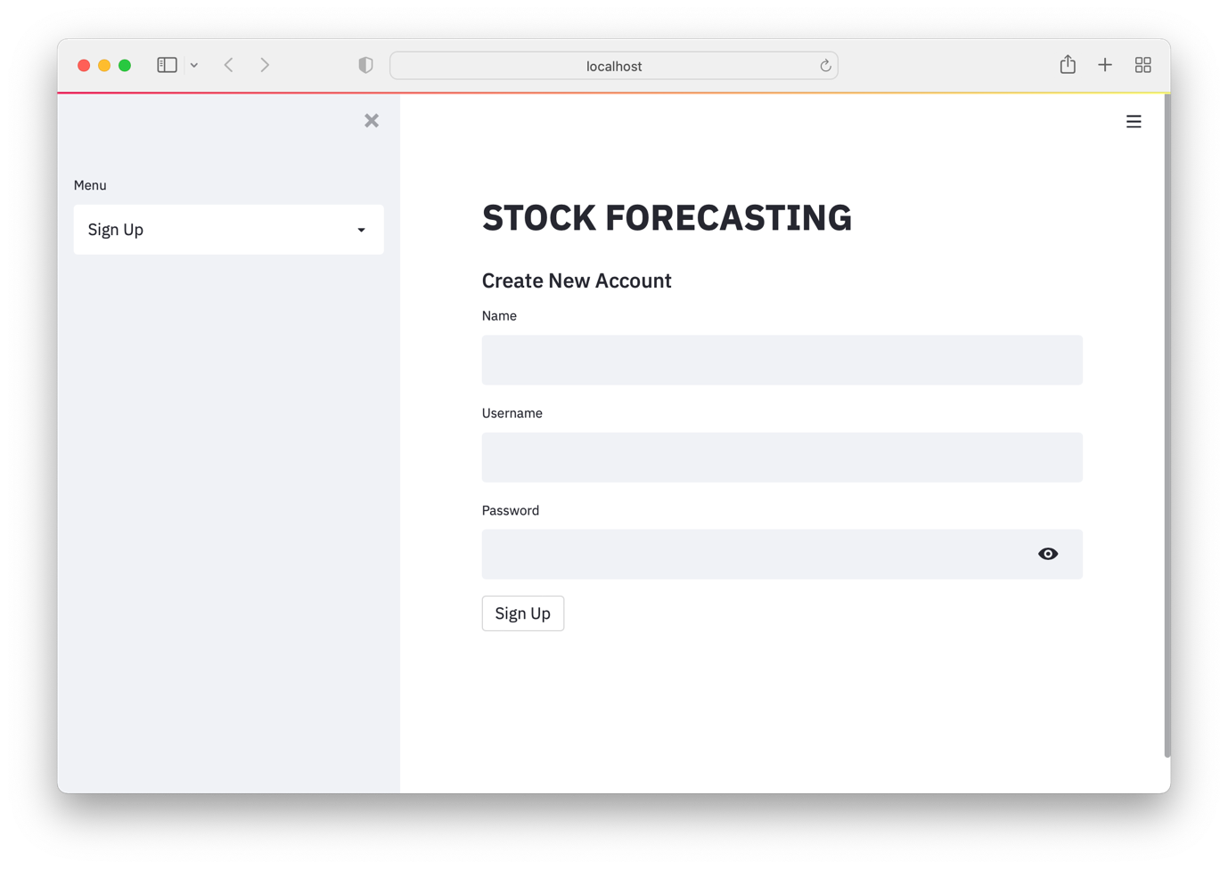

Usability Feature: sidebar which is retractable allowing for more screen real-estate when using the app

Usability Feature: large page titles which doesn’t change no matter what page go (just to remind what you are doing)

Usability Feature: large page titles to make it very visible to user which page they are on

Usability Feature: I will have a simple colour scheme of white, grey, and black for clear and professional look as per Q7 from the client interview

Allows user to register as per #2 in success criteria allowing for a tailored experience for the user in the upcoming programs

Usability Feature: large buttons to make them easier to see and click as per #13 in the success criteria

Usability Feature: there will be a clear acceptance label when a new account has been created or an error label here if the user enters a repeated username as per #3 and #13 in the success criteria

Usability Feature: a logical form which the user should be used to from other programs or websites to make the sign-up process easier

Usability Feature: drop down menu makes the user experience more interactive and allows user to see the 3 main pages only when required increasing the screen real-estate when not in use

Usability Feature: large clear headings for accessing the 3 main pages of the web app - welcome page, login page and registration page as per #13 in the success criteria

On Registration Page,

On Login Page,

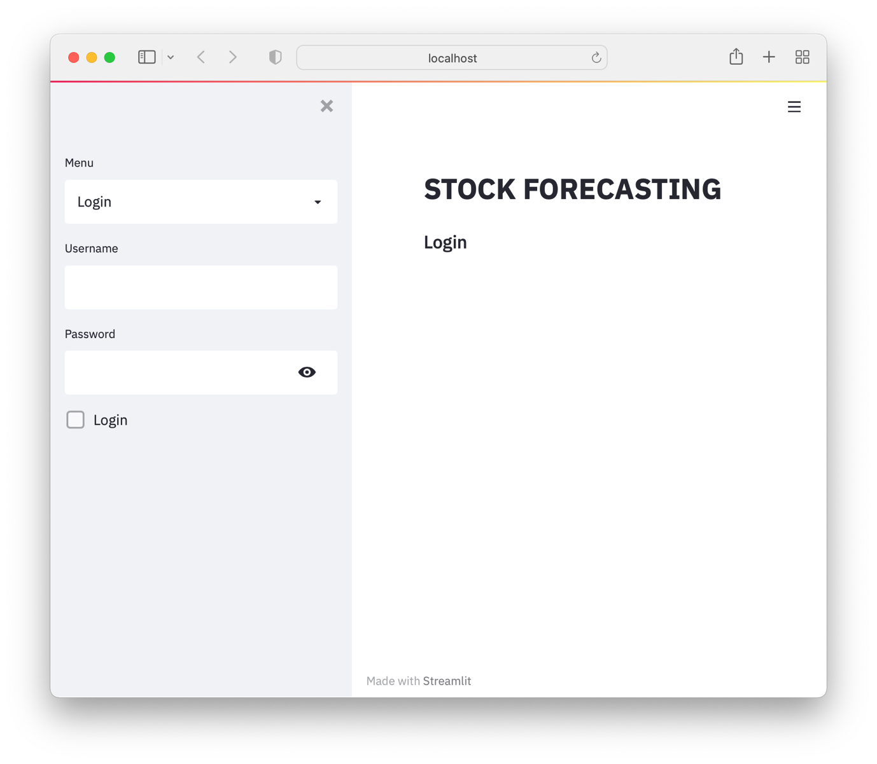

Usability Feature: sidebar which is retractable allowing for more screen real-estate when using the app

Usability Feature: large page titles which doesn’t change no matter what page go (just to remind what you are doing)

Usability Feature: I will have a simple colour scheme of white, grey, and black for clear and professional look as per Q7 from the client interview

Usability Feature: large page titles to make it very visible to user which page they are on

Pressing ‘Login’ will allow user to sign in after valid inputs as per #2, 3 and 5 in success criteria

Usability Feature: large buttons to make them easier to see and click as per #13 in the success criteria

Usability Feature: there will be a clear acceptance label when a new account has been created or an error label here if the user enters a repeated username as per #3 and #13 in the success criteria

Usability Feature: a logical form which the user should be used to from other programs or websites to make the sign-up process easier

Allows user to sign in as per #2, 3 and 5 in success criteria allowing for a tailored experience for the user in the upcoming programs

Usability Feature: drop down menu makes the user experience more interactive and allows user to see the 3 main pages only when required increasing the screen real-estate when not in use

On Welcome Page,

Usability Feature: large page titles to make it very visible to user which page they are on

Usability Feature: large page titles which doesn’t change no matter what page go (just to remind what you are doing)

Usability Feature: sidebar which is retractable allowing for more screen real-estate when using the app

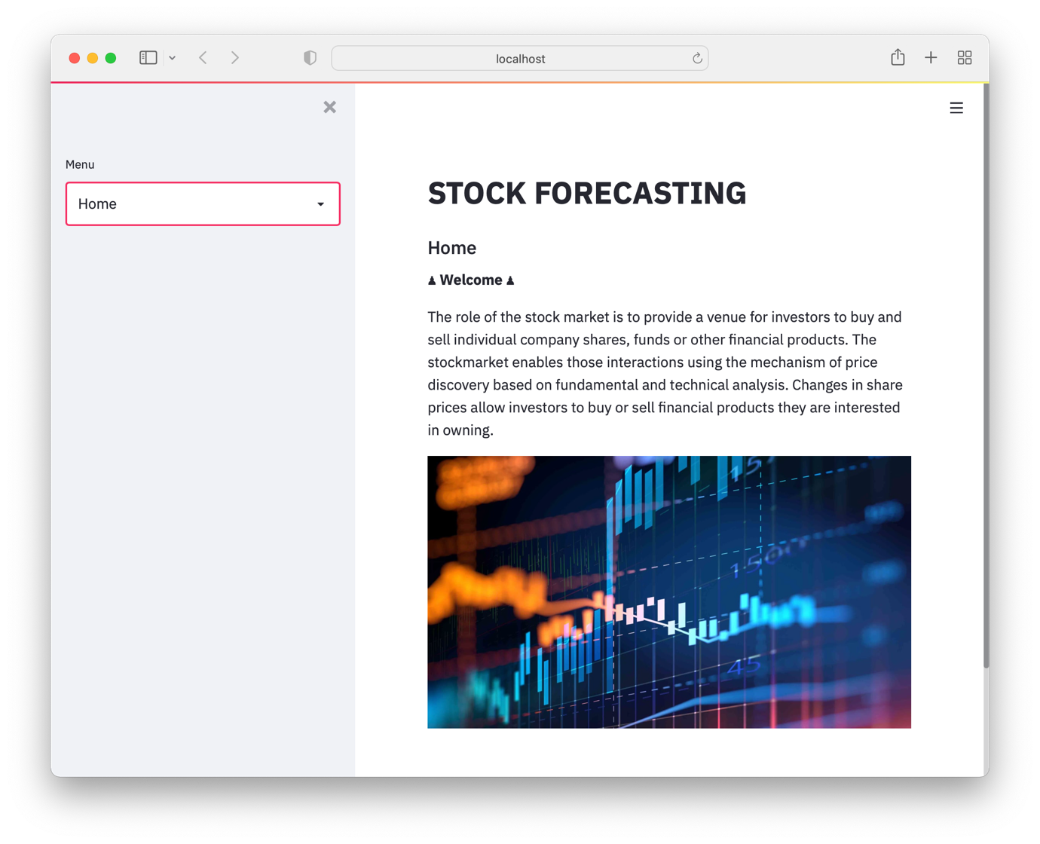

Usability Feature: large clear headings for accessing the 3 main pages of the web app - welcome page, login page and registration page as per #13 in the success criteria

Usability Feature: a logical form which the user should be used to from other programs or websites to make the sign-up process easier

Welcome message to the user to further inform they have logged in lets them know what to do next ie choose from one of the options below

Usability Feature: drop down menu makes the user experience more interactive and allows user to see the 3 main pages only when required increasing the screen real-estate when not in use

On Stock Forecasting Page,

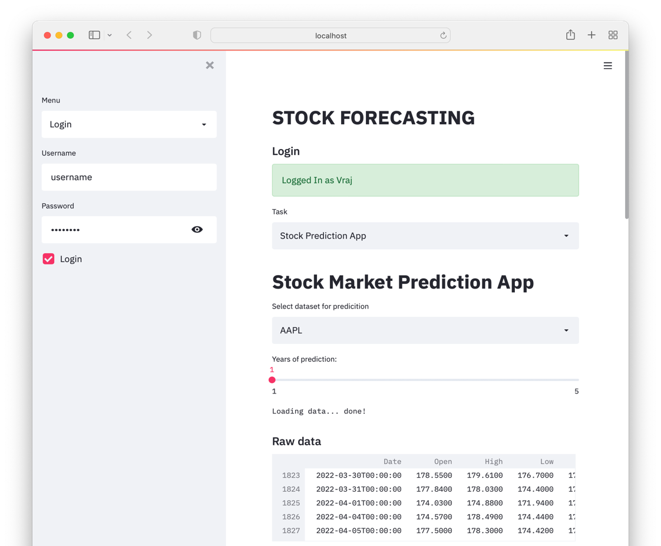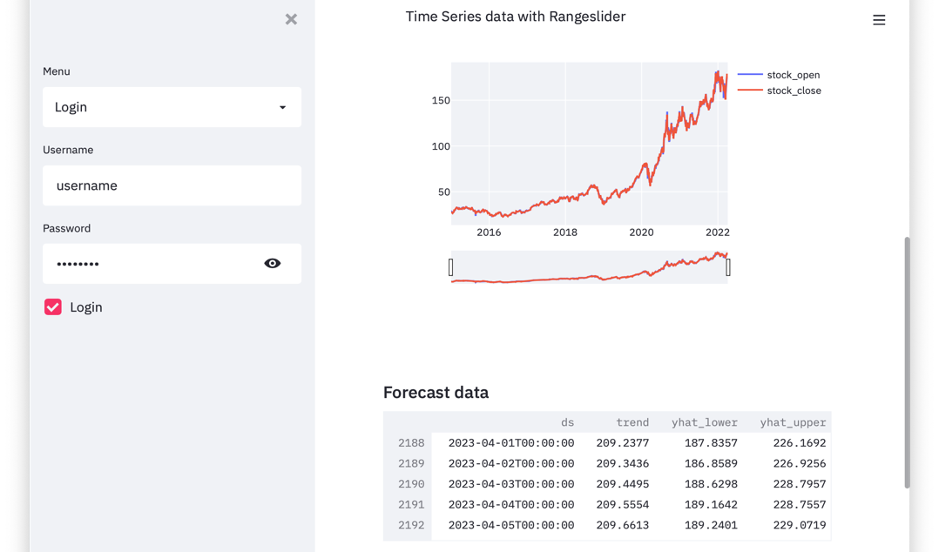

Usability Feature: sidebar which is retractable allowing for more screen real-estate when using the app

Usability Feature: large page titles to make it very visible to user which page they are on

Usability Feature: whenever the stock / cryptocurrency selected or the forecasting time is altered, the page should automatically refresh displaying the revised / new data

Usability Feature: drop down menu makes the user experience more interactive and allows user to see the 3 main pages and stocks/ cryptocurrencies respectively only when required increasing the screen real-estate when not in use

Usability Feature: slider option menu makes the user experience more interactive and as per Q2 in the client interview

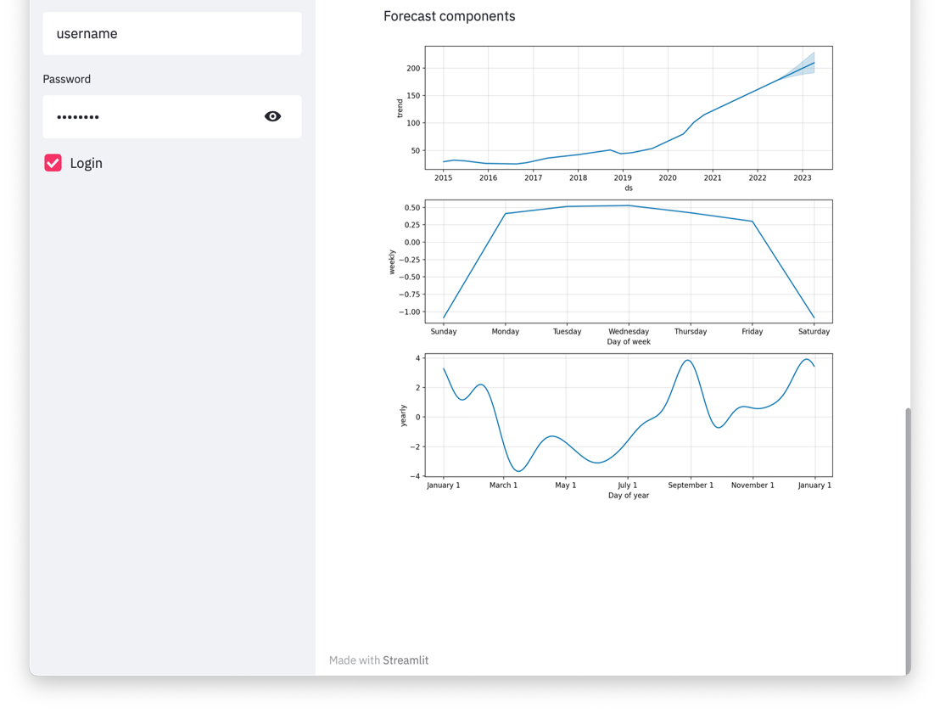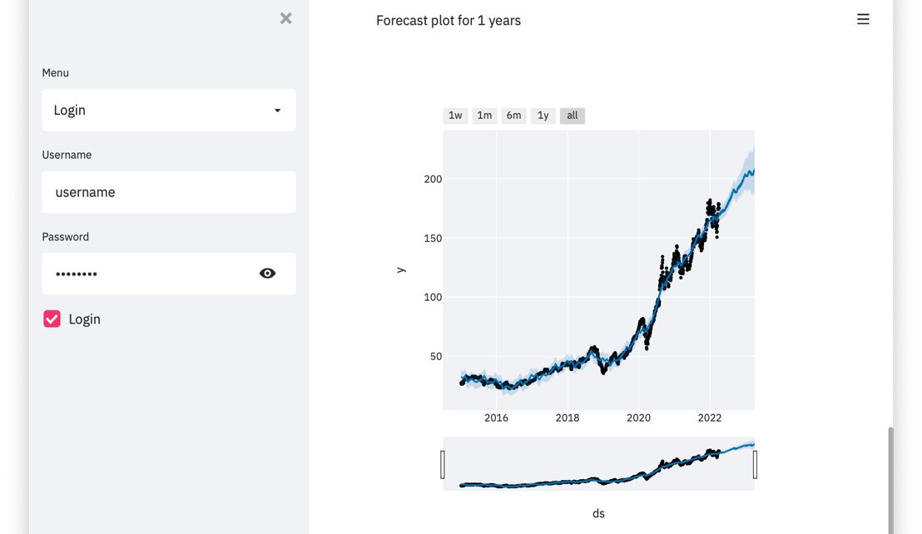

On Analytics Page,

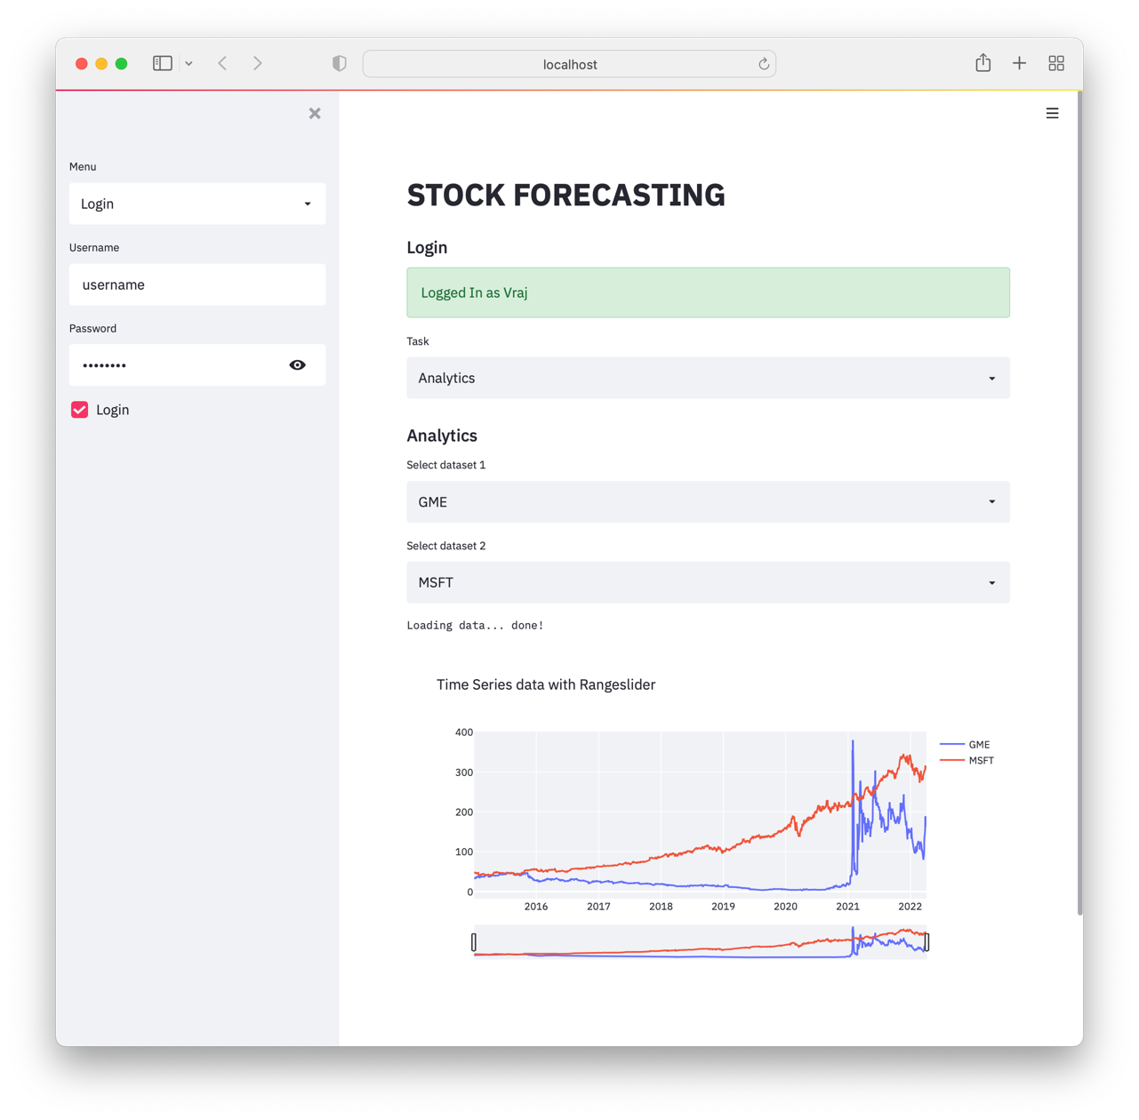

Usability Feature: sidebar which is retractable allowing for more screen real-estate when using the app

Usability Feature: large page titles to make it very visible to user which page they are on

Usability Feature: whenever the stock / cryptocurrency selected or the forecasting time is altered, the page should automatically refresh displaying the revised / new data

Usability Feature: drop down menu makes the user experience more interactive and allows user to see the 3 main pages and stocks/ cryptocurrencies respectively only when required increasing the screen real-estate when not in use

Usability Feature: as two different markets are on the same graph, there will definitely be a colour coded key in the corner to indicate which market is which

Usability Feature: the stock displayed will only be the opening prices of each market to reduce confusion and aid readability to increase productivity and clarity of the suer as this one of the key requirements as per #13 in success criteria and Q3 in the client interview

On Profiles Page,

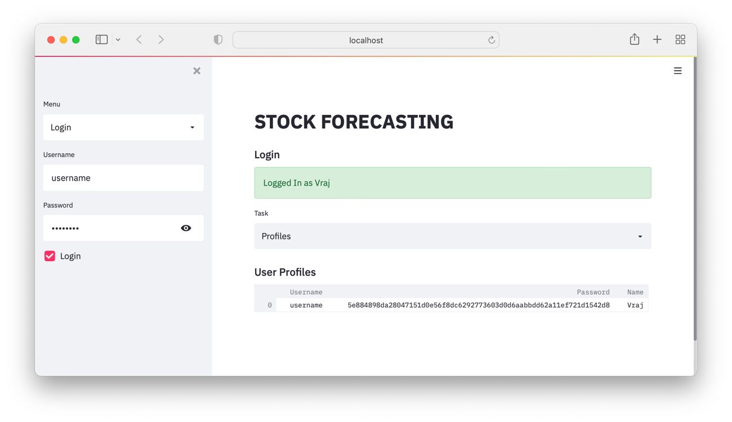

Usability Feature: sidebar which is retractable allowing for more screen real-estate when using the app

Usability Feature: large page titles to make it very visible to user which page they are on

Usability Feature: drop down menu makes the user experience more interactive and allows user to see the 3 main pages and stocks/ cryptocurrencies respectively only when required increasing the screen real-estate when not in use

Usability Feature: this is the database storing all the user’s login details

Usability Feature: for security reasons, the password will be stored as in hashed format so even the developer cannot access the sensitive information

**Improvements with Explanation**

1. The validation of the username and password could be made through doing a range check whereby the username and password be of a certain length such between 6 and 24 characters for the security of the user’s account and makes it difficult to hack into the account. For further security, the validation may require at least 1 number to be entered and also 1 special character in the password and maybe in the username require there to be ‘@’ in it
2. A clearer login and logout button could replace the tick box that I have used
3. The database could be stored on a server rather than locally on a computer
4. The program has to be run in terminal, which may seem a little complicated when opening the web app every time
5. Project is making it tailored to the client, however at the moment, for choosing the stock / cryptocurrencies that are available in the drop-down menu, those are entered physically by me however, it would be better if the user selected the stocks / cryptocurrencies they wanted and they would be at their disposal. To add to this, if the client has an interest in a new stock / cryptocurrency, they will have to inform me, and I would have to add it and then it would update. This is very bad as per the program being self - maintained
6. Could have a way of resetting the password if forgotten, but due to the hashing of the passwords, password recovery cannot be possible so a two - step authentication has to occur whereby an email is sent with an attached code which then allows the user to authenticate they want to change their password
7. Database should be stored on a serve rather than locally for all users to access

**Limitations**

On limitation was my skillset. My limited knowledge and experience with programming applications, using streamlit and other libraries meant that the final result wasn’t as sleek or technically advanced as it could be.

Another limitation was that I was doing the project alone. If I had a team, the tasks could’ve been split according to expertise. For example, I could have given the creation of the stock forecasting page to one individual and the login system with the database to another person. This would have made the program better and development would have been more efficient.

A further limitation was that I developed my program on MacOS. This means I don’t know if / how well it works on other operating systems such as Windows and Linux.

However, the biggest limitation which in a way resulted in the above limitations was time. If I had more time, I could have expanded my skillset, done the project more thoroughly adding more features and testing it on multiple operating systems.

**How Limitations Could Have Been Avoided**

The lack of skillset problem could have been avoided by doing courses such as database design courses or progressing further on the machine learning course to predict the prices with more accuracy.

The limitation of time could have been avoided if I had started my project earlier which would have allowed me to expand my skills and add more features to my program.

**Unmet Usability Features**

All usability features were completed.

**Maintenance**

Once my product goes on the market, certain aspects will require regular maintenance.

1. The database (design) will have to maintained and updated by a database systems manager as more users register
2. The customisation of each users’ requirements mean they will to be stored on the database alongside their credentials and will have been retrieved from the database and inserted into the program as required
3. New features will have to be regularly updated to keep up with alternative services (of which there are very few)
4. The forecasting algorithm has to be kept up to date for as accurate prices as possible for greater customer satisfaction
5. The design and layout will have to be updated in order to keep it modern and up to clients’ requirements to keep the program visually appealing for them
6. As our userbase grows, we may employ the use of servers for a variety of purposes such as advanced machine learning techniques or to simply store our database. A systems and networks manager will have to maintain the server
7. Expanding to mobile platforms such as IOS and Android may help attract more of a userbase

**X**

Menu

▼

STOCK FORECASTING

Create a New Account